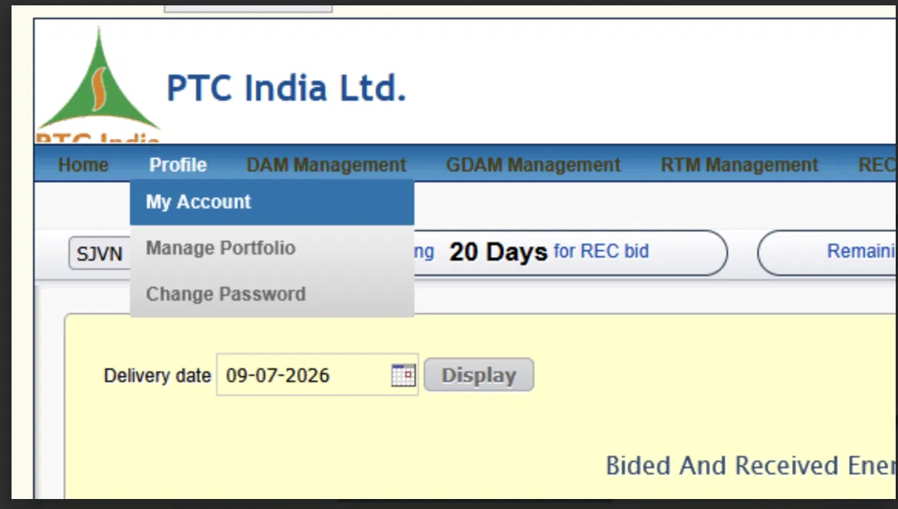

First — A Major Discovery
Notice the "SJVN" label/dropdown on the left. This confirms exactly what we discussed earlier about PTC — this PTC portal serves multiple client-companies, and SJVN is logged in as one of PTC's clients.
Remember we discussed way back — PTC is an independent, established power-trading company with its own trading-license and exchange-membership. Now it's clear — PTC acts as a "broker/facilitator" for clients like SJVN, exactly like the Zerodha-analogy I gave earlier. SJVN manages its bids through PTC's portal, and PTC (using its own membership/access) actually pushes those orders to the real exchange.
This is why your manager is telling you to use PTC's portal as the "foundation" — because this is a real, battle-tested, production trading-platform UI that already does exactly what your new system needs to do.

Element-by-Element Breakdown

1. Header/Branding Area
- "PTC India Ltd." logo + name — company branding, no functional role, just visual identity.

2. Top Navigation Menu (Blue Bar)
Menu Item | What It Means (Connecting to Our Discussion)
Home | Dashboard/landing page — likely an overall summary/quick-links page
Profile | User account settings (detailed below)
DAM Management | Recall — DAM = Day-Ahead Market. This section is for managing DAM-specific bids — placing, viewing, editing/cancelling bids
GDAM Management | GDAM = Green DAM — same as DAM, but renewable-specific. A separate menu-item confirms that your system should have separate DAM and GDAM modules/screens, not one generic form (exactly as I said in the Bid Management discussion)
RTM Management | RTM = Real-Time Market — a separate section for the fast, immediate-trading segment
REC [cut off] | Likely the full "REC Management" section (cut off in screenshot) — for REC certificates
Important observation: Every market-product (DAM/GDAM/RTM/REC) has its own top-level menu-section. This directly confirms our earlier analysis — each product needs its own workflow/screen, not a generic "trading screen." This is a direct blueprint for your information architecture (IA).

3. Profile Dropdown (Expanded)
When "Profile" is clicked/hovered, these 3 options open:
- My Account (currently highlighted — meaning the user is on this page right now)
- Manage Portfolio — interesting! This directly relates to our "Clients & Counterparties" module — SJVN likely manages its "portfolio" (its projects/generators/allocations) right here
- Change Password — standard account-security feature (matches our "User Management & Access Control" module)

4. Client Selector — "SJVN"
This is a dropdown/label showing which client-account is currently active. It tells us — this PTC portal serves multiple clients (SJVN being one), and the system supports switching between clients (if a user manages multiple accounts).

5. Alert/Countdown Banner — "...ng 20 Days for REC bid" and "Remaini..."
This is exactly the cutoff-countdown concept we discussed in detail earlier! The full text is likely: "Closing in 20 Days for REC bid" with another counter on the right cut off, probably "Remaining [X] Days."
What this means: The system proactively reminds the user of an approaching deadline — we called this "Alerts before deadline (T-30min, T-15min)" earlier, but here it's shown at day-level granularity (makes sense for REC, since it's not time-block-based like DAM, it's a longer cycle).

6. Main Content Area (Yellow Background)
"Delivery date" — Label + Date-input field ("09-07-2026" — DD-MM-YYYY format) + calendar-icon picker.
This connects to our "96 time-blocks for a specific date" concept — the user first selects which date's data they want to view.
"Display" Button — Currently appears greyed-out/disabled in the screenshot (indicated by the lighter gray color). This means the button likely activates once a date is selected, and clicking it will fetch/load/refresh that date's data — a standard "search/query" button pattern.
"Bided And Received Ener..." (cut off, likely "Bided And Received Energy") — This is a section header/table title, and below it there's probably a table showing:
- How much was bid (bid-quantity)
- How much was actually received/cleared (this is exactly our "Bid vs Cleared" ratio discussion from the Trading Dashboard module)

Key Takeaways From This Screenshot
- Product-wise separate sections — DAM, GDAM, RTM, REC each get their own menu and screens
- Date-based navigation — the whole system is designed around "select a specific delivery-date, then view its data"
- Bid-vs-Received tracking — exactly the "clear-ratio-analytics" concept we discussed, now visible in a real UI
- Client-account model — PTC serves multiple clients (like SJVN) from one portal, with separate account-contexts
- Countdown-alerts are built directly into the UI, not just email/SMS — visible right on the dashboard

Analytics and Summary View :
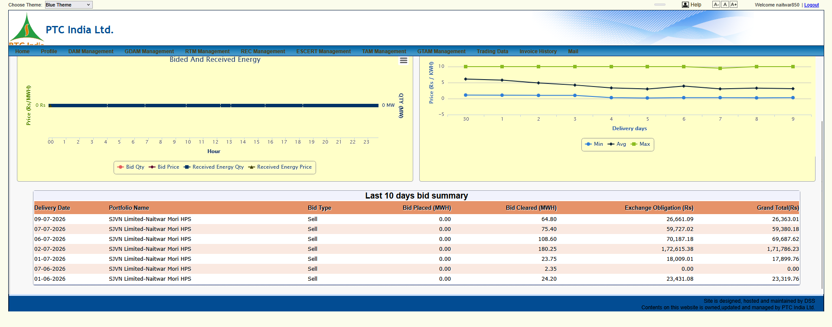

1. Top Navigation Bar (Expanded Scope)
In addition to what we saw in Screenshot 1, this top menu reveals the full array of market segments PTC supports:
- Market Segments Shown:
  - Home | Profile
  - DAM Management (Day-Ahead Market)
  - GDAM Management (Green Day-Ahead Market)
  - RTM Management (Real-Time Market)
  - REC Management (Renewable Energy Certificates)
  - ESCERT Management (Energy Saving Certificates / PAT scheme)
  - TAM Management (Term-Ahead Market)
  - GTAM Management (Green Term-Ahead Market)
  - Trading Data | Invoice History | Mail
- Header Controls:
  - Theme Switcher: Choose Theme: Blue Theme (top-left) — basic UI styling drop-down.
  - Accessibility Controls: A- A A+ (font size adjustment).
  - User Session Info: Welcome naitwar850 | Logout — indicates client/portfolio-specific login context (specifically logged in under the Naitwar Mori HPS credentials).

2. Chart 1: "Bided And Received Energy" (Left Visualizer)
This dual-axis hourly chart tracks bid submission versus actual cleared/received energy across a 24-hour delivery timeline (00 to 23 hours).
- Left Y-Axis (Price (Rs / MWH)): Tracks monetary pricing. Note the unit is explicitly ₹/MWh (not ₹/kWh), which is standard for exchange-level settlement calculations.
- Right Y-Axis (QTY (MW)): Tracks power capacity in Megawatts (MW).
- X-Axis (Hour): Shows 24 hourly blocks (00 through 23).
- Legend Series:
  - Bid Qty (MW placed in the market)
  - Bid Price (₹/MWh requested)
  - Received Energy Qty (MW actually cleared/allocated by the exchange)
  - Received Energy Price (Clearing price / MCP achieved)
- Business Context: This visualization directly measures Clearance Efficiency. Traders use this to immediately spot if their bids were partially cleared or completely rejected due to uncompetitive price limits.

3. Chart 2: Market Price Trend (Right Visualizer)
This chart tracks historical market price movements across recent delivery days.
- Y-Axis (Price (Rs / KWH)): Shows market prices in ₹/kWh (ranging from -5 to 10 on the scale shown).
- X-Axis (Delivery days): Displays day-wise progression (e.g., 30, 1, 2, 3, 4, 5, 6, 7, 8, 9).
- Legend Series:
  - Min (Minimum Market Clearing Price across 96 blocks for that day)
  - Avg (Weighted Average MCP for that day)
  - Max (Peak MCP recorded for that day)
- Business Context: Gives the trader an instant macro-trend view of market volatility over the past 10 days to guide upcoming day-ahead bid strategies.

4. Table Breakdown: "Last 10 days bid summary"
This table provides the daily transactional rollup for a specific generating entity.
Column Name | Observed Sample Data | What It Means (Domain/Business Logic) | Replicated Code Logic
Delivery Date | 09-07-2026, 07-07-2026, etc. | The physical date electricity is supplied. | delivery_date: Date
Portfolio Name | SJVN Limited-Naitwar Mori HPS | Specifies the exact generating asset. Naitwar Mori is SJVN’s 60 MW Hydro Power Station in Uttarakhand. | portfolio_id: UUID mapped to asset model
Bid Type | Sell | Indicates whether SJVN was selling surplus power or buying. (Generators primarily place Sell orders). | enum BidType { SELL, BUY }
Bid Placed (MWH) | 0.00 | Total energy quantity requested in submitted bids. (Note: In these sample rows, 0.00 indicates standing bids/revised trades or system auto-populates cleared energy from power exchange reports). | bid_qty_mwh: Decimal
Bid Cleared (MWH) | 64.80, 75.40, 108.60, 180.25 | The actual volume cleared by the exchange clearing system. | cleared_qty_mwh: Decimal
Exchange Obligation (Rs) | 26,661.09, 59,727.02, 1,72,615.38 | Gross monetary value owed by/to the exchange for the energy cleared (Cleared Volume × Clearing Price). | exchange_obligation_inr: Decimal
Grand Total (Rs) | 26,363.01, 59,380.18, 1,71,786.23 | Net financial obligation after deducting exchange trading margins, STU/CTU transmission charges, and statutory fees. Notice Grand Total is slightly less than Exchange Obligation (e.g., ₹26,661.09 vs ₹26,363.01) due to fee subtractions. | net_total_inr: Decimal (derived via fee breakdown)

5. UI Patterns & Key takeaways for Your Build
- Portfolio Asset Context:
  - In your platform, SJVN owns multiple generating plants (Naitwar Mori Hydro, Rampur Hydro, Nathpa Jhakri, Solar SPVs).
  - The top bar/filter must allow traders to filter by Portfolio Asset so they only view trades and obligations for that specific plant/SPV.
- Dual Unit Awareness (MWh vs kWh / MW):
  - Notice that the table and Chart 1 track volume in MWh and capacity in MW, while Chart 2 tracks price in Rs/kWh.
  - Your backend FastAPI models should standardise unit storage (e.g., store all volume in MWh and prices in INR/MWh) and let the React UI handle conversion display formats.
- Net vs. Gross Obligation Breakdown:
  - The discrepancy between Exchange Obligation and Grand Total confirms that your Trading Settlement module must explicitly account for line-item deductions (Exchange transaction fee, Application fee, F&A charges) rather than recording a single lump sum.

Bided And Received Energy :
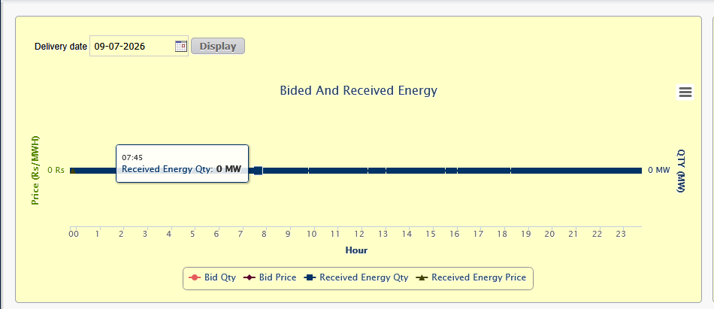

1. Contextual Control Layer
- Delivery Date Picker (Delivery date 09-07-2026 + Display button):
  - UI Pattern: A standard date selector with a explicit triggering button (Display).
  - UX Flow: Changing the date in the picker does not immediately auto-refetch the graph; the user must click Display to submit the date parameter query to the backend API.
  - Business Need: In high-volume financial systems, requiring explicit trigger buttons prevents unnecessary API calls while the user navigates calendar pickers.

2. Dynamic Tooltip & Granularity Discovery
- Tooltip Hover Inspection (07:45 | Received Energy Qty: 0 MW):
  - Crucial Domain Discovery: While the X-axis visually marks discrete hour blocks (00, 1, 2, ..., 23), the underlying data points and tooltip popup reveal 15-minute time-block granularity (07:45)!
  - Regulatory Linkage: This directly aligns with the Indian Power Market standard 96 time-blocks per day (each block being 15 minutes: 00:00, 00:15, 00:30, ..., 23:45).
  - Visualization Rule: The chart engine displays tick marks at the hourly level (to keep the X-axis legible), but the hover state hooks into the 15-minute sub-block data.

3. Dual-Axis Data Mapping & Legend
- Left Y-Axis (Price (Rs/MWH)): Renders the clearing or bid price scale in ₹/MWh.
- Right Y-Axis (QTY (MW)): Renders the capacity scale in Megawatts (MW).
- Legend Metrics Breakdown:
  - Bid Qty (Red Line / Circle marker): Volume (MW) offered in the bid.
  - Bid Price (Dark Brown / Diamond marker): Minimum price (₹/MWh) requested.
  - Received Energy Qty (Dark Blue / Square marker): Actual cleared volume (MW) allocated by the exchange.
  - Received Energy Price (Olive Green / Star marker): Final Market Clearing Price (MCP, ₹/MWh) at which the block cleared.
- Chart Context Menu (☰ icon, top right): Standard Highcharts/Chart.js export button allowing traders to export the visual graph directly to PNG, SVG, PDF, or raw CSV.

4. Technical Implementation Guidelines (React + Recharts + FastAPI)
To replicate this exact UX/UI functionality in your FastAPI + React stack, structure your component and backend response as follows:

A. FastAPI Backend Data Schema
Your API endpoint for this widget (e.g., GET /api/v1/trading/analytics/bided-vs-cleared) needs to return 96 data points for the selected delivery date:
JSON
{
"delivery_date": "2026-07-09",
"portfolio_id": "NAITWAR_MORI_HPS",
"time_blocks": [
{
"block_number": 32,
"time_stamp": "07:45",
"bid_qty_mw": 0.0,
"bid_price_inr_mwh": 0.0,
"cleared_qty_mw": 0.0,
"cleared_price_inr_mwh": 0.0
}
// ... up to 96 blocks
]
}

B. React (Recharts) Implementation Notes
Use a <ComposedChart> in Recharts to combine dual Y-axes with multiple line series:
- Dual Y-Axes:
  - <YAxis orientation="left" unit=" ₹/MWh" yAxisId="price"/>
  - <YAxis orientation="right" unit=" MW" yAxisId="qty"/>
- X-Axis Ticks: Set the XAxis dataKey to time_stamp, but set interval={3} (or custom tick formatter) so it only displays labels for every 4th block (on the hour: 00:00, 01:00, etc.) to prevent overlapping label text while keeping all 96 hoverable points.
- Tooltip Customization: Pass a custom Tooltip renderer to match the block time + metric format (07:45 - Received Energy Qty: 0 MW).

5. UI Pattern Summary for Your Design System
- Hourly Axis with Sub-hourly Hover: X-axis shows 24 labels, but the tooltip reads 96 blocks.
- Explicit Query Action: Date Picker -> Click Display -> Fetch Data.

Alert Header / Countdown Bar and the Chart Context Export Menu
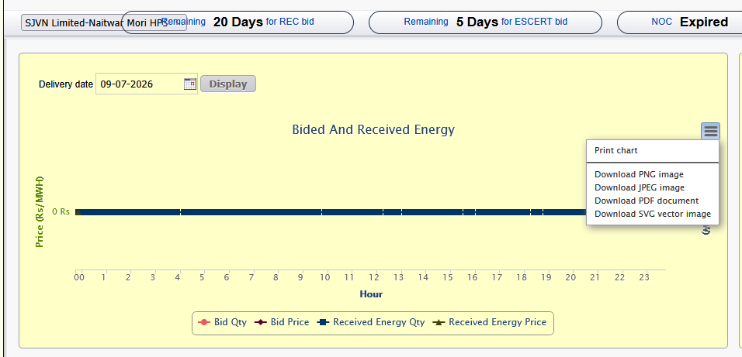

1. Top Alert & Countdown Banner (Critical Operational Safeguards)
Across the top of the content panel, three pill-shaped alert banners are displayed:

A. Asset Switcher Dropdown (Left Overlay)
- UI Control: SJVN Limited-Naitwar Mori HPS
- Functionality: Dropdown selector allowing the user to switch between different portfolio assets (e.g., switching from Naitwar Mori HPS to Rampur HPS or a Solar SPV).
- UI Bug in PTC Portal: Notice how the dropdown text overlaps directly onto the countdown badge (Remaining 20 Days...). In your React implementation, ensure proper flex layout spacing (gap-4) and CSS z-index management so dropdown menus don't visually clip or overlap adjacent badges.

B. Segment-Specific Countdown Timers
- Badge 1: Remaining 20 Days for REC bid
- Badge 2: Remaining 5 Days for ESCERT bid
- Domain Logic: Unlike Day-Ahead Market (DAM) and Real-Time Market (RTM) which operate on daily or 30-minute cycles, REC (Renewable Energy Certificates) and ESCERT (Energy Saving Certificates) operate on monthly or periodic auction windows.
- Business Need: Traders need persistent, in-UI deadline countdowns so monthly auction submission deadlines are never missed.

C. Critical Compliance Status Indicator (NOC Expiry Alert)
- Badge 3: NOC Expired (High-contrast bold alert)
- Domain & Regulatory Context:
  - A No Objection Certificate (NOC) from the Standing Clearance / Regional Load Despatch Centre (RLDC / SLDC) is legally mandatory for any grid-connected entity to trade on power exchanges.
  - Without a valid, active NOC, an entity is legally barred from placing trades or schedules on the exchange.
- System Safeguard Rule: When NOC Expired is active, your system's backend (FastAPI) must throw a hard validation block on the Bid Management module. It should disable the "Submit Bid" button across all market segments (DAM, RTM, GDAM) for that specific portfolio asset until a renewed NOC document is verified.

2. Chart Context Menu (Export Capabilities)
The screenshot shows the expanded context menu (☰ icon) on the Highcharts graph:
- Options Shown:
  - Print chart
  - Download PNG image
  - Download JPEG image
  - Download PDF document
  - Download SVG vector image
- Implementation Note for React: If using libraries like Recharts or Chart.js, you can implement this exact menu by wrapping the chart container with html2canvas or jspdf / recharts-to-png hooks to let traders quickly download executive-ready visual charts for daily trading reports.

3. UI Patterns & System Rules to Replicate
- Portfolio Asset Selector with Context Scoping:
  - Selecting a portfolio asset (e.g., Naitwar Mori HPS) re-scopes the NOC status, countdown timers, and graph data to that single entity.
- Hard Regulatory Blocks (NOC Management):
  - Link NOC validity dates stored in the Clients & Counterparties / Onboarding module directly to the Bid Submission engine. If today() > noc_expiry_date, switch the status badge to red (NOC Expired) and disable bid submission endpoints.
- In-UI Deadline Banners:
  - Display dynamic countdown banners for long-cycle products (REC, ESCert, TAM) right on the home dashboard.

Area Clearing Price :
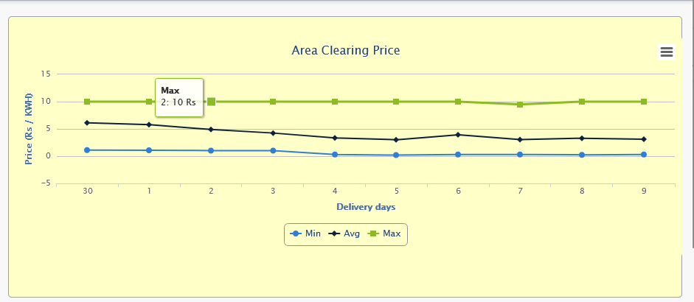

1. Core Visualizer Analysis: Area Clearing Price (ACP)

A. Title & Conceptual Domain (ACP vs MCP)
- Title Header: Area Clearing Price
- Domain Context (ACP vs MCP):
  - MCP (Market Clearing Price): The uniform unconstrained price calculated across the entire national grid assuming zero transmission congestion.
  - ACP (Area Clearing Price): The actual price calculated for a specific bid area/zone (e.g., N1, N2, W1, S1) when transmission corridor congestion occurs. Power exchanges divide the Indian national grid into 13 bid areas.
- Business Relevance: Generators and traders are paid based on the Area Clearing Price (ACP) of their specific injection node, not just the national unconstrained MCP.

2. Dynamic Tooltip & Price Cap Floor Discovery
- Tooltip Hover Inspection (Max | 2: 10 Rs):
  - Interpretation: On delivery day index 2 (e.g., 2nd of the month), the peak recorded Area Clearing Price reached 10 Rs/kWh.
  - Regulatory Significance (CERC Price Cap): Notice how the Max line (light green with square markers) runs flat across almost all delivery days at exactly 10 Rs/kWh. This visualizes the standard regulatory ceiling price set by CERC for normal DAM/RTM market segments to prevent market gouging during peak demand periods.

3. Axis & Series Breakdown
- Y-Axis (Price (Rs / KWH)): Tracks market rate in ₹/kWh (ranging from -5 to 15).
  - Note: Indian power exchanges can occasionally register negative or zero prices during severe over-generation/low-demand periods, which is why the Y-axis extends down to -5.
- X-Axis (Delivery days): Plots daily data points across consecutive delivery days (e.g., 30th of the previous month, followed by 1st through 9th of the current month).
- Legend Metrics:
  - Min (Blue Line / Circle Marker): The lowest ACP recorded across all 96 blocks for that delivery day.
  - Avg (Black Line / Diamond Marker): The weighted average ACP across all 96 blocks for that delivery day.
  - Max (Green Line / Square Marker): The highest ACP recorded across all 96 blocks for that delivery day.

4. Technical Implementation Guidelines (React + FastAPI)
To replicate this widget in your React + FastAPI architecture:

A. Backend Schema (FastAPI)
Your endpoint (e.g., GET /api/v1/trading/analytics/area-clearing-price) should return aggregated daily statistics scoped to the entity's specific delivery region (bid area):
JSON
{
"portfolio_id": "NAITWAR_MORI_HPS",
"bid_area": "N2",
"daily_acp_summary": [
{
"delivery_date": "2026-07-02",
"day_label": "2",
"min_acp_inr_kwh": 1.10,
"avg_acp_inr_kwh": 5.02,
"max_acp_inr_kwh": 10.00
}
// ... items for the last 10 delivery days
]
}

B. React (Recharts / Chart.js) Setup
- Component Type: <LineChart> with 3 <Line> components.
- Reference Line: Add a horizontal <ReferenceLine label="CERC Cap" stroke="red" strokeDasharray="3 3" y="{10}"/> to explicitly highlight the regulatory ceiling cap.
- Tooltip Formatter: Custom tooltip showing Day: {x}, {metric}: {y} Rs/kWh.

5. Summary of UI Patterns Established So Far
With this 5th screenshot, we have fully documented the Home Dashboard Layout:
- Top Header: Accessibility, Theme, Portfolio Switcher, NOC Expiry & Segment Countdown Banners.
- Main Analytics Grid:
  - Left: 15-minute block-wise Bided And Received Energy (Dual Y-Axis: Price ₹/MWh vs Qty MW).
  - Right: 10-day Area Clearing Price trend (Min / Avg / Max in ₹/kWh).
- Data Summary Table: Last 10 days bid summary capturing Portfolio, Bid Type, Bided MWh, Cleared MWh, Exchange Obligation (Rs), and Net Grand Total (Rs).
Whenever you are ready, please share the next screenshot (e.g., clicking into DAM Management or another navigation tab)

Date Picker Dropdown Interaction
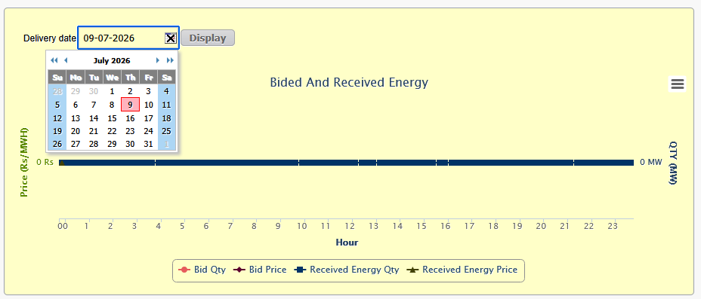

1. Calendar Overlay & Date Formatting Analysis

A. Date Format Standard
- Input Box Display: 09-07-2026
- Format: DD-MM-YYYY (Standard Indian billing and regulatory date representation).
- Implementation Rule: In your React application using UI libraries like date-fns or dayjs, explicitly format input strings as DD-MM-YYYY for display while sending standard ISO format (YYYY-MM-DD) to your FastAPI backend.

B. Calendar Navigation Elements
- Header Navigation (◄◄ ◄ July 2026 ► ►►):
  - ◄◄ / ►►: Year decrease / increase (e.g., jump to 2025 or 2027).
  - ◄ / ►: Month decrease / increase (e.g., jump to June 2026 or August 2026).
- Day Highlight: 9 highlighted with a bold red box border, corresponding directly to the 09 in the 09-07-2026 text field.
- Month-Boundary Padding: Shows muted/greyed-out dates from adjacent months (28, 29, 30 from June; 1 from August) to maintain the full 7-day grid structure (Su through Sa).

2. Interaction State & UX Flow
- Focus State: Selecting or clicking the input box triggers a blue outline around the text field and opens the absolute-positioned calendar overlay.
- Clear Control (✖ Icon): A inline clear button is available right inside the input field, allowing the trader to wipe the date value immediately without manual backspacing.
- Execution Delay (Explicit Query):
  - Selecting a date in the popover updates the input box, but does not trigger an immediate API re-fetch.
  - The fetch action is deferred until the user explicitly presses the Display button.

3. Technical Implementation Guidelines (React + FastAPI)
To replicate this cleanly in React (using standard Tailwind + Shadcn UI / Radix Popover & Calendar components):

A. State Management Structure
TypeScript
const [selectedDate, setSelectedDate] = useState<Date>(new Date("2026-07-09"));
const [appliedDate, setAppliedDate] = useState<string>("2026-07-09");

// Fetch data only when 'appliedDate' changes (triggered by Display button)
const { data, isLoading } = useQuery({
queryKey: ["bidedAndReceivedEnergy", portfolioId, appliedDate],
queryFn: () => fetchBidedAndReceivedEnergy(portfolioId, appliedDate),
});

const handleDisplayClick = () => {
setAppliedDate(format(selectedDate, "yyyy-MM-dd"));
};

B. UI Component Mapping (Shadcn UI / Tailwind equivalent)
- Replace PTC's retro legacy table calendar with a modern, accessible Radix <Popover> containing a <Calendar> component.
- Keep the explicit Display trigger button to prevent erratic network refetches while traders click through months.

Alert Header / Compliance Banner Strip

1. Complete Breakdown of Banner Elements (Left to Right)

A. Asset / Client Context Selector
- UI Control: SJVN Limited-Naitwar Mori HPS
- Purpose: Sets the portfolio scope for the entire dashboard.
- UI Layout Flaw Note: Notice again the clear CSS overflow/z-index bug where the selector box overlays directly on top of the next badge (Remaining 20 Days...). In your React system, ensure flex wrappers with gap-3 and responsive shrinking (flex-shrink-0) are used to prevent overlapping badges.

B. Segment Bidding Countdowns
- Pill 1: Remaining 20 Days for REC bid
- Pill 2: Remaining 5 Days for ESCERT bid
- Domain Function: Active window countdowns for periodic/monthly market segments (Renewable Energy Certificates and Energy Saving Certificates).

C. Grid Access Clearance Indicator
- Pill 3: NOC Expired
- Regulatory Meaning: Indicates that the Regional Load Despatch Centre (RLDC / SLDC) No Objection Certificate for Naitwar Mori HPS has passed its validity date.

D. Agreement & Contract Validity Status (NEW ELEMENT)
- Pill 4 (Far Right): Agreement Active For Expired(REC), 176 Days(TAM), Expired(ESCERT)
- Domain & Business Logic:
  - What this represents: This tracks the validity of the Service/Trading Agreement signed between the Client (SJVN) and the Trading Member / Facilitator (PTC India) for each market product.
  - Multi-Product Scoping: A single client agreement covers multiple trading segments, but each segment can have its own distinct start and end validity date:
    - Expired(REC): The contract authorizing PTC to trade Renewable Energy Certificates on SJVN's behalf has expired.
    - 176 Days(TAM): The contract authorizing Term-Ahead Market trading remains active and valid for another 176 days.
    - Expired(ESCERT): The contract for Energy Saving Certificates trading has expired.

2. Strategic Implementation Guidance for Your Platform
This banner strip provides a blueprint for how your platform should handle Compliance, Risk, and Entitlement Checks before allowing any trade execution.

A. Distinction Between NOC vs. Member Agreement
In your platform's PostgreSQL database, you must distinguish between two separate legal constraints:
Legal Instrument | Scope | System Action on Expiry
Grid NOC (Standing Clearance) | Issued by RLDC/SLDC. Authorizes physical injection into the grid. | Hard block on physical scheduling/bidding across all exchange markets (DAM, RTM, GDAM).
Trading Member Agreement | Commercial agreement between Portfolio Owner and Trading Facilitator. | Segment-level feature toggling (e.g., allow TAM bidding, but disable REC/ESCert bidding endpoints).

B. FastAPI Validation Middleware (Pre-Bid Check Pipeline)
When a trader attempts to submit or save a bid in your FastAPI backend, pass the payload through a strict validation pipeline that reads these exact statuses:
Python
# Conceptual Pre-Bid Validation Logic for FastAPI
def validate_bid_submission(portfolio_id: str, market_segment: str, db: Session):
# 1. Check Grid NOC Validity
noc_status = db.query(NOCRecord).filter_by(portfolio_id=portfolio_id).first()
if not noc_status or noc_status.expiry_date < date.today():
raise HTTPException(
status_code=403,
detail="NOC Expired: Trading barred by RLDC/SLDC grid regulations."
)

# 2. Check Segment-Specific Agreement Validity
agreement = db.query(TradingAgreement).filter_by(
portfolio_id=portfolio_id,
segment=market_segment
).first()

if not agreement or agreement.expiry_date < date.today():
raise HTTPException(
status_code=403,
detail=f"Trading Agreement for segment '{market_segment}' has expired."
)

return True

C. React UI Design Pattern (Status Bar Component)
Instead of individual cramped pill buttons, group these into a cohesive, modern Asset Health & Compliance Bar at the top of your trading screen:
- Green Badges (Active): For valid NOCs and agreements with >30 days remaining.
- Amber Badges (Expiring Soon): For NOCs/agreements expiring within 30 days (e.g., TAM: 176 Days Left).
- Red/Destructive Badges (Expired): For expired NOCs or agreements (NOC Expired, Expired(REC)), accompanied by a lock icon on the affected market module.
Whenever you're ready, please share the next screenshot (e.g., navigating into DAM Management, RTM Management, or a bid entry grid)

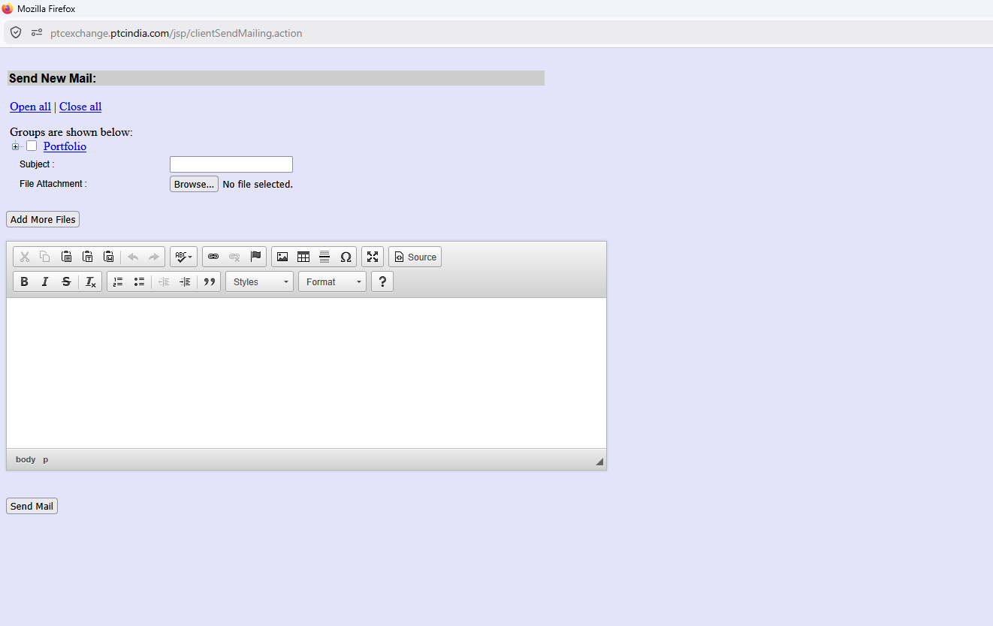

1. Page Context & High-Level Purpose
- URL Path: [ptcexchange.ptcindia.com/jsp/clientSendMailing.action](https://ptcexchange.ptcindia.com/jsp/clientSendMailing.action)
- Module Title: "Send New Mail:"
- Business Purpose: This screen is a Client Bulk Communication / Notification Hub built into the exchange/broker portal. In power trading operations, trading desks frequently need to broadcast critical operational updates to specific entities, portfolios, regional desks, or counterparties.
Common trading use cases for this screen include:
- Gate Closure / Cutoff Warnings: Sending urgent reminders to plant operators or DISCOM managers before exchange order-books lock.
- Curtailment / Grid Advisories: Notifying portfolio contacts about grid congestion, SLDC curtailments, or emergency schedule revisions.
- Daily Settlement / Billing Dispatches: Sending daily trade confirmation summaries, NOC status updates, or invoice notices directly to designated recipient groups.

2. Granular UI Element Breakdown

A. URL & Navigation Context
- URL: .../clientSendMailing.action (Struts/JSP legacy backend architecture)
- Design Note: In the legacy portal, this runs as a standalone page. In our modern React platform, this functionality should live under a Communication & Audit or Client Desk Management section.

B. Recipient Group Selector (Open all | Close all & Groups are shown below:)
Visual Element | Found On Screen | Business / Functional Purpose
Action Links | Open all | Close all | Toggles tree expansion for nested target groups (portfolios, assets, plants, or regions).
Hierarchical Tree | [+] [ ] Portfolio | A tree-view selection control allowing traders/brokers to target specific categories of recipients.

Business Context:
In power trading, communications rarely go to "all users." They are highly target-specific. For example:
- By Portfolio/Entity: Select specific RE generators (e.g., Solar SPV 1, Wind Site 2) or DISCOM clients.
- By Role: Target only Authorized Signatories, Scheduling Officers, or Billing Desk Contacts.
- By Region: Target entities within a specific Regional Power Committee (NRPC, WRPC, SRPC, etc.).

C. Message Meta Inputs (Subject & File Attachment)
Field | Input Control | Functionality
Subject: | Text Box | Subject line for the broadcast email / system message.
File Attachment: | Browse... No file selected. | File picker for attaching documents.
Add More Files | Button | Allows attaching multiple documents sequentially.

Business Context:
Trading dispatches frequently require supporting evidence or standard forms:
- Format-D schedule sheets
- Signed NOC certificates or Open Access approvals
- Daily cleared trade reports or Provisional Billing PDFs

D. Rich Text Editor (CKEditor / WYSIWYG)
- Features Present: Bold, Italic, Strikethrough, Remove Format, Bulleted/Numbered Lists, Indent/Outdent, Blockquote, Links/Unlink, Anchor, Image Embed, Table Generator, Special Characters, Fullscreen, Source Code View, Style/Format dropdowns.
- Business Context: Allows traders to format complex operational notices cleanly (including tabular data like block-wise power allocations or grid advisory details) rather than sending unformatted plain text.

E. Action Button (Send Mail)
- Control: Send Mail button (bottom left).
- Business Context: Triggers the backend email dispatch engine to send the composed message and attachments to all contact email addresses associated with the checked group nodes in the tree view.

3. How to Implement This in Our Tech Stack (FastAPI + React + PostgreSQL)
Rather than replicating this dated 2000s-era UI directly, we can modernize it into a clean, modern broadcast tool inside our platform using our chosen tech stack.

A. Architecture & Tech Choice
+-------------------------------------------------------------+
| React Frontend |
| - Rich Text: TipTap / `@tinymce/tinymce-react` |
| - Group Selector: Radix UI / Shadcn `Tree View` / Checkbox |
+-------------------------------------------------------------+
|
v (REST API / Multi-part Form)
+-------------------------------------------------------------+
| FastAPI Backend |
| - Background Tasks: Celery + Redis (or APScheduler) |
| - Email Dispatch: Async SMTP (aiosmtplib / FastAPI-Mail) |
| - File Storage: MinIO / Local S3 Bucket for attachments |
+-------------------------------------------------------------+
|
v
+-------------------------------------------------------------+
| PostgreSQL Database |
| - Table: `communication_logs` (Audit Trail) |
| - Table: `recipient_groups` & `client_contacts` |
+-------------------------------------------------------------+

B. Database Schema Design (PostgreSQL)
To support this feature cleanly and maintain audit history (critical for regulatory and dispute compliance):
SQL
-- Track all outgoing client broadcasts
CREATE TABLE client_communications (
id UUID PRIMARY KEY DEFAULT gen_random_uuid(),
sender_id UUID NOT NULL REFERENCES users(id),
subject VARCHAR(255) NOT NULL,
body_html TEXT NOT NULL,
recipient_filter_json JSONB NOT NULL, -- Stores target portfolio/role criteria
attachment_urls TEXT[], -- Array of stored file paths
status VARCHAR(20) DEFAULT 'PENDING', -- PENDING, SENT, FAILED
sent_at TIMESTAMP WITH TIME ZONE,
created_at TIMESTAMP WITH TIME ZONE DEFAULT CURRENT_TIMESTAMP
);

-- Individual delivery tracking per recipient contact
CREATE TABLE communication_delivery_logs (
id UUID PRIMARY KEY DEFAULT gen_random_uuid(),
communication_id UUID NOT NULL REFERENCES client_communications(id),
contact_id UUID NOT NULL REFERENCES client_contacts(id),
email_address VARCHAR(255) NOT NULL,
delivery_status VARCHAR(20) DEFAULT 'QUEUED', -- QUEUED, DELIVERED, FAILED
error_message TEXT,
delivered_at TIMESTAMP WITH TIME ZONE
);

C. FastAPI Backend Implementation Strategy
Because sending emails to multiple contacts and handling attachments can take time, this MUST be handled asynchronously so the UI does not freeze or time out:
Python
from fastapi import APIRouter, BackgroundTasks, UploadFile, File, Form, Depends
from typing import List
import json

router = APIRouter(prefix="/api/v1/communications", tags=["Communications"])

@router.post("/send-broadcast")
async def send_client_broadcast(
background_tasks: BackgroundTasks,
subject: str = Form(...),
body_html: str = Form(...),
group_ids: str = Form(...), # JSON string of selected group/portfolio IDs
attachments: List[UploadFile] = File(None),
current_user = Depends(get_current_user)
):
parsed_group_ids = json.loads(group_ids)

# 1. Save uploaded attachments to server/S3 storage
saved_file_paths = await save_attachments(attachments)

# 2. Save communication record to PostgreSQL (Audit Trail)
comm_record = await create_comm_record(
sender_id=current_user.id,
subject=subject,
body_html=body_html,
target_groups=parsed_group_ids,
attachment_paths=saved_file_paths
)

# 3. Offload email rendering & SMTP dispatch to background worker
background_tasks.add_task(
process_email_broadcast_dispatch,
comm_id=comm_record.id,
target_groups=parsed_group_ids,
subject=subject,
body_html=body_html,
attachment_paths=saved_file_paths
)

return {"status": "SUCCESS", "message": "Broadcast queued for delivery", "communication_id": comm_record.id}

4. UI Patterns to Replicate (Adding to our Running Master List)
Here is how we refine this legacy pattern into our modern React design system:
- Modern Hierarchical Selection Tree:
  - Replace basic JSP checkbox lists with a collapsible, searchable Tree Select Component (e.g., using @radix-ui/react-checkbox or React-Arborist).
  - Include quick-filters like "Select All RE Generators", "Select All DISCOM Contacts", or "Select All Active Bidding Desks".
- Template Integration (New Value-Add):
  - Add a "Select Template" dropdown above the subject line (e.g., Format-D Dispatch Notice, Gate Closure Reminder, Monthly Settlement Summary).
  - Pre-fill the editor with standard variables like {{client_name}}, {{delivery_date}}, {{contract_id}}.
- In-App + Email Dual Channel Dispatch:
  - Instead of email only, add checkboxes: [x] Send via Email and [x] Send In-App Notification (Dashboard Alert). This ensures urgent operational notices are seen inside the portal dashboard immediately.
- Delivery Status & Audit History Tab:
  - Provide a secondary tab on this screen called "Communication Log" where traders can review past broadcasts, see who received them, check delivery failures, and view exact timestamps for compliance auditing.

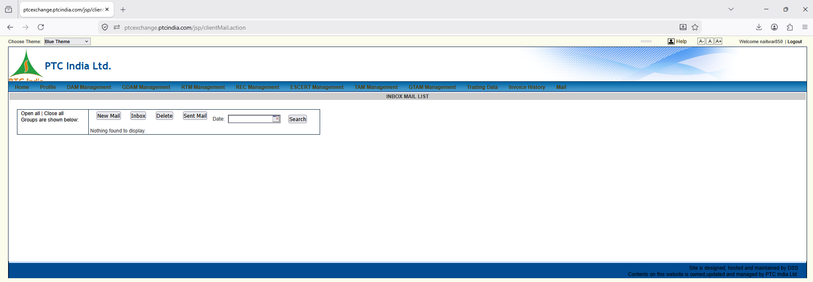

1. Context & Global Navigation Analysis
This screenshot gives us a full-width view of the main PTC trading portal header and the Mail Management Inbox page.
- URL Path: [ptcexchange.ptcindia.com/jsp/clientMail.action](https://ptcexchange.ptcindia.com/jsp/clientMail.action)
- Module Title Banner: INBOX MAIL LIST
- User Context: Logged in as naitwar850 (top-right header). "Naitwar" refers to SJVN's Naitwar Mori Hydro Electric Project (60 MW) in Uttarakhand—confirming this portal account is mapped to specific asset/client credentials.

Top Navigation Bar (Master Market Product Menu)
This top horizontal bar reveals the full market product landscape supported by the platform:
Menu Item | Market Segment / Product Domain | Domain Description & SJVN Context
Home | Portal Dashboard | Landing view with announcements and client portfolio summary.
Profile | Entity / Portfolio Config | Account settings, bank details, portfolio mapping, NOC management.
DAM Management | Day-Ahead Market | Physical power trading 1 day in advance (96 time blocks of 15-min each).
GDAM Management | Green Day-Ahead Market | Renewable-only DAM; clears before conventional DAM in sequence.
RTM Management | Real-Time Market | Intraday trading in half-hourly sessions (48 sessions/day).
REC Management | Renewable Energy Certs | Pure environmental attribute certificates (1 REC = 1 MWh).
ESCERT Management | Energy Saving Certs | PAT scheme compliance certificates.
TAM Management | Term-Ahead Market | Multi-day to multi-month bilateral contracts.
GTAM Management | Green Term-Ahead Market | Renewable & hydro-based multi-day contracts.
Trading Data | Market Data & Reports | Historical market prices, cleared volumes, and exchange reports.
Invoice History | Billing & Financials | Invoices, credit notes, and payment settlement records.
Mail (Active) | Internal Messaging / Desk | System messages, operational notices, and client broadcasts.

2. Granular UI Element Breakdown (Inbox Control Panel)
The main content panel on this page serves as an Internal Communication Desk / Inbox for official notices sent between PTC traders and client desk operators (like SJVN's Naitwar Mori plant operators).
+-----------------------------------------------------------------------------------+
| Open all | Close all [ New Mail ] [ Inbox ] [ Delete ] [ Sent Mail ] |
| Groups are shown below: Date: [ YYYY-MM-DD 📅 ] [ Search ] |
| (Empty Group Tree) ------------------------------------------------- |
| "Nothing found to display." |
+-----------------------------------------------------------------------------------+

Element Breakdown Table
Visual Element | Found On Screen | Business / Functional Purpose
Group Filter Panel (Left) | Open all | Close all  Groups are shown below: | Tree view filter to narrow down messages by client portfolio, generation unit, or regional desk.
New Mail Button | Action Button | Opens the compose broadcast screen (the exact screen analyzed in your previous screenshot!).
Inbox Button | Folder Toggle Tab | Filters table to display incoming operational messages and alerts.
Delete Button | Action Button | Soft-deletes selected message threads from the mailbox view.
Sent Mail Button | Folder Toggle Tab | Filters table to display outgoing communications sent by the user.
Date: Input Box | [ ] 📅 Date Picker | Filters message logs by a specific operational/delivery date.
Search Button | Query Trigger | Executes the query based on selected group, folder, and date parameters.
Data Grid / Table | "Nothing found to display." | Grid displaying message thread subject, sender, date/time, attachment icon, and read/unread status.

3. Business Purpose & Technical Mapping
In power trading operations, official messaging within the trading software is legally and operationally critical:
- Audit Evidence: Email servers can drop messages or get flagged as spam. An in-app messaging audit trail proves that a bid closure warning, curtailment advice, or settlement statement was formally delivered to the client.
- Multi-Asset Mapping: Operators logging in under asset handles (like naitwar850) must only see messages relevant to their specific plant/portfolio.

4. Modern Architecture Implementation (FastAPI + React + PostgreSQL)
Instead of using primitive HTML form posts and full-page refreshes like this legacy JSP implementation, we will integrate this into a modern Notification & Message Center in React.

A. Database Schema Design (PostgreSQL)
To link messages with asset portfolios, users, and audit logs:
SQL
-- Internal Message Store
CREATE TABLE system_messages (
id UUID PRIMARY KEY DEFAULT gen_random_uuid(),
sender_id UUID NOT NULL REFERENCES users(id),
recipient_id UUID REFERENCES users(id), -- NULL if broadcasted to portfolio
portfolio_id UUID REFERENCES portfolios(id), -- Links to asset (e.g., Naitwar Mori)
folder VARCHAR(10) NOT NULL CHECK (folder IN ('INBOX', 'SENT', 'ARCHIVE')),
subject VARCHAR(255) NOT NULL,
body_text TEXT NOT NULL,
has_attachments BOOLEAN DEFAULT FALSE,
is_read BOOLEAN DEFAULT FALSE,
created_at TIMESTAMP WITH TIME ZONE DEFAULT CURRENT_TIMESTAMP
);

CREATE INDEX idx_messages_portfolio_date ON system_messages(portfolio_id, created_at DESC);

B. FastAPI Endpoint Architecture
Python
from fastapi import APIRouter, Depends, Query
from typing import Optional
from datetime import date

router = APIRouter(prefix="/api/v1/mail", tags=["Mail & Messaging"])

@router.get("/inbox")
async def get_client_inbox(
folder: str = Query("INBOX", enum=["INBOX", "SENT"]),
portfolio_id: Optional[str] = None,
filter_date: Optional[date] = None,
current_user = Depends(get_current_user),
db = Depends(get_db)
):
"""
Retrieves filtered operational messages for the logged-in client account.
Auto-restricts data to the user's assigned plant/portfolio (e.g. Naitwar Mori).
"""
query = """
SELECT id, sender_id, subject, has_attachments, is_read, created_at
FROM system_messages
WHERE folder = :folder
AND (portfolio_id = :portfolio_id OR recipient_id = :user_id)
"""
if filter_date:
query += " AND DATE(created_at) = :filter_date"

query += " ORDER BY created_at DESC"

# Execute query and return structured JSON
results = await db.fetch_all(query, {
"folder": folder,
"portfolio_id": current_user.assigned_portfolio_id,
"user_id": current_user.id,
"filter_date": filter_date
})
return {"status": "SUCCESS", "count": len(results), "data": results}

5. Master UI Patterns Identified (Adding to Running Refinement List)
- Top Horizontal Navigation Structure:
  - This screenshot confirms our top-level navigation hierarchy. Each market product (DAM, GDAM, RTM, REC, ESCERT, TAM, GTAM) gets its dedicated primary tab.
- Asset Context Banner:
  - The top-right display of Welcome naitwar850 highlights that users need clear, constant visual feedback on which trading entity or plant account they are currently operating under.
- Integrated Search & Date-Based Filtering:
  - Operational messages are indexed primarily by Date and Portfolio Group rather than standard full-text search alone.

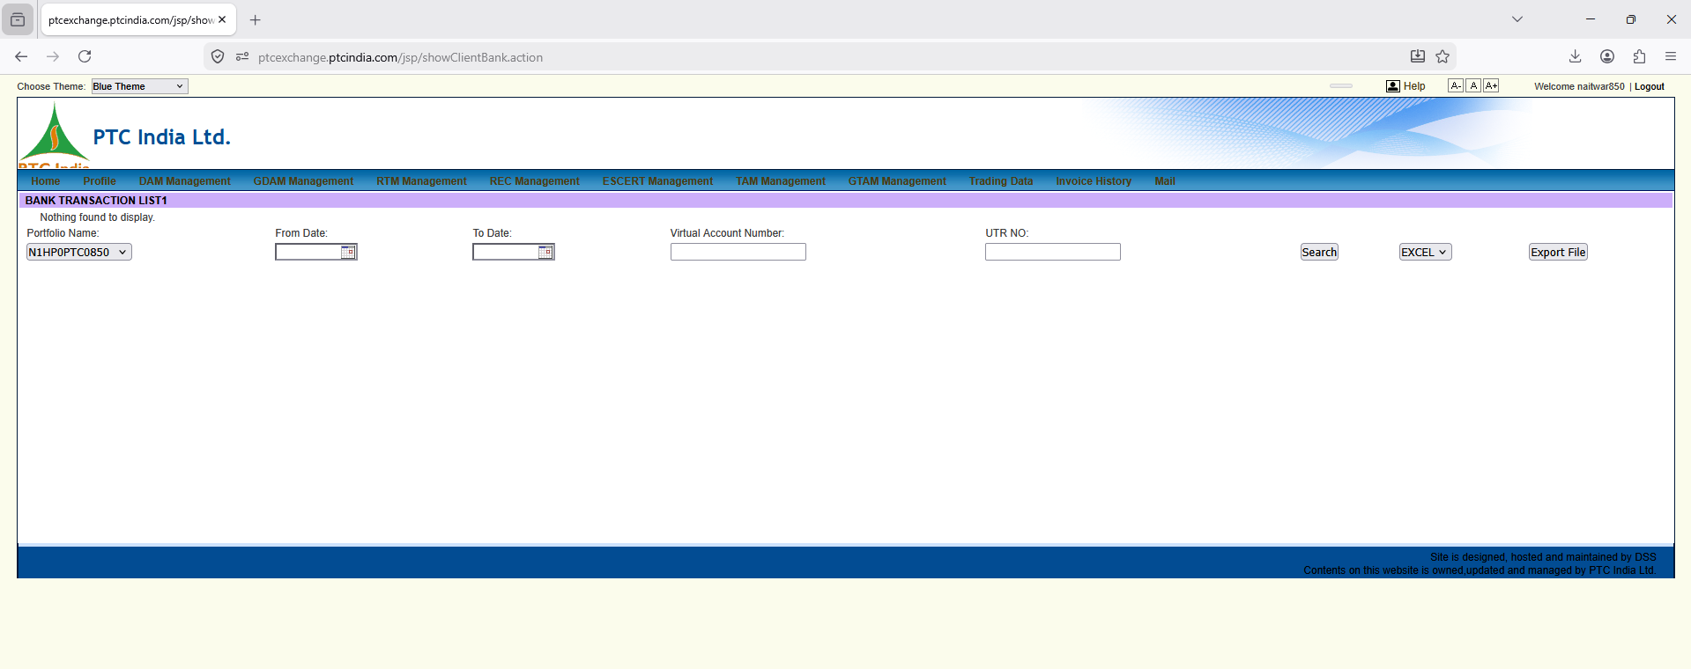

1. Page Context & Domain Purpose
- URL Path: [ptcexchange.ptcindia.com/jsp/showClientBank.action](https://ptcexchange.ptcindia.com/jsp/showClientBank.action)
- Module Title: BANK TRANSACTION LIST1
- Parent Menu Context: Accessible via Profile or Invoice History / Trading Data.
- Business Purpose: This page acts as a Client Ledger / Virtual Bank Transaction Portal. In power exchange trading, power exchanges (like IEX, PXIL, HPX) require advance margins, daily pay-in settlements, and collateral maintenance. When trading through a broker/facilitator like PTC India, clients (such as SJVN) deposit funds into dedicated Virtual Account Numbers (VANs) assigned to specific generation units/portfolios.
This screen allows the client and trader to track:
- Pay-in / Pay-out Receipts: Fund transfers made to/from the trading desk via UTR (Unique Transaction Reference) numbers.
- Virtual Account Statement: Real-time visibility into funds credited against a specific portfolio ID.
- Margin & Settlement Adjustments: Daily trade obligations, exchange margin holds, and refund transfers.

2. Granular UI Element Breakdown
+---------------------------------------------------------------------------------------------------------+
| BANK TRANSACTION LIST1 |
| Nothing found to display. |
| Portfolio Name: From Date: To Date: Virtual Account Number: UTR NO: |
| [ N1HP0PTC0850 v ] [ 📅 ] [ 📅 ] [ ] [ ] |
| |
| [ Search ] [ EXCEL v ] [ Export File ] |
+---------------------------------------------------------------------------------------------------------+

Element Breakdown Table
Visual Element | Text / Input Control | Business / Domain Context & Operational Rule
Portfolio Name | Dropdown (N1HP0PTC0850) | Unique Client Portfolio Code. Notice the identifier structure:  • N1: Northern Region 1  • HP: Himachal Pradesh  • 0PTC: PTC Client Tag  • 0850: Unique Asset Code mapped to Naitwar Mori HEP (60 MW).
From Date / To Date | Date Pickers (DD-MM-YYYY) | Date-range filters for querying banking ledger entries (daily, weekly, monthly reconciliation periods).
Virtual Account Number | Text Input | The specific virtual bank account (usually ICICI/HDFC/Axis VAN) assigned to this portfolio for automated CMS (Cash Management System) auto-reconciliation.
UTR NO | Text Input | Unique Transaction Reference number generated by the bank during RTGS/NEFT/IFT transfers. Traders use this to look up and confirm specific bank transfer receipts.
Search Button | Action Button | Executes database query based on the selected portfolio, date range, VAN, or UTR.
Export Controls | Dropdown (EXCEL) + Export File | Allows downloading payment ledgers for financial auditing, SAP ERP sync, and monthly settlement reconciliation.
Data Grid / Table | Status: "Nothing found to display." | Grid header area that populates banking records once searched.

3. Financial & Operational Workflow (How This Works in Real Trading)
+---------------------------------------------------------------------------------+
| SJVN Finance Desk |
| Initiates RTGS / NEFT transfer for daily margin/pay-in to PTC's Virtual Account |
+---------------------------------------------------------------------------------+
|
v (Bank CMS / Webhook API)
+---------------------------------------------------------------------------------+
| PTC India Virtual Account |
| Bank detects incoming UTR with Virtual Account: "VAN-SJVN-NAITWAR" |
+---------------------------------------------------------------------------------+
|
v (Reflected on this UI)
+---------------------------------------------------------------------------------+
| Bank Transaction List |
| Shows Credit Entry: Date | UTR | Amount | Status (Cleared/Margin-Hold) |
+---------------------------------------------------------------------------------+
|
v (Auto-checks before Bidding)
+---------------------------------------------------------------------------------+
| Exchange Bid Engine |
| Validates available margin balance before allowing DAM/RTM bid submission |
+---------------------------------------------------------------------------------+

5. Key UI/UX Patterns to Replicate in Our System
- Portfolio ID Naming Standard:
  - We should adopt a standardized portfolio naming pattern similar to PTC's ([Region][State][Type][AssetCode]), e.g., NR-HP-HYDRO-NAITWAR0850 or WR-GJ-SOLAR-SJVN001.
- Instant UTR Lookup Bar:
  - Provide an explicit UTR Search input. Finance desks constantly search by UTR when verifying whether a payment made earlier in the day has reflected in the platform.
- Auto-Reconciliation Status Indicators:
  - Add visual badge tags in our React data table:
    - 🟢 Matched & Applied: Funds verified and margin released.
    - 🟡 Pending Verification: Bank webhook received, awaiting bank confirmation.
    - 🔴 Unreconciled / Amount Mismatch: Discrepancy between expected obligation and actual transferred amount.
- SAP Direct Sync Status Indicator:
  - Since our system must integrate with SJVN's SAP ERP, each transaction row should display a SAP Voucher Status icon (e.g., Synced to SAP GL 102390, Pending Sync, Sync Failed).

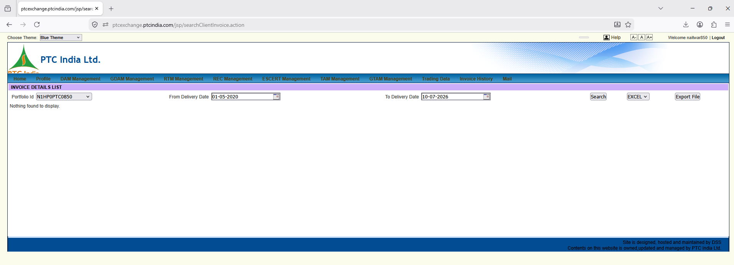
Here is the granular, element-by-element analysis of this fourth PTC portal screenshot, which focuses on client invoice search, billing management, and historical financial document retrieval.

1. Page Context & Domain Purpose
- URL Path: [ptcexchange.ptcindia.com/jsp/searchClientInvoice.action](https://ptcexchange.ptcindia.com/jsp/searchClientInvoice.action)
- Module Title: INVOICE DETAILS LIST
- Parent Menu Context: Active under Invoice History on the top menu bar.
- Business Purpose: This screen serves as the Client Billing & Invoice Management Desk. In exchange power trading, billing is not handled via standard simple receipts; it involves daily trading obligation statements, weekly open access charges, exchange transaction fees, and monthly net financial settlements.
This screen allows the client (SJVN's Naitwar Mori plant unit) and trading desk managers to query and retrieve:
- Trading Invoices: Tax invoices for physical power traded across DAM, GDAM, RTM, and TAM.
- Trading Margin / Commission Invoices: Invoices for PTC's trading margin fees (e.g., ₹0.02/kWh or contracted slab rates).
- Open Access & Statutory Charge Invoices: Invoices covering wheeling charges, RLDC/SLDC scheduling fees, and NOAR application charges.
- Credit / Debit Notes: True-up adjustments arising from post-facto REA/SEA energy revisions.

2. Granular UI Element Breakdown
+---------------------------------------------------------------------------------------------------------+
| INVOICE DETAILS LIST |
| Nothing found to display. |
| Portfolio Id: From Delivery Date: To Delivery Date: |
| [ N1HP0PTC0850 v ] [ 01-05-2020 📅 ] [ 10-07-2026 📅 ] |
| |
| [ Search ] [ EXCEL v ] [ Export File ] |
+---------------------------------------------------------------------------------------------------------+

Element Breakdown Table
Visual Element | Text / Input Control | Business / Domain Context & Operational Rule
Portfolio Id | Dropdown (N1HP0PTC0850) | Asset Account Filter. Selects the specific asset account (Naitwar Mori HEP, 60 MW) for invoice context.
From Delivery Date | Date Input (01-05-2020) | Delivery Date Filter Start. Crucial domain distinction: Invoices are queried by Power Delivery Date (when power actually flowed), not just the invoice generation date.
To Delivery Date | Date Input (10-07-2026) | Delivery Date Filter End. Range bound up to the current operational period.
Search Button | Action Button | Queries the database for all generated tax invoices and settlement statements matching the delivery range.
Export Format Dropdown | Dropdown (EXCEL) | Format selector (EXCEL, PDF, CSV) for bulk downloading billing summaries.
Export File Button | Action Button | Triggers a file generation job to download selected invoice data.
Data Grid Area | Status: "Nothing found to display." | Table container that populates fields: Invoice No, Invoice Date, Delivery Period, Billed Energy (kWh), Tariff (₹/kWh), Taxable Value, GST Amount, Total Payable/Receivable, and Download PDF link.

3. Key Financial & Regulatory Billing Nuances
In our platform (which replaces both SJVN-ISET and internal client interactions), this screen maps directly to the Trading Billing & Settlement Module.

A. Delivery Date vs. Trade Date vs. Invoice Date
- Trade Date (T): The day the order cleared on IEX/PXIL/HPX.
- Delivery Date (T+1): The day power physically flowed through the grid.
- Invoice Date: The date the tax invoice was formally generated.
- Rule: The UI specifically uses Delivery Date because energy accounting and REA (Regional Energy Account) reconciliation are linked to physical delivery dates.

B. Tax Treatment & Statutory Line Items
Unlike basic commercial invoices, trading invoices must break out line items distinctly:
- Power Sale Value (Exempt from GST under Indian GST rules for electrical energy).
- Trading Margin / Commission (Taxable under GST @ 18%).
- Exchange Transaction Fees & CTUIL Transmission Charges.

5. UI/UX Refinement Patterns for Our Platform
- Delivery Date Range Quick-Select:
  - Provide quick presets in our React frontend: [This Month], [Last Month], [Current Quarter], [FY 2026-27].
- Direct PDF Preview & Download Cell:
  - Add a dedicated column with a PDF icon button for instant inline document preview and download.
- SAP ERP Document Link:
  - Display the SAP FI Financial Document number directly in the table row so accountants can cross-check SAP accounting entries without switching tabs.
- Payment Status Badge:
  - Include status pills: 🟢 Paid, 🔴 Overdue, 🟡 Partially Paid, 🔵 Draft / Unbilled.
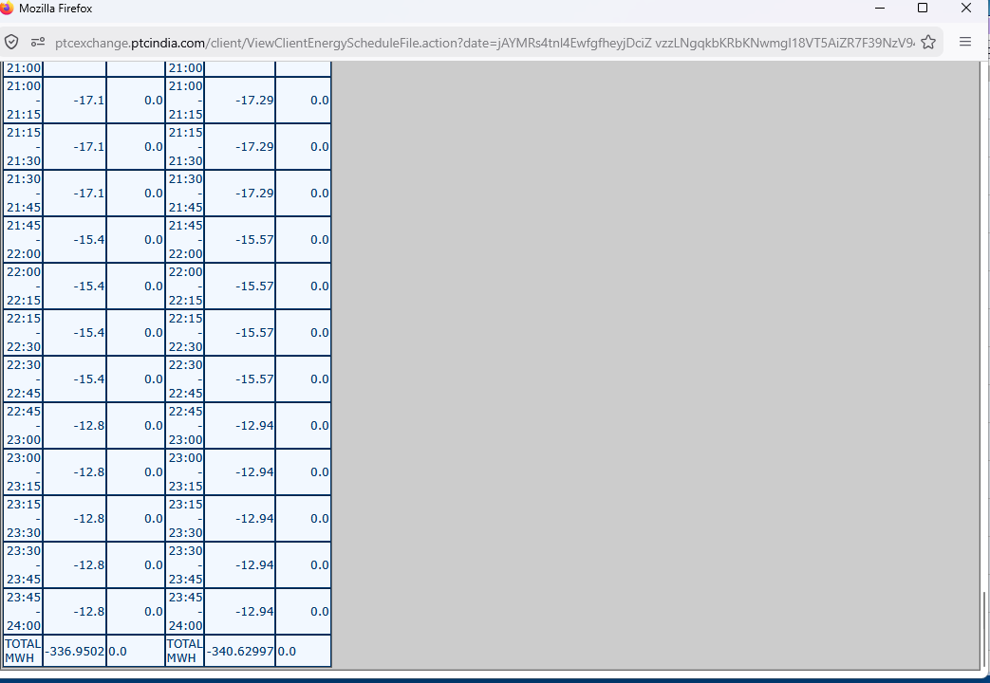

1. Page Context & Domain Purpose
- URL Path: [ptcexchange.ptcindia.com/client/ViewClientEnergyScheduleFile.action?date=](https://ptcexchange.ptcindia.com/client/ViewClientEnergyScheduleFile.action?date=)...
- Module Title: View Client Energy Schedule File
- Business Purpose: This screen renders the Cleared Energy Schedule File (15-Minute Block Wise) for a specific trading day.
- In Indian power markets (IEX/PXIL/HPX and RLDC/SLDC scheduling), a 24-hour day is divided into 96 time blocks of 15 minutes each. When a Day-Ahead Market (DAM) or Real-Time Market (RTM) bid clears, the exchange generates this block-wise scheduled energy file.
This document forms the official legal and commercial baseline for:
- Physical Dispatch Orders: Sent to the plant control room (e.g., Naitwar Mori HEP) to adjust generation output.
- Format-D Preparation: Bilateral and exchange scheduling submissions to SLDC/RLDC.
- Deviation Settlement Mechanism (DSM): The baseline against which actual metered generation (JMR/Meters) is compared to calculate over-generation or under-generation penalties.

2. Granular Data Structure & Field Breakdown
The screenshot shows the bottom section of the 96-block table (from Block 85 at 21:00 hrs down to Block 96 at 24:00 hrs, followed by daily totals):
+-------------------------------------------------------------------------------+
| TIME BLOCK | INJECTION PERIPHERY | BUYER PERIPHERY | TIME BLOCK | ... |
| (15-Min) | (MW / MWh) | (MW / MWh) | (15-Min) | |
+---------------+---------------------+-----------------+-------------+---------+
| 21:00 - 21:15 | -17.1 | 0.0 | ... -17.29 | 0.0 |
| 21:15 - 21:30 | -17.1 | 0.0 | ... -17.29 | 0.0 |
| 21:30 - 21:45 | -17.1 | 0.0 | ... -17.29 | 0.0 |
| 21:45 - 22:00 | -15.4 | 0.0 | ... -15.57 | 0.0 |
| ... | ... | ... | ... ... | ... |
| 23:45 - 24:00 | -12.8 | 0.0 | ... -12.94 | 0.0 |
+---------------+---------------------+-----------------+-------------+---------+
| TOTAL MWH | -336.9502 | 0.0 | -340.62997 | 0.0 |
+-------------------------------------------------------------------------------+

Granular Column Analysis & Domain Mechanics
Column / Row | Value Sample | Essential Domain & Accounting Rule
Time Block Column 1 | 21:00 - 21:15  down to 23:45 - 24:00 | 15-Minute Interval Window. Block 85 through Block 96 of the standard 96-block power day.
Negative Values | -17.1, -15.4, -12.8 | Crucial Grid Sign Convention:  • Negative (-) = Power Injection / Generation (e.g., SJVN supplying/selling power into the grid).  • Positive (+) = Power Drawal / Consumption (e.g., DISCOM pulling power out of the grid).
Generator Periphery (MW) | -17.1 MW | Scheduled power generation at the Plant / Generator Busbar (Ex-Power Plant).
Regional / Delivery Periphery | -17.29 MW | Scheduled power at the Regional Transmission Grid Boundary (STU/ISTS). Notice -17.29 vs -17.1—the difference reflects Transmission Losses applied dynamically by the grid operator.
Buyer Columns | 0.0 | Shows 0.0 because this specific file is from the Seller / Generator (SJVN) perspective. SJVN is injecting, not drawing power.
TOTAL MWH Row | -336.9502 MWh  -340.62997 MWh | Daily Cumulative Energy Volume. Sum of all 96 blocks.  • Calculation: $\text{Energy (MWh)} = \sum_{b=1}^{96} \left(\frac{\text{MW}_b}{4}\right)$ because each block is $\frac{1}{4}$ of an hour.

3. Critical Business Rules Discovered for Platform Logic
- Sign Convention Handling in Code:
  - In UI displays, raw negative numbers (-17.1) can confuse non-traders. In our database, we must store raw values with correct sign conventions (- for injection, + for drawal), but in our modern React frontend, we should render them with clear directional badges: 🟢 17.1 MW (Injection).
- Precision & Rounding Rules:
  - Notice the total row contains high-precision floating numbers: -340.62997 MWh.
  - Rule: Billing calculations use floating precision up to 5 decimal places to avoid compounding errors across millions of units before final financial rounding.
- Loss Factor Correlation:
  - Injection at plant periphery (-17.1 MW) maps to regional delivery (-17.29 MW). Our schedule parsing engine must store both Ex-Bus (Plant) and Ex-Periphery (Grid) numbers to accurately calculate transmission loss deductions.

5. Modern UI/UX Patterns for Our React Terminal
Instead of raw plain-text HTML tables, our React application will transform this into a high-density Trading Schedule Matrix Grid:
- Visual Heatmap Grid (96 Blocks View):
  - Color-code block rows based on load intensity (e.g., peak solar hours vs. off-peak hours).
- Interactive Hourly Aggregation Toggle:
  - Allow traders to collapse the 96 blocks into 24 Hourly Summaries or expand to full 15-minute resolution.
- Difference Highlighting (Scheduled vs. Actual Meter):
  - Overlay Joint Meter Reading (JMR) data on top of this schedule table. Highlight blocks where deviation exceeds regulatory thresholds in 🔴 red to warn traders of impending DSM deviation charges.
- Instant Export to CSV / Format-D / SAP:
  - One-click export formatted directly for RLDC Format-D upload or SAP GL posting.

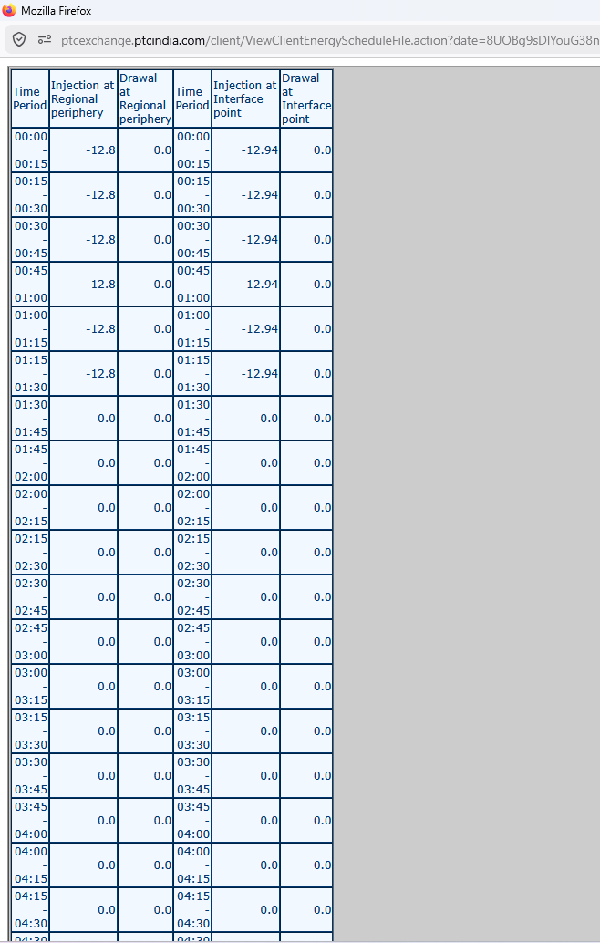

Haan bhai, ye wahi 15-minute Energy Schedule file hai, par isme 2 bade differences hain:
- Time Window Difference: Pichle screenshot mein raat ke aakhiri blocks (21:00-24:00) the, jabki isme din ke shuruati blocks (00:00 - 04:30 AM / Block 1-18) dikh rahe hain.
- Column Headers & Detail Visibility: Is screenshot mein table ke top headers (titles) saaf dikh rahe hain, jo pichle wale mein cut gaye the.

📑 Detailed Functional & Domain Breakdown

1. Clear Headers Uncovered
- URL: .../ViewClientEnergyScheduleFile.action?date=... (Same schedule file generator URL)
- Injection at Regional periphery: Regional grid boundary par cleared schedule.
- Drawal at Regional periphery: DISCOM/Buyer side ka drawal schedule (SJVN ke case mein zero/0.0 hai kyunki SJVN seller hai).
- Injection at Interface point: Plant/STU interface point par generation schedule.
- Drawal at Interface point: Local interface drawal.

2. Operational Insight: Plant Shutdown / Non-Bidding Window
Notice kiye:
- 00:00 to 01:30 AM: Plant se -12.8 MW / -12.94 MW ki continuous generation/injection dikh rahi hai.
- 01:30 AM se onwards (04:30 tak): Values ekdam 0.0 MW ho gayi hain.
Business Purpose:
- In trading operations, 0.0 value ka matlab hai ki ya toh:
  - Plant ne un specific blocks ke liye bid submit hi nahi kiya.
  - Exchange par submitted bid us clearing price (MCP) par clear nahi ho payi.
  - Plant physically off-line/shut down tha.

3. Loss Accounting Formula (Grid vs Plant Periphery)
Dono peripheries ke numbers ko compare karein:
- Interface Point (Plant End): -12.94 MW
- Regional Periphery (Grid End): -12.80 MW
$$\text{Transmission Loss} = \vert{}-12.94\vert{} - \vert{}-12.80\vert{} = 0.14\text{ MW}$$
Domain Rule: Generator plant se 12.94 MW nikal raha hai, par delivery point par 12.80 MW hi pahunch raha hai. 0.14 MW (~1.08%) transmission loss grid operator dwara deduce kar liya gaya hai.

🎨 UI/UX Pattern for SJVN Platform Replicating This
- Visual Block Indicators: 0.0 values wale blocks ko blank chhodne ke bajaye, UI mein neutral/greyed-out dikhayenge taaki trader ko ek glance mein pata chal jaye ki kaunse blocks uncleared/zero-schedule hain.
- Loss Delta Display: Mouse hover karne par automatically inline loss % dikhana (1.08% ISTS Loss Applied).

📑 Functional & Domain Breakdown
➡️ Header Clarifications:
- Injection / Drawal at Regional periphery: Inter-state / Regional grid boundary par cleared schedule volume.
- Injection / Drawal at Interface point: Plant ya local STU busbar/meter point par actual injected volume.
- Drawal Columns (0.0): SJVN ek seller/generator hai, isliye Drawal hamesha zero (0.0) rahega.
➡️ Operational Insight (Zero-Schedule Blocks):
- 00:00 - 01:30 AM: Plant continuous -12.8 MW / -12.94 MW inject kar raha hai.
- 01:30 AM onwards: Schedule poora 0.0 MW ho gaya hai.
- Meaning: In blocks mein bid clear nahi hui, plant shutdown tha, ya zero-bidding set ki gayi thi.
➡️ Loss Calculation (Grid vs Plant):
- Interface (Plant): -12.94 MW
- Regional Grid: -12.80 MW
- Loss: $12.94 - 12.80 = \mathbf{0.14\text{ MW}}$ (~1.08% ISTS transmission loss deduction).

🎨 Replicating in SJVN Platform
- Smart Color Coding: 0.0 values ko greyed-out show karenge aur active generation blocks ko solid green badges mein render karenge.
- Loss Hover Tooltip: Mouse hover karne par automatically percentage delta (1.08% Loss Applied) dikhayenge.
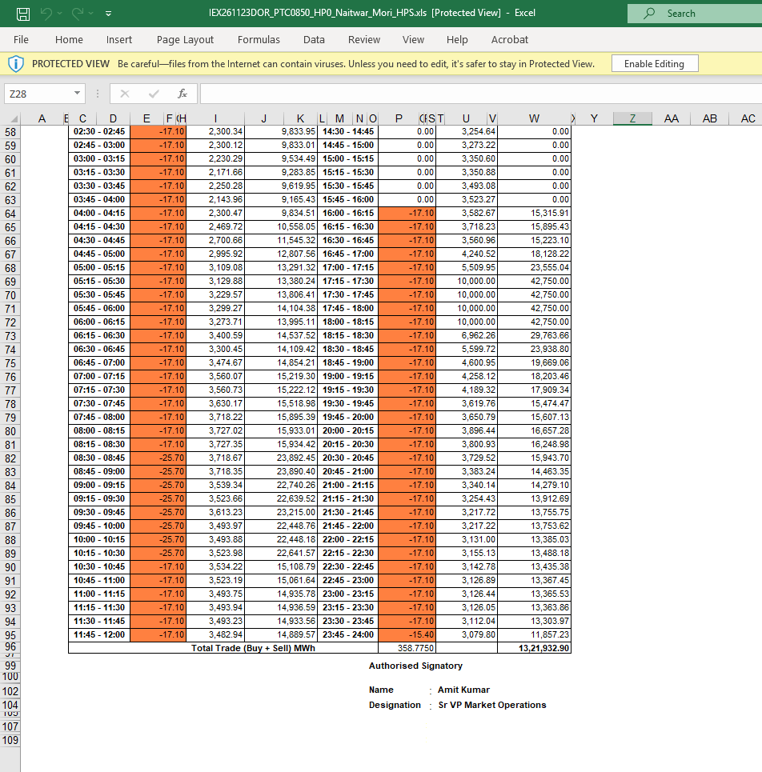
Notice the filename at the top: IEX261123DOR_PTC0850_HP0_Naitwar_Mori_HPS.xls. This breaks down as:
- IEX: Indian Energy Exchange
- 261123: Date of trade/delivery
- DOR: Daily Obligation Report / Detailed Obligation Report
- PTC0850_HP0_Naitwar_Mori_HPS: Client asset mapping tag
Here is the functional, domain, and data-structure breakdown without any code snippets.

1. Structural & Grid Layout Analysis
The sheet uses a side-by-side split layout to fit all 96 time blocks onto a single printable page:
- Left Side (Blocks 1–48): Morning & Early Afternoon periods (00:00 to 12:00).
- Right Side (Blocks 49–96): Late Afternoon, Peak Evening & Night periods (12:00 to 24:00).

2. Granular Field & Column Breakdown
Looking closely at the headers and data columns (from left to right):
Column / Data Area | Sample Values | Business & Financial Purpose
Time Block | 02:30 - 02:45 (Col C)  14:30 - 14:45 (Col N/O) | 15-Minute Interval Window (96 total blocks).
Volume / Power (MW) (Highlighted in Orange) | -17.10, -25.70, -15.40 (Cols E & R) | Cleared MW Volume.  • Negative (-): Power Injected/Sold by Naitwar Mori HEP into the grid.  • Notice the step-up to -25.70 MW during morning hours (08:30 – 10:30) as water flow / generation availability increased.
Market Clearing Price (MCP) | 2,300.34, 3,727.02, 10,000.00 (Cols I & U) | Market Price in ₹/MWh (or ₹/unit equivalent).  • Notice the price during evening peak (17:15 – 18:15): hits 10,000.00 ₹/MWh (or ₹10.00/kWh), which was the CERC regulatory price ceiling!
Trade Value (₹) | 9,833.95, 42,750.00, 11,857.23 (Cols J & W) | Total Gross Financial Yield per Block.  • Calculation: $\text{Volume (MWh)} \times \text{MCP (₹/MWh)}$.
Total Trade Summary (Row 96/97) | 358.7750 MWh  ₹13,21,932.90 | Daily Total Summary Row.  • Total Energy Cleared: $358.775\text{ MWh}$.  • Total Revenue Earned: $₹13,21,932.90$ (approx. ₹13.22 Lakhs for the day).
Signatory Panel | Name: Amit Kumar  Designation: Sr VP Market Operations | Audit & Legal Compliance Stamp. Proves this document is verified by PTC’s market operations lead before being dispatched to SJVN.

3. Key Operational Insights for Platform Building
- Multi-Column Excel Layout Parsing:
  - When our platform imports or parses these vendor Excel exports, the ingestion engine must recognize that Blocks 1–48 are in columns C–J and Blocks 49–96 are in columns N–W. It must stitch them sequentially into a single 1-to-96 series.
- Price Cap & Tariff Ceiling Rules:
  - The presence of flat 10,000.00 values during blocks 69–72 shows the impact of exchange price caps. Our bidding and price analytics dashboard must visually highlight blocks where market prices hit the regulatory ceiling.
- Weighted Average Tariff Calculation:
  - From this sheet, the effective average realization rate for Naitwar Mori for that day is:
$$\text{Average Rate} = \frac{₹13,21,932.90}{358.775\text{ MWh}} = ₹3,684.58/\text{MWh} \quad (\approx ₹3.68/\text{unit})$$
  - Our Consolidated Dashboard should automatically compute and highlight this Average Realized Tariff (₹/kWh) per asset.

4. UI Patterns to Replicate in Our React Application
- Dual-Column Matrix View Option: Traders like this side-by-side 2-column layout because it fits 96 blocks on a single screen without vertical scrolling. We should offer a toggle: [Single Column List] vs [Compact Split Grid (1-48 / 49-96)].
- Peak Price Highlighting: Color-code blocks where MCP is high (e.g., > ₹8,000/MWh) in bold green/gold so traders can immediately spot high-yield hours.
- One-Click Excel / PDF Export: Replicate this clean printable PDF layout with automated digital signature stamps for client billing attachments.

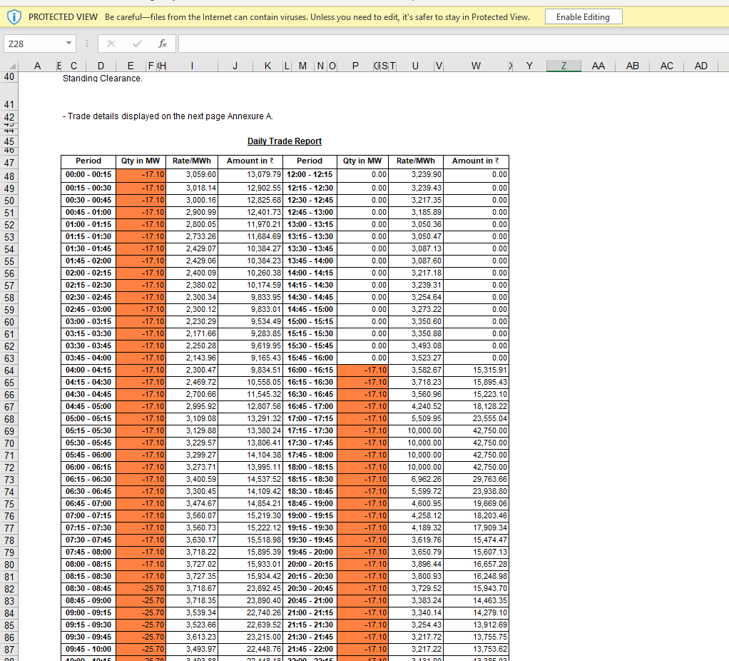

1. Important Legal & Operational Text Uncovered (Top Lines)
Look closely at rows 40–42 above the table:
- Text Found: "Standing Clearance." and "- Trade details displayed on the next page Annexure A."
- Domain Context (Standing Clearance / NOC):
  - Under Indian Open Access rules (NOAR/RLDC), every generator or portfolio must have a valid, active Standing Clearance / NOC (No Objection Certificate) issued by its State Load Despatch Centre (SLDC) before participating in exchange trading.
  - The mention of "Standing Clearance" on this report confirms that this daily report serves as formal proof that trades were executed under a legally valid Open Access approval.
- Annexure Structure: This report is structured as an official Annexure/Attachment to the main contract or billing cover letter.

2. Granular Field & Column Breakdown
The table title is explicitly labeled: Daily Trade Report.
Column Header | Field Name | Functional Meaning & Domain Logic
Period | 00:00 - 00:15 to 11:45 - 12:00 (Left)  12:00 - 12:15 to 23:45 - 24:00 (Right) | 15-Minute Time Block Intervals (96 blocks total).
Qty in MW | -17.10, -25.70, 0.00 | Cleared MW Volume.  • -17.10 MW: Power injected/sold by Naitwar Mori HEP.  • 0.00 MW: Periods between 12:00 PM and 16:00 PM (12:00 - 16:00) where zero power was cleared / scheduled.
Rate/MWh | 3,059.60, 3,239.90, 10,000.00 | Market Clearing Price (MCP) in ₹/MWh.  • Notice that even during zero-quantity blocks (12:00 - 16:00), the exchange rate is still recorded (e.g., 3,239.90 ₹/MWh). This represents the market price that existed during those hours, even though SJVN did not clear any volume.
Amount in ₹ | 13,079.79, 0.00, 42,750.00 | Block Revenue Earned.  • For 0.00 MW blocks, the financial yield is correctly ₹0.00.

3. Key Operational Insights for Platform Design
- Uncleared vs Cleared Block Analysis:
  - During 12:00 PM to 04:00 PM (Blocks 49 to 64), the quantity is 0.00 MW.
  - Why this happens in Hydro plants: Run-of-river hydro plants like Naitwar Mori often conserve water in their small headrace ponds/desilting basins during low-tariff afternoon hours (12:00 - 16:00) and conserve water to maximize generation during peak evening hours (17:00 - 22:00) when rates hit ₹10,000/MWh!
  - Platform Logic: Our trading analytics dashboard should track this Peaking Efficiency Index—showing how effectively hydro plants shift generation away from low-price blocks into high-tariff peak blocks.
- Parsing Rates for Market Analytics:
  - Even when SJVN's cleared quantity is 0.00, capturing the market price (Rate/MWh) for those zero-volume blocks is critical. It allows our Price Analytics engine to perform Opportunity Loss Calculations (e.g., "If 10 MW had been bid during 14:00-15:00 at ₹3,239/MWh, additional revenue would have been ₹32,390").

4. UI Patterns to Replicate in Our React Application
- Standing Clearance Expiry Warning Banner:
  - Since "Standing Clearance" is required for these trade reports, our platform's Profile / Asset Module should feature an explicit status widget showing: 🟢 Standing Clearance (SLDC) Valid Until: 31-DEC-2026 [View Document].
  - If Standing Clearance is within 15 days of expiry, the system must trigger automated alerts and block unapproved exchange order submissions.
- Visual Block State Badging in Tables:
  - Render block rows in 3 distinct visual states:
    - 🟢 Cleared & Generating: Colored fill with MW, Price, and Amount (e.g. -17.10 MW).
    - 🟡 Price Recorded, Zero Cleared: Grey/Neutral row displaying market price but zero amount (0.00 MW | ₹3,239.90 | ₹0.00).
    - 🔴 Rejected / Invalid Bid: Highlighted in light red if a bid was rejected due to transmission constraints or gate closure.

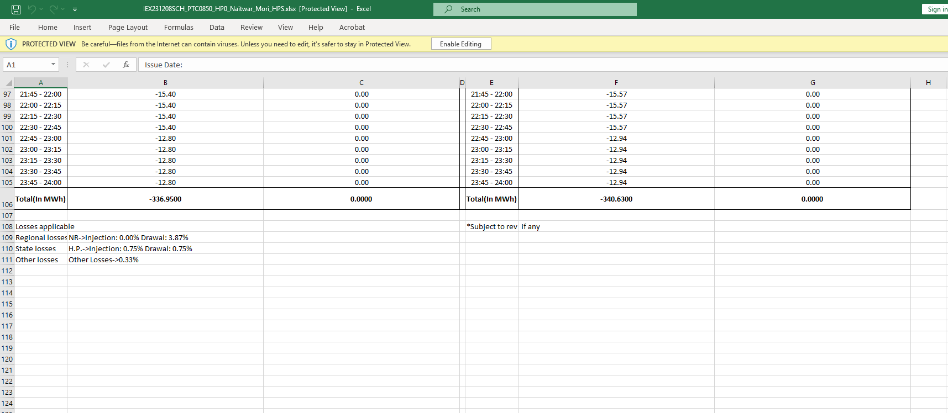

This screenshot is a goldmine for understanding transmission losses in Indian power trading!
Notice the filename at the top: IEX231208SCH_PTC0850_HP0_Naitwar_Mori_HPS.xlsx.
- 231208: Schedule Date (8th Dec 2023).
- SCH: Schedule Report (different from DOR which was the Daily Obligation Report analyzed earlier).
While earlier reports showed numbers, this specific sheet reveals the exact regulatory transmission loss percentages applied by grid authorities (RLDC / STU / ISTS).
Here is the functional, domain, and data breakdown for our platform design.

1. Top Section: 96-Block Schedule Totals (Rows 97–106)
This table displays the final 9 blocks (Blocks 88 to 96, from 21:45 to 24:00) and the cumulative daily totals:
+-------------------------------------------------------------------------------------------------------+
| TIME BLOCK | INJECTION (MW) | DRAWAL (MW) | TIME BLOCK | INJECTION (MW) | DRAWAL (MW) |
| (Periphery A) | | | (Periphery B) | | |
+---------------+----------------+-------------+---------------+----------------+-----------------------+
| 21:45 - 22:00 | -15.40 | 0.00 | 21:45 - 22:00 | -15.57 | 0.00 |
| 23:45 - 24:00 | -12.80 | 0.00 | 23:45 - 24:00 | -12.94 | 0.00 |
+---------------+----------------+-------------+---------------+----------------+-----------------------+
| Total(In MWh) | -336.9500 MWh | 0.0000 MWh | Total(In MWh) | -340.6300 MWh | 0.0000 MWh |
+-------------------------------------------------------------------------------------------------------+

Key Numbers:
- Plant / Interface Injection: -340.6300 MWh (Total energy injected at Naitwar Mori HEP plant busbar).
- Regional Periphery Injection: -336.9500 MWh (Total energy scheduled at the Regional Grid boundary).
- Total Energy Deduction: $340.6300 - 336.9500 = \mathbf{3.6800\text{ MWh}}$. This $3.68\text{ MWh}$ is the physical electricity lost in transit across transmission lines.

2. Bottom Section: Transmission Loss Breakdown (Rows 108–111)
This is the most critical part of the screenshot, as it details why the numbers differ across peripheries:
Losses applicable

Regional losses : NR->Injection: 0.00% Drawal: 3.87%
State losses : H.P.->Injection: 0.75% Drawal: 0.75%
Other losses : Other Losses->0.33%

*Subject to revision if any

Granular Loss Type Analysis & Regulatory Rules
Loss Category | Parameter Shown | Domain Meaning & Business Logic
Regional Losses (ISTS) | NR->Injection: 0.00%  Drawal: 3.87% | Northern Region Inter-State Transmission System Loss.  • Injected power into NR grid had 0.00% loss applied at injection.  • Buyers (DISCOMs) drawing power from NR grid absorb a 3.87% transmission loss deduction.
State Losses (STU) | H.P.->Injection: 0.75%  Drawal: 0.75% | Himachal Pradesh State Transmission Utility (HPPTCL) Loss.  • Since Naitwar Mori HEP injects into the HP state grid before hitting the national grid, HPPTCL deducts a flat 0.75% injection loss.
Other Losses | Other Losses->0.33% | Local / Point-of-Connection (PoC) or Corridor Loss.  • Additional line-loss allowance (0.33%) applied across specific sub-station corridors.
Total Effective Loss | $\approx \mathbf{1.08\%}$ (Seller End) | Sum of State Loss ($0.75\%$) + Other Loss ($0.33\%$) = $1.08\%$.  • Verification: $340.63\text{ MWh} \times (1 - 0.0108) = 336.95\text{ MWh}$. The math matches the total row exactly!
Legal Disclaimer | *Subject to revision if any | Grid losses are published provisionally and dynamically updated weekly/monthly by RLDC/RPCs. True-ups occur during monthly REA accounting.

3. Critical Platform Requirements for SJVN
- Multi-Tier Loss Engine:
  - Our platform cannot treat transmission loss as a single fixed number. It must maintain a Loss Structure Table that stores:
    - Regional Losses (updated dynamically per Regional Power Committee weekly notifications).
    - State STU Losses (configured per state, e.g., HP = $0.75\%$, Uttarakhand = $1.2\%$, etc.).
    - POC / Corridor Losses.
- Automated Periphery Calculations:
  - When a trader enters a bid quantity or parses an exchange schedule, the platform must automatically calculate both values:
$$\text{Regional Periphery MWh} = \text{Plant Busbar MWh} \times (1 - \text{Total Injection Loss})$$
- Provisional-to-Final REA True-Up Workflow:
  - Because losses are *Subject to revision, invoices generated initially are Provisional Invoices. When the official Regional Energy Account (REA) PDF/file arrives at month-end with finalized loss figures, the platform must auto-flag any delta and prepare a Supplementary Invoice / Credit Note.

4. UI Patterns to Replicate in Our React Application
- Interactive Loss Waterfall Component:
  - In our Schedule Details view, render a visual step-down card showing how plant generation steps down to delivered power:
[Plant Generation: 340.63 MWh]
↓ (-0.75% HP State Loss = -2.55 MWh)
[STU Boundary: 338.08 MWh]
↓ (-0.33% Corridor Loss = -1.13 MWh)
[Regional Delivery: 336.95 MWh] 🟢 CLEARED

- Dynamic Loss Configuration Screen:
  - Provide an admin UI where commercial team members can update weekly/monthly STU & ISTS loss percentages published by RLDC/SLDC websites.

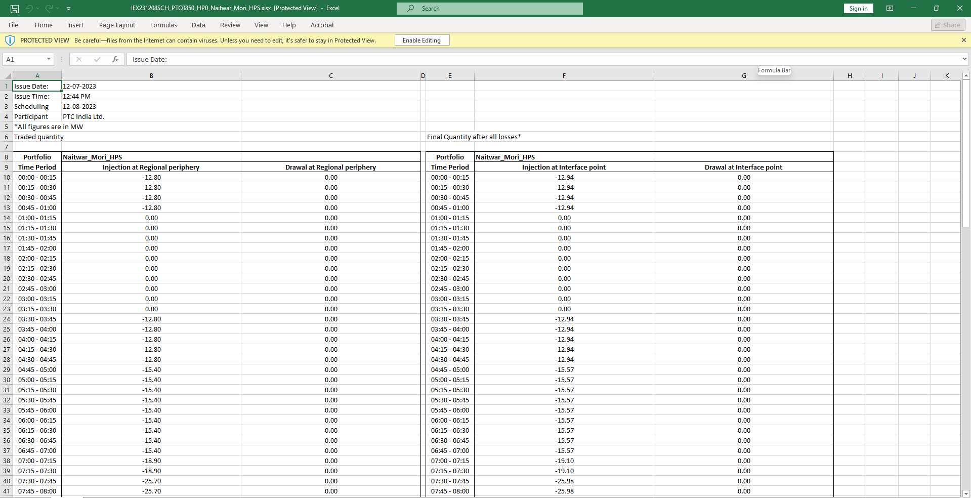

his screenshot shows the top header section and initial time blocks (Blocks 1–32, 00:00 to 08:00 AM) of the exact same Excel schedule file (IEX231208SCH_PTC0850_HP0_Naitwar_Mori_HPS.xlsx) whose loss breakdown we analyzed in the previous view!
This top section reveals crucial document metadata, issuing timestamps, and initial morning generation scheduling. Here is the functional and domain breakdown for your platform design.

1. Document Header & Metadata Analysis (Rows 1–5)
Looking at the top-left metadata block:
- Issue Date (A1:B1): 12-07-2023 (Notice this is in DD-MM-YYYY format, issued on 12th July 2023).
- Issue Time (A2:B2): 12:44 PM.
  - Operational Importance: This timestamp records the exact time PTC generated and dispatched the cleared schedule file following IEX gate closure and clearing publication.
- Scheduling Date (A3:B3): 12-08-2023 (12th August 2023 — Power Delivery Day).
- Participant (A4:B4): PTC India Ltd. (The trading licensee executing trades on behalf of SJVN).
- Unit Flag (A5): *All figures are in MW (Confirms table values represent power capacity in MW per block, not total MWh).

2. Table Headers & Dual-Periphery Comparison (Rows 6–9)
The sheet presents a side-by-side comparison of Traded Quantity vs Final Quantity after all losses:
+-------------------------------------------------------------------------------------------------------------------+
| Traded quantity (Regional Boundary) | Final Quantity after all losses* (Plant Interface Point) |
+------------------------------------------------------+------------------------------------------------------------+
| Portfolio: Naitwar_Mori_HPS | Portfolio: Naitwar_Mori_HPS |
| Time Period | Injection at Regional | Drawal at Regional | Time Period | Injection at Interface | Drawal at Interface|
| (15-Min) | Periphery (MW) | Periphery (MW) | (15-Min) | Point (MW) | Point (MW) |
+------------------------------------------------------+------------------------------------------------------------+

Granular Column Analysis:
Column Pair | Value Sample | Operational Meaning & Domain Context
Regional Periphery (Cols A–C) | 00:00 - 00:15  Injection: -12.80 MW | Cleared Schedule at Grid Boundary. The net energy volume traded on IEX after state and corridor loss deductions.
Interface Point (Cols D–G) | 00:00 - 00:15  Injection: -12.94 MW | Required Plant Busbar Generation. The gross power Naitwar Mori HEP must physically generate at its busbar to fulfill the grid delivery obligation.
Drawal Columns (C & G) | 0.00 | Always zero because SJVN is acting purely as a generator/seller in this context.

3. Operational Observations (Early Morning Load Curve)
- Blocks 1–4 (00:00 – 01:00): Generating at -12.94 MW (delivered -12.80 MW).
- Blocks 5–13 (01:00 – 03:15): 0.00 MW (Plant idling / zero schedule).
- Blocks 14–20 (03:30 – 05:00): Resumes at -12.94 MW.
- Blocks 21–28 (05:00 – 07:00): Steps up to -15.57 MW as morning demand increases.
- Blocks 29–32 (07:00 – 08:00): Ramps further to -19.10 MW and then -25.98 MW.

4. Key Platform Requirements for SJVN
- Schedule Ingestion Metadata Parsing:
  - When parsing vendor schedule files, your backend must extract the top header metadata—specifically Issue Date, Issue Time, and Scheduling Date. This ensures that if multiple schedule revisions arrive in a single day (e.g., due to grid curtailments or RTM updates), the platform always orders them by Issue Time to keep the latest revision active.
- Dual-Periphery Display:
  - Plant operators in the control room need to see Interface Point MW (what to set the turbine governors to).
  - Commercial traders need to see Regional Periphery MW (what is commercially settled at the exchange).
  - Your UI should present both side-by-side with clear labels.

5. UI Patterns to Replicate in Our React Terminal
- Schedule Header Card:
  - Render a neat metadata summary card above the 96-block table:
    - Asset: Naitwar Mori HPS
    - Schedule Date: 12-AUG-2023
    - Issued At: 12-JUL-2023 12:44 PM
    - Status: 🟢 Active / Cleared
- Periphery View Toggle:
  - Provide a toggle bar above the table: [ Show Both Peripheries ] | [ Plant Busbar Only (Ex-Bus) ] | [ Grid Periphery Only (Ex-Grid) ]

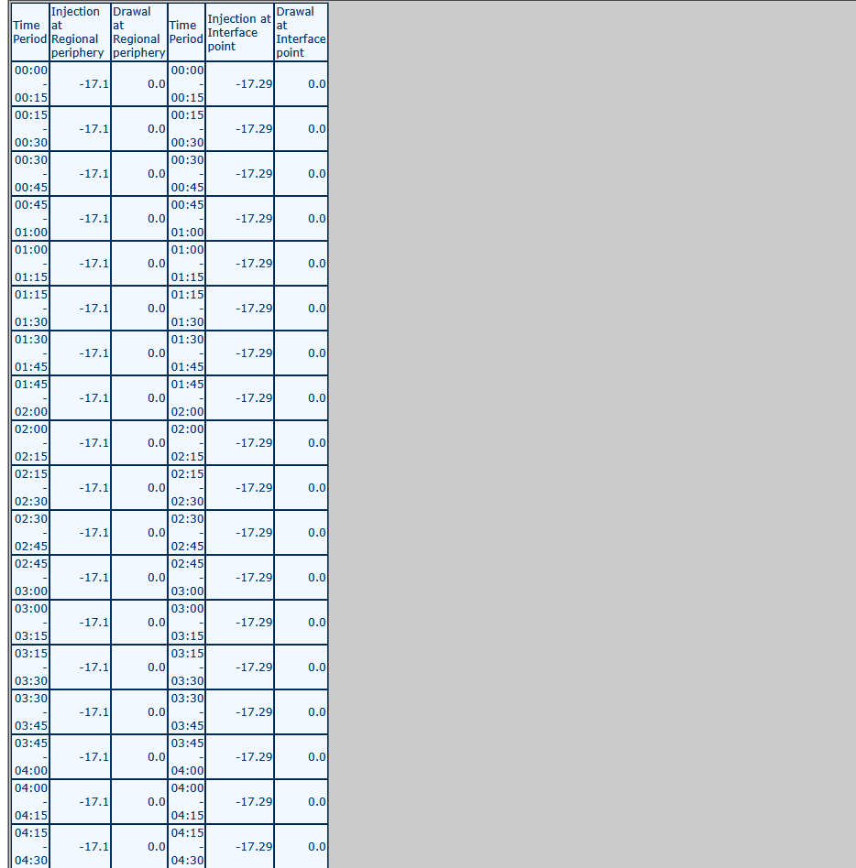

Ye screenshot Energy Schedule File ka Blocks 1–18 (00:00 - 04:30 AM) ka complete view dikha raha hai. Isme Naitwar Mori HEP plant ka continuous flat generation/injection pattern visible hai. Niche iska detailed, granular breakdown diya gaya hai.

1. Page Context & Operational View
- Module: View Client Energy Schedule File (/client/ViewClientEnergyScheduleFile.action).
- Time Range: Time Block 1 (00:00 - 00:15) se Time Block 18 (04:15 - 04:30) tak ka early morning schedule.
- Trading Context: Ye view hydro-generator (SJVN) ka baseload / night-time power injection profile show kar raha hai.

2. Granular Field & Column Analysis
+-----------------------------------------------------------------------------------------+
| Time Period | Injection at Regional | Drawal at Regional | Time Period | Injection at Interface | Drawal at Interface |
| (15-Min) | periphery (MW) | periphery (MW) | (15-Min) | point (MW) | point (MW) |
+-------------+----------------------+--------------------+-------------+------------------------+---------------------+
| 00:00-00:15 | -17.1 | 0.0 | 00:00-00:15 | -17.29 | 0.0 |
| ... | ... | ... | ... | ... | ... |
| 04:15-04:30 | -17.1 | 0.0 | 04:15-04:30 | -17.29 | 0.0 |
+-----------------------------------------------------------------------------------------+

Field / Column | Observed Value | Operational Rule & Business Logic
Time Period | 00:00 - 00:15 to 04:15 - 04:30 | 15-minute standard time blocks (Blocks 1 to 18).
Injection at Regional periphery | -17.1 MW | Net scheduled injection at Regional Grid boundary (ISTS) after loss deduction.
Drawal at Regional periphery | 0.0 | Zero drawal because SJVN is strictly acting as a generator/seller.
Injection at Interface point | -17.29 MW | Gross physical power required at the plant busbar (Ex-Bus generation).
Drawal at Interface point | 0.0 | Zero auxiliary drawal scheduled in this window.

3. Core Domain Insights & Loss Math
- Flat Baseload Injection: Plant lagataar 18 blocks tak bina kisi change ke -17.29 MW generate kar raha hai. Hydro plants mein ye night-time minimum environmental flow / continuous run-of-river schedule ko represent karta hai.
- Transmission Loss Breakdown:
  - Plant Busbar (Interface): -17.29 MW
  - Regional Delivery (Grid): -17.10 MW
  - Line Loss Deducted: $17.29 - 17.10 = \mathbf{0.19\text{ MW}}$ (approx 1.1% total transmission loss).

4. SJVN Platform Features to Replicate
- Dual Periphery Columns: Frontend mein Plant Busbar (-17.29 MW) aur Regional Grid (-17.10 MW) dono side-by-side display honge.
- Block Status Indicators: Active injection wale blocks ko clear green badges ke saath aur zero-generation blocks को greyed-out state mein render karenge

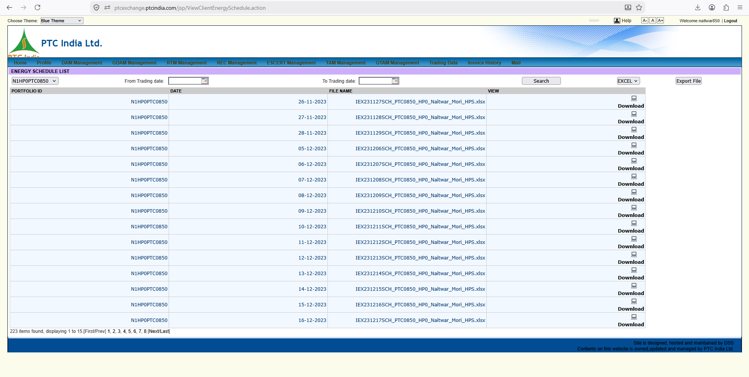

1. Page Context & High-Level Purpose
- URL Path: [ptcexchange.ptcindia.com/jsp/ViewClientEnergySchedule.action](https://ptcexchange.ptcindia.com/jsp/ViewClientEnergySchedule.action)
- Module Title: ENERGY SCHEDULE LIST
- Parent Menu Context: Accessible via Trading Data or DAM/RTM Management.
- Business Purpose: Central repository for retrieving cleared energy schedule files generated by power exchanges (IEX/PXIL/HPX). Plant operators, scheduling engineers, and commercial billing managers visit this screen daily to download official schedule sheets needed for:
  - Submitting Format-D files to RLDC/SLDC.
  - Verifying daily cleared volumes against submitted bids.
  - Performing month-end REA vs. Billed energy reconciliations.

2. Granular UI Element Breakdown
+-------------------------------------------------------------------------------------------------------------------------+
| ENERGY SCHEDULE LIST |
| PORTFOLIO ID From Trading date: [ 📅 ] To Trading date: [ 📅 ] [ Search ] [ EXCEL v ] [ Export File ] |
| [ N1HP0PTC0850 v ] |
+-------------------------------------------------------------------------------------------------------------------------+
| PORTFOLIO ID | DATE | FILE NAME | VIEW |
+---------------+------------+-----------------------------------------------------+--------------------------------------+
| N1HPOPTC0850 | 26-11-2023 | IEX231127SCH_PTC0850_HP0_Naitwar_Mori_HPS.xlsx | 💾 Download |
| N1HPOPTC0850 | 27-11-2023 | IEX231128SCH_PTC0850_HP0_Naitwar_Mori_HPS.xlsx | 💾 Download |
| ... | ... | ... | ... |
+-------------------------------------------------------------------------------------------------------------------------+
| 223 items found, displaying 1 to 15. [First/Prev] 1, 2, 3, 4, 5, 6, 7, 8 [Next/Last] |
+-------------------------------------------------------------------------------------------------------------------------+

Control Panel & Data Table Analysis
Visual Element | Text / Value Sample | Business & Domain Logic
PORTFOLIO ID Dropdown | N1HPOPTC0850 | Asset Selector. Filters schedule records specifically for Naitwar Mori HEP (60 MW).
From Trading date / To Trading date | Date Pickers [ 📅 ] | Trading Date Filter. Filters schedules by the date the trade was cleared on the exchange.
Search Button | Action Button | Triggers the database query to populate the grid based on selected filters.
Export File Button | Action Button + Dropdown (EXCEL) | Bulk exports the metadata list into Excel format.
Table Column: PORTFOLIO ID | N1HPOPTC0850 | Asset context badge for each row.
Table Column: DATE | 26-11-2023 to 16-12-2023 | Trading Date. Note: The filename contains 231127 (Delivery Date = 27th Nov), while the date column shows 26-11-2023 (Trade Date = 26th Nov)!
Table Column: FILE NAME | IEX231127SCH_PTC0850_...xlsx | Standardized naming convention encoding: Exchange (IEX) + Delivery Date (231127) + Schedule Tag (SCH) + Asset Tag (PTC0850_...).
Table Column: VIEW | 💾 Download | Direct link to download the actual Excel file for local parsing or viewing.
Pagination Bar | 223 items found, displaying 1 to 15... | Confirms historical archive depth (223 total daily schedules logged for this asset).

3. Key Operational & Architectural Insights for SJVN Platform
- Trade Date vs Delivery Date Mapping:
  - Notice that for Trade Date 26-11-2023, the generated file is IEX231127SCH....
  - Domain Rule: Day-Ahead Market (DAM) bids placed on Day $T$ (26th Nov) clear for physical delivery on Day $T+1$ (27th Nov).
  - Platform Requirement: Your database must store both trade_date and delivery_date explicitly so users can search using either parameter.
- Automated Schedule Ingestion (Replacing Manual Download):
  - In PTC's legacy setup, users manually click "Download" for each file.
  - In your new platform (which replaces SJVN-ISET), when exchange schedules are fetched via API or automated web jobs, the backend should automatically parse and store the 96-block values directly into PostgreSQL rather than just storing static .xlsx files on disk.
- Bulk Schedule Export for Audits:
  - Commercial auditors frequently request multi-month schedule data. Providing a "Bulk Download Range" (e.g., zip archive of selected month's schedules or a single consolidated multi-day master Excel sheet) will save huge manual effort for SJVN staff.

4. Master UI Patterns to Replicate in Our React Terminal
- Schedule Document Status Badging:
  - In our grid, add visual badges showing ingestion state:
    - 🟢 Parsed & Active: 96-block data successfully extracted into DB.
    - 🟡 Pending Ingestion: Raw file stored, parsing in progress.
    - 🔴 Revision Superseded: Newer schedule revision available for this date.
- Inline Fast-Preview Drawer:
  - Clicking on a row shouldn't force a full page navigation or file download. Instead, open a side drawer showing the 24-hour / 96-block energy curve chart immediately inline.
- Quick Date Range Presets:
  - Include quick filter buttons above the table: [ Last 7 Days ], [ Current Month ], [ Last Month ].

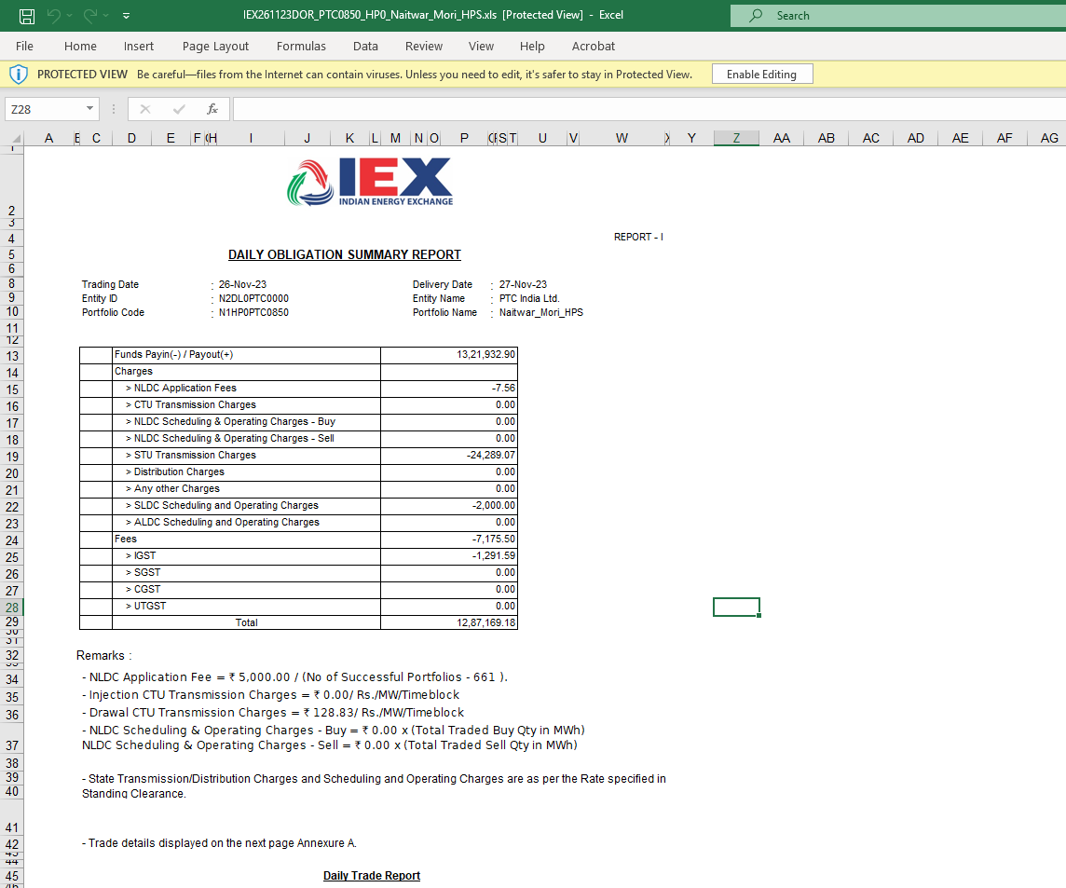

This screenshot is a huge milestone in our reverse-engineering process! 🎯
It shows the DAILY OBLIGATION SUMMARY REPORT (Report - I) issued directly by the Indian Energy Exchange (IEX) for SJVN’s Naitwar Mori Hydro Power Station (N1HP0PTC0850).
While earlier screenshots showed energy schedules and trade rates, this sheet exposes the exact net financial math, statutory fee deductions, transmission charges, and tax breakup applied to daily exchange trades.
Here is the granular, element-by-element, and financial-formula breakdown for your platform design.

1. Document Header & Metadata Analysis (Rows 2–10)
Looking at the metadata block at the top:
- IEX Logo & Title: Labeled explicitly as DAILY OBLIGATION SUMMARY REPORT (REPORT - I).
- Trading Date: 26-Nov-23 (The date the bid was matched on the exchange).
- Delivery Date: 27-Nov-23 (The date power physically flowed through the grid).
- Entity ID: N2DL0PTC0000 (IEX unique registration code for PTC India Ltd. as the trading licensee).
- Entity Name: PTC India Ltd.
- Portfolio Code: N1HP0PTC0850 (SJVN's Naitwar Mori asset portfolio code).
- Portfolio Name: Naitwar_Mori_HPS.

2. Granular Financial Breakdown & Obligation Formula (Rows 13–29)
This table shows how gross trade revenue is converted into the Net Payout Amount transferred to SJVN.
+-----------------------------------------------------------------------------------+
| LINE ITEM DESCRIPTION | AMOUNT IN ₹ |
+----------------------------------------------------+------------------------------+
| Funds Payin(-) / Payout(+) | 13,21,932.90 |
| Charges: | |
| > NLDC Application Fees | -7.56 |
| > CTU Transmission Charges | 0.00 |
| > NLDC Scheduling & Operating Charges - Buy | 0.00 |
| > NLDC Scheduling & Operating Charges - Sell | 0.00 |
| > STU Transmission Charges | -24,289.07 |
| > Distribution Charges | 0.00 |
| > Any other Charges | 0.00 |
| > SLDC Scheduling and Operating Charges | -2,000.00 |
| > ALDC Scheduling and Operating Charges | 0.00 |
| Fees | -7,175.50 |
| GST Breakup: | |
| > IGST | -1,291.59 |
| > SGST | 0.00 |
| > CGST | 0.00 |
| > UTGST | 0.00 |
+----------------------------------------------------+------------------------------+
| TOTAL NET PAYOUT | 12,87,169.18 |
+----------------------------------------------------+------------------------------+

Granular Line-Item Analysis:
Financial Line Item | Value (₹) | Domain Meaning & Financial Rule
Gross Funds Payout (+) | 13,21,932.90 | Total Energy Revenue Earned. Matches the gross trade value we saw in the earlier trade report ($\sum \text{MWh} \times \text{MCP}$).
NLDC Application Fees | -7.56 | Shared application fee charged by National Load Despatch Centre. (Calculated as ₹5,000 divided among 661 successful portfolios that day, as explained in Remarks row 34).
CTU Transmission Charges | 0.00 | Inter-state Central Transmission Utility charge. Sellers (generators) are exempt under current GNA regulations; only buyers pay CTU charges (₹128.83/MW/block).
STU Transmission Charges | -24,289.07 | State Transmission Utility Charge (HPPTCL). Deducted for utilizing the state transmission grid to evacuate power.
SLDC Scheduling Charges | -2,000.00 | Fixed daily fee paid to the State Load Despatch Centre for approving and managing the 15-minute schedule.
IEX Transaction Fees | -7,175.50 | IEX Exchange Operating Fee. Charged at ₹0.02/kWh (or contracted exchange slab rate) on total cleared energy.
IGST Tax | -1,291.59 | 18% Integrated GST applied strictly on taxable services (IEX fees + NLDC charges), NOT on electricity itself (electricity is GST-exempt).
NET TOTAL PAYOUT | 12,87,169.18 | Final Net Receivable by SJVN.  $$\text{Gross Revenue } (₹13.22\text{ L}) - \text{Total Statutory Deductions } (₹0.35\text{ L}) = \mathbf{₹12,87,169.18}$$

3. Explanatory Remarks & Formula Footnotes (Rows 32–40)
The footnotes provide explicit regulatory formulas used by IEX:
- NLDC Fee Sharing: $\text{NLDC Fee per Portfolio} = \frac{₹5,000}{\text{Total Successful Portfolios (661)}} = \mathbf{₹7.56}$.
- CTU Directional Rules:
  - Injection CTU Transmission Charges = ₹0.00 / Rs./MW/Timeblock (Sellers pay ₹0).
  - Drawal CTU Transmission Charges = ₹128.83 / Rs./MW/Timeblock (Buyers absorb full CTU charge).
- Standing Clearance Linkage: State charges are dynamically driven by rates specified in the active Standing Clearance / NOC.

4. Key Platform Requirements for Our System (FastAPI + React)
- Exchange Settlement Engine (Auto-Calculation):
  - Our backend must not only record raw trade results; it must feature a Settlement Reconciliation Engine that takes gross trade value and automatically computes net receivable amounts by applying:
    - Per-MWh Exchange Fees
    - SLDC Flat Charges
    - STU Percentage/Slab Charges
    - GST @ 18% on fee/charge components only
- Automated Reconciliation (IEX Statement vs Internal Records):
  - When IEX publishes this Daily Obligation Summary report, our system should compare IEX's net total (₹12,87,169.18) against SJVN’s internally calculated expected payout.
  - If there is a mismatch (e.g., unexpected SLDC fee or tax delta), flag it as a Discrepancy Exception for the trading desk.
- SAP ERP Financial Journal Posting:
  - This specific summary forms the exact basis for the accounting journal voucher in SAP:
    - Debit: Exchange Settlement Clearing Account = ₹12,87,169.18
    - Debit: STU / SLDC Expense Accounts = ₹26,289.07
    - Debit: Exchange Fee Expense Account = ₹7,175.50
    - Debit: Input Tax Credit (IGST) = ₹1,291.59
    - Credit: Power Sale Revenue Account = ₹13,21,932.90

5. UI Patterns to Replicate in Our React Application
- Obligation Waterfall Summary Card:
  - Render a clean visual card showing the step-down breakdown:
Gross Traded Value: ₹13,21,932.90
(-) Statutory Line Charges: - ₹26,303.63
(-) Exchange & Admin Fees: - ₹7,175.50
(-) Applicable Taxes (GST): - ₹1,291.59
-------------------------------------------
NET RECEIVABLE: ₹12,87,169.18 🟢 MATCHED

- One-Click Voucher Export for SAP:
  - Add a button labeled [ Generate SAP FI Journal Entry ] that formats these exact line items into SJVN's SAP GL posting schema

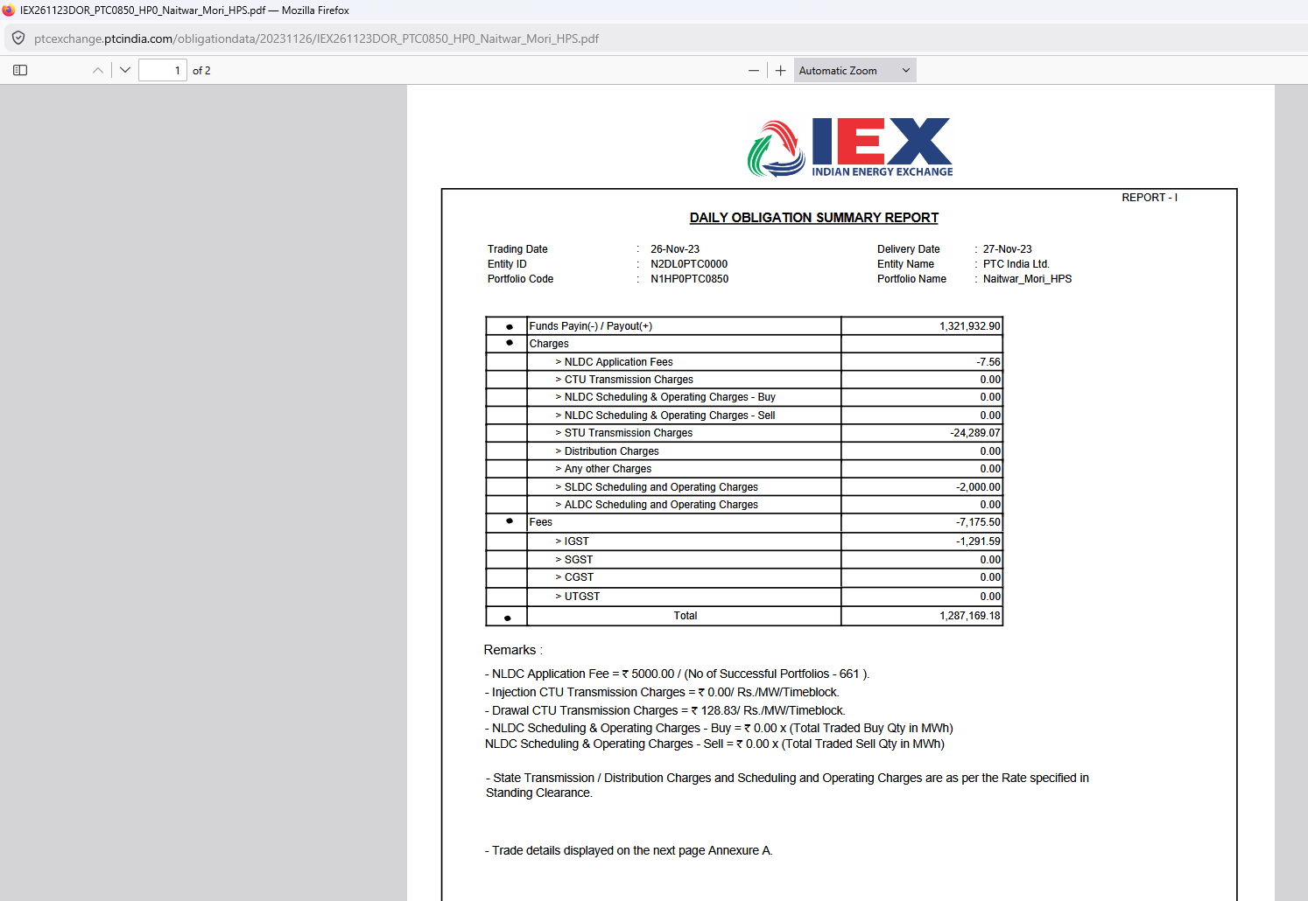

This screenshot shows the official PDF rendering of the DAILY OBLIGATION SUMMARY REPORT (Report - I) issued by the Indian Energy Exchange (IEX).
While the previous screenshot was the raw Excel sheet exported from the exchange, this view shows how the exact same statement is served directly as a downloadable PDF file from the PTC portal web server ([ptcexchange.ptcindia.com/obligationdata/20231126/IEX261123DOR_PTC0850_HP0_Naitwar_Mori_HPS.pdf](https://ptcexchange.ptcindia.com/obligationdata/20231126/IEX261123DOR_PTC0850_HP0_Naitwar_Mori_HPS.pdf)).
Here is the functional, domain, and UI/UX breakdown for our platform design.

1. Page Context & Document Origin
- URL Path: [ptcexchange.ptcindia.com/obligationdata/20231126/IEX261123DOR_PTC0850_HP0_Naitwar_Mori_HPS.pdf](https://ptcexchange.ptcindia.com/obligationdata/20231126/IEX261123DOR_PTC0850_HP0_Naitwar_Mori_HPS.pdf)
- Page Viewer: Mozilla Firefox built-in PDF viewer.
- Page Count Indicator: 1 of 2 (Confirms Page 1 is the Summary Obligation Statement, and Page 2 is "Annexure A" containing the 96-block trade details).
- Business Purpose: This is the legally binding PDF tax document generated directly by IEX's clearinghouse. SJVN's finance and accounts team uses this PDF as the primary legal voucher attachment for auditing, GST filing, and SAP GL entry validation.

2. Granular Field & Financial Summary Verification
Since this is the PDF counterpart of the Excel sheet we analyzed, all numbers match the exchange clearing record perfectly:
Header / Line Item | Document Value | Functional Domain Context
Trading Date | 26-Nov-23 | Bid matching date on IEX.
Delivery Date | 27-Nov-23 | Physical power delivery day.
Portfolio Code / Name | N1HP0PTC0850 / Naitwar_Mori_HPS | SJVN Naitwar Mori Hydro Asset (60 MW).
Gross Funds Payout | 1,321,932.90 | Gross revenue earned from cleared power sales ($\sum \text{MWh} \times \text{MCP}$).
NLDC Application Fees | -7.56 | $\frac{₹5,000}{661\text{ Portfolios}}$ shared NLDC expense.
STU Transmission Charges | -24,289.07 | HPPTCL state network wheeling deduction.
SLDC Operating Charges | -2,000.00 | State despatch centre daily scheduling fee.
IEX Transaction Fees | -7,175.50 | Exchange operational charge.
IGST (18%) | -1,291.59 | Tax applied on exchange/NLDC service fees only.
TOTAL NET PAYOUT | 1,287,169.18 | Net receivable transferred to SJVN's account.

3. Important Architectural Insights for Our Platform
- PDF File Naming Structure Parsing:
  - Notice the folder structure in the URL: /obligationdata/20231126/IEX261123DOR_...pdf.
  - The folder date is 20231126 (26th Nov 2023 = Trade Date), while the filename contains 261123DOR.
  - Platform Rule: When our automated scraper or API collector stores exchange PDFs in our document store, it must maintain a consistent folder hierarchy: /documents/trading_obligations/YYYY/MM/DD/ for fast retrieval during financial audits.
- Multi-Page Handling:
  - The viewer indicates Page 1 of 2.
  - Page 1 is Report - I (Obligation Summary).
  - Page 2 is Annexure A (96-Block Trade Details).
  - Your automated PDF parsing engine (using tools like pdfplumber or camelot in Python) must explicitly target Page 1 for extracting financial line items and Page 2 for extracting block-wise prices and volumes.

4. Master UI Patterns for SJVN React Terminal
- Embedded In-App PDF Preview Drawer:
  - Instead of opening PDFs in a new browser tab or forcing a download, provide an inline Document Viewer Modal inside the React UI.
  - Users can view the original signed IEX PDF on the left side while reviewing the parsed database line items on the right side for 100% verification confidence.
- Verification Stamp Status:
  - Display a badge next to each invoice row:
    - 🟢 PDF Hash Verified: Document matches official IEX checksum.
    - 🔵 Synced with SAP: Journal Entry created under SAP Document No.

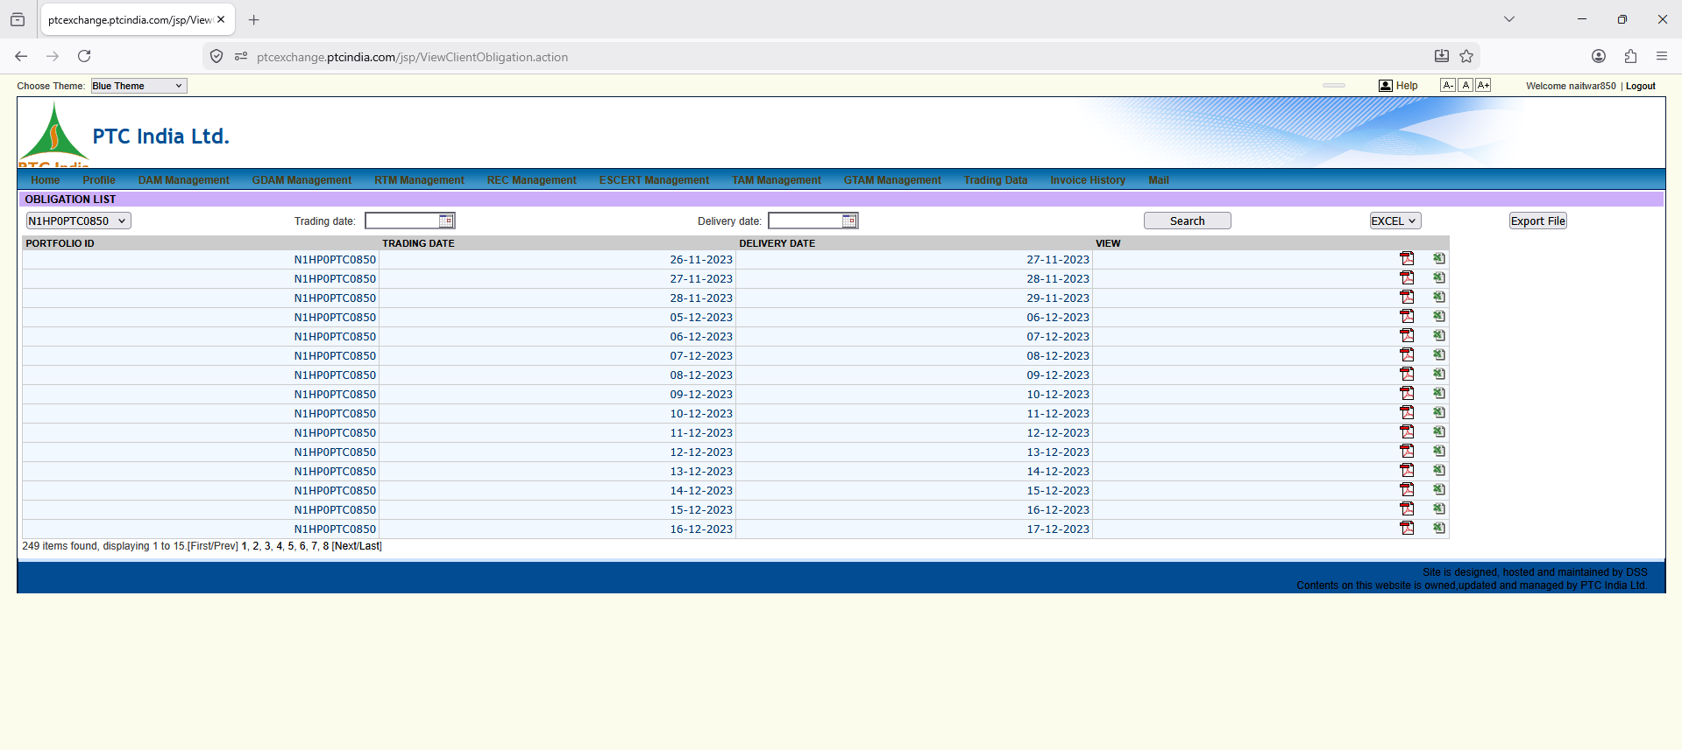

This screenshot completes the operational loop for trading settlements! It shows the Daily Obligation Download Portal Page (OBLIGATION LIST) on PTC India’s portal.
While a previous screenshot (ViewClientEnergySchedule.action) served as the hub for downloading Energy Schedule Files (SCH), this page (ViewClientObligation.action) is the central repository for downloading official Daily Obligation Reports (DOR) in both PDF and Excel formats—the exact files we analyzed in the preceding two screenshots!
Here is the detailed, granular, element-by-element breakdown and functional design for your platform.

1. Page Context & Operational Purpose
- URL Path: [ptcexchange.ptcindia.com/jsp/ViewClientObligation.action](https://ptcexchange.ptcindia.com/jsp/ViewClientObligation.action)
- Module Title: OBLIGATION LIST
- Parent Menu Context: Accessible under Trading Data or Invoice History / Settlements.
- Business Purpose: Central repository for retrieving daily financial obligation and clearing statements published by power exchanges (IEX/PXIL/HPX). Commercial accountants, billing officers, and financial managers use this screen to:
  - Download official Daily Obligation Statements (PDFs) for tax records and auditor verification.
  - Download raw Financial Obligation Sheets (Excel) for automated SAP GL posting and true-up reconciliations.
  - Verify daily gross revenue, statutory fees, and net payouts across all trading days.

2. Granular UI Element Breakdown
+-------------------------------------------------------------------------------------------------------------------------+
| OBLIGATION LIST |
| PORTFOLIO ID Trading date: [ 📅 ] Delivery date: [ 📅 ] [ Search ] [ EXCEL v ] [ Export File ]|
| [ N1HP0PTC0850 v ] |
+-------------------------------------------------------------------------------------------------------------------------+
| PORTFOLIO ID | TRADING DATE | DELIVERY DATE | VIEW |
+---------------+--------------+---------------+--------------------------------------------------------------------------+
| N1HPOPTC0850 | 26-11-2023 | 27-11-2023 | 📄 (PDF Icon) 📊 (Excel Icon) |
| N1HPOPTC0850 | 27-11-2023 | 28-11-2023 | 📄 (PDF Icon) 📊 (Excel Icon) |
| ... | ... | ... | ... |
+-------------------------------------------------------------------------------------------------------------------------+
| 249 items found, displaying 1 to 15.[First/Prev] 1, 2, 3, 4, 5, 6, 7, 8 [Next/Last] |
+-------------------------------------------------------------------------------------------------------------------------+

Control Panel & Table Fields Analysis
Visual Element | Value Sample | Operational Meaning & Domain Context
PORTFOLIO ID Dropdown | N1HPOPTC0850 | Asset Selector. Restricts search context to Naitwar Mori HEP (60 MW).
Trading date / Delivery date | Date Pickers [ 📅 ] | Dual Date Filters. Allows querying by either the Trade Execution Date ($T$) or Power Delivery Date ($T+1$).
Search Button | Action Button | Triggers database query to populate the obligation file grid.
Export File Controls | Dropdown (EXCEL) | Bulk exports the metadata summary list into an Excel format for audit reporting.
Table Column: PORTFOLIO ID | N1HPOPTC0850 | Asset context tag mapped to each record row.
Table Column: TRADING DATE | 26-11-2023 to 16-12-2023 | The date bids were matched and cleared on the exchange.
Table Column: DELIVERY DATE | 27-11-2023 to 17-12-2023 | The actual physical power flow date ($T+1$ shift explicitly shown for every row).
Table Column: VIEW (Dual File Icons) | 📄 (Red PDF)  📊 (Green XLS) | Direct File Downloads:  • PDF Icon: Downloads IEX261123DOR_...pdf (Official signed tax/audit report).  • Excel Icon: Downloads IEX261123DOR_...xls (Raw multi-sheet trade breakdown).
Pagination Metadata | 249 items found... | Displays total archived obligation logs (249 total trading days recorded for this portfolio).

3. Key Operational Insights for Platform Design
- Dual Format Provisioning (PDF vs Excel Purpose):
  - Why both formats exist:
    - PDF: Used as an immutable, digitally verifiable legal document for external auditors, GST compliance, and DISCOM billing disputes.
    - Excel: Used internally by financial software and automated ERP integration scripts to parse line items into database tables.
  - Platform Requirement: When our automated job fetches exchange reports, it must ingest both formats—parsing the Excel sheet for database values while storing the original PDF in object storage for visual proof.
- $T$ vs $T+1$ Date Correlation Grid:
  - Notice how every row explicitly shows the 1-day shift:
    - Trade Date 26-11-2023 $\rightarrow$ Delivery Date 27-11-2023
    - Trade Date 05-12-2023 $\rightarrow$ Delivery Date 06-12-2023
  - Domain Rule: Day-Ahead Market (DAM) settlements must always maintain this dual-date indexing. If an accountant queries by "Delivery Date = 27th Nov", the system must immediately map it to "Trade Date = 26th Nov".
- Archive Depth & Performance Indexing:
  - With 249+ records for a single asset, table performance requires proper indexing on (portfolio_id, trade_date, delivery_date) in PostgreSQL to ensure sub-second search responses as historical trading volume grows across 20 GW of assets.

4. UI Patterns to Replicate in Our React Application
- Unified Document & Financial Center:
  - Combine Energy Schedules (SCH) and Financial Obligations (DOR) into a single, intuitive Daily Trading Dossier View rather than splitting them into separate legacy pages.
  - Selecting a date (e.g., 27-11-2023) will show all associated documents in one row:
    - [ 📈 View 96-Block Schedule ]
    - [ 📄 Download Official Obligation PDF ]
    - [ 📊 Export Raw Settlement Data ]
    - [ ⚡ Sync to SAP Voucher ]
- Bulk File Export & Compression:
  - Add a feature allowing users to check multiple rows and click "Download Selected as Zip" or "Export Consolidated Monthly Accounting Summary", saving significant time for SJVN accountants during month-end closing.
- Visual Matching Badge:
  - Render status badges next to each row:
    - 🟢 Fully Reconciled: Net payout matches bank credit.
    - 🟡 Pending Bank Payout: Obligation statement generated, awaiting T+2 settlement credit.
    - 🔴 Discrepancy: Mismatch between expected trade value and exchange statement.
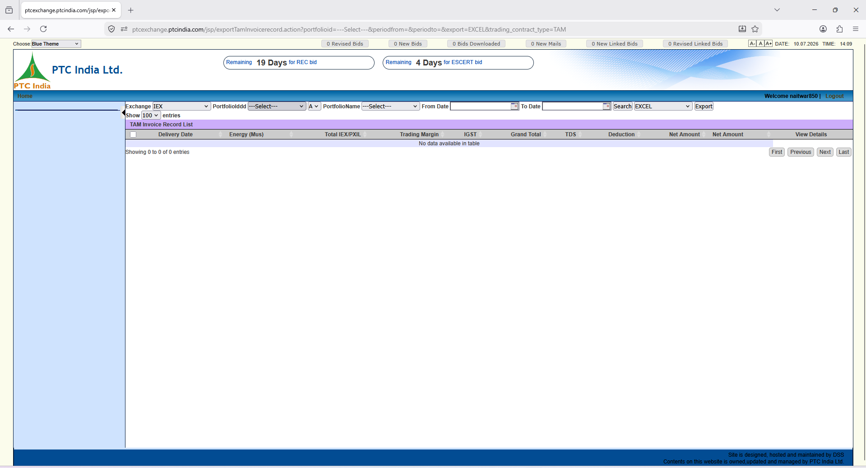

This screenshot brings us to a major new market segment on the PTC India portal: TAM (Term-Ahead Market) Invoice Records!
Unlike Day-Ahead Market (DAM) or Real-Time Market (RTM) which deal with 15-minute daily/intraday schedules, TAM covers bilateral, multi-day, weekly, or monthly contracts traded on power exchanges.
Here is the full, granular breakdown of every UI element, domain logic, and feature requirement for your platform.

1. Page Context & Navigation Hierarchy
- URL Path: [ptcexchange.ptcindia.com/jsp/exportTamInvoicerecord.action?...&trading_contract_type=TAM](https://ptcexchange.ptcindia.com/jsp/exportTamInvoicerecord.action?...&trading_contract_type=TAM)
- Module Title Banner: TAM Invoice Record List
- Top Countdown / Alert Banners:
  - Remaining 19 Days for REC bid
  - Remaining 4 Days for ESCERT bid
  - Operational Context: These countdown widgets sit persistently above the workspace to warn traders of impending monthly/periodic certificate auction deadlines.
- Quick Status Badges: 0 Revised Bids, 0 New Bids, 0 Bids Downloaded, 0 New Mails, 0 New Linked Bids, 0 Revised Linked Bids.

2. Granular Filter Bar Breakdown (Top Controls)
+-----------------------------------------------------------------------------------------------------------------------------------+
| Exchange: [ IEX v ] PortfolioIddd: [ ---Select--- v ] [ A v ] PortfolioName: [ ---Select--- v ] From Date: [ 📅 ] To Date: [ 📅 ] |
| [ Search ] [ EXCEL v ] [ Export ] |
+-----------------------------------------------------------------------------------------------------------------------------------+

Control Field | Options / Input | Business & Domain Purpose
Exchange | Dropdown (IEX, PXIL, HPX) | Multi-Exchange Selector. Filters TAM contracts executed on specific power exchanges.
PortfolioIddd | Dropdown (---Select---) | Portfolio ID Filter. Selects specific asset IDs (e.g., N1HP0PTC0850).
Region / Zone Flag | Dropdown (A) | Filters portfolios by Regional Power Committee or State dispatch zones.
PortfolioName | Dropdown (---Select---) | Friendly asset name filter (e.g., Naitwar_Mori_HPS).
From Date / To Date | Date Pickers (DD-MM-YYYY) | Delivery / Contract Date Filter. Queries TAM invoices covering specific multi-day or monthly billing cycles.
Search Button | Action Trigger | Fetches TAM billing records matching the selected parameters.
Export Options | Dropdown (EXCEL) + Export | Allows bulk downloading the financial grid into Excel/CSV for accounting audits.

3. Data Grid Breakdown & Financial Column Structure
The table structure for TAM Invoices differs significantly from daily DAM obligation sheets because TAM contracts are term-based (multi-day) and require tax deduction at source (TDS) & statutory adjustments:
+-------------------------------------------------------------------------------------------------------------------------------------+
| [ ] | Delivery Date | Energy (Mus) | Total IEX/PXIL | Trading Margin | IGST | Grand Total | TDS | Deduction | Net Amount | View Details |
+-------------------------------------------------------------------------------------------------------------------------------------+
| (No data available in table) |
+-------------------------------------------------------------------------------------------------------------------------------------+

Granular Column Analysis & Accounting Formulas:
Column Name | Unit / Type | Financial & Domain Logic
Selection Checkbox | [ ] | Allows checking multiple invoice rows for bulk PDF downloads or bulk SAP export.
Delivery Date | Date / Range | The specific delivery day or multi-day term contract period.
Energy (Mus) | Million Units ($1\text{ MU} = 10^6\text{ kWh} = 1,000\text{ MWh}$) | Volume in Million Units (MUs). TAM contracts operate in higher volume aggregates than daily MWh sheets.
Total IEX/PXIL | Amount in ₹ | Gross Power Value. The gross contract value calculated at exchange clearing rates.
Trading Margin | Amount in ₹ | PTC / Broker Fee. The contracted trading margin (e.g., ₹0.02/kWh or fixed slab rate).
IGST | Amount in ₹ | 18% Integrated GST applied to taxable service line items (Exchange fees + Trading margin).
Grand Total | Amount in ₹ | $\text{Gross Power Value} + \text{Trading Margin} + \text{Taxes}$.
TDS | Amount in ₹ | Tax Deducted at Source (Section 194Q / 194-O). Indian Income Tax statutory deduction withheld on power transactions.
Deduction | Amount in ₹ | Other line-item adjustments (SLDC/RLDC fees, Open Access charges, or transmission loss penalties).
Net Amount | Amount in ₹ | Final Net Receivable / Payable:  $$\text{Net Amount} = \text{Grand Total} - \text{TDS} - \text{Deductions}$$
View Details | Link / Button | Opens the underlying contract, Format-D schedule linkage, or original signed tax invoice PDF.

4. Key Differences: TAM vs DAM/RTM Billing
Understanding these differences is vital for designing the backend billing module in your platform:
- Volume Unit Standards:
  - DAM / RTM: Billed in MWh (e.g., $358.775\text{ MWh}$).
  - TAM (Term-Ahead): Billed in MUs (Million Units) (e.g., $1.5\text{ MU}$).
- Statutory TDS Handling:
  - TAM invoices explicitly track TDS (Tax Deducted at Source) withholding amounts, which must sync directly into SAP FI for Form 26AS reconciliation.
- Multi-Exchange Filtering:
  - While DAM is heavily dominated by IEX, TAM contracts are actively split across IEX, PXIL, and HPX. The UI must support switching exchange contexts seamlessly.

5. UI/UX Refinement Patterns for Our React Application
- Unified Countdown Header Widget:
  - Replicate the persistent countdown banners for periodic auctions (19 Days for REC bid, 4 Days for ESCERT bid) as a global top bar in React. This ensures traders never miss gate-closure windows.
- Volume Unit Conversion Toggle:
  - Provide an inline toggle switch on financial tables: [ Show in MUs (Million Units) ] vs [ Show in MWh / kWh ].
- Integrated TDS & Tax Summary Card:
  - Include a dedicated summary card above the table showing cumulative TDS withheld for the financial year, aiding direct reconciliation with SJVN's finance team.
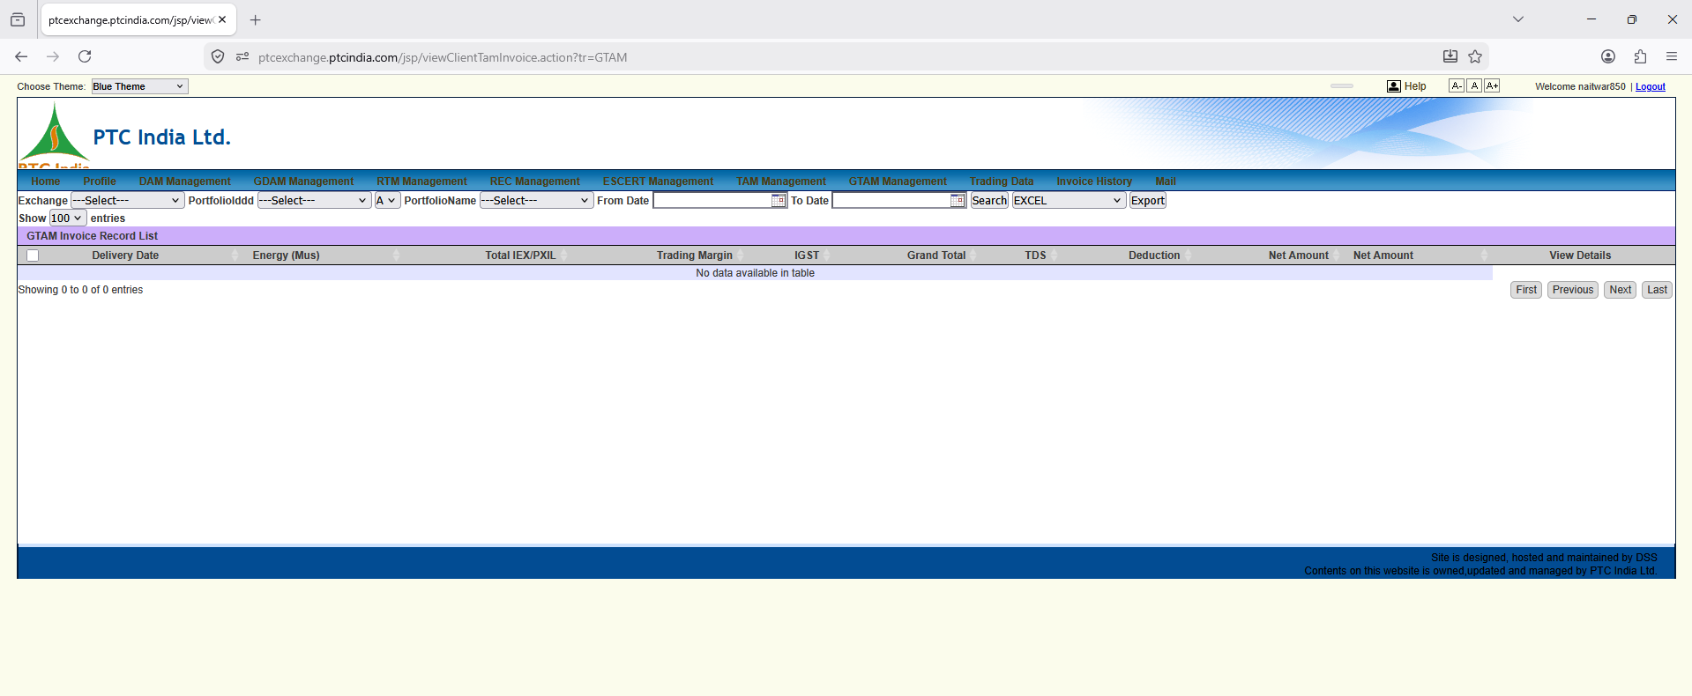

This screenshot brings us to another specialized market segment on the PTC portal: GTAM (Green Term-Ahead Market) Invoice Records!
While the previous screenshot covered conventional TAM (conventional multi-day contracts), this view specifically tracks GTAM—which is reserved exclusively for Renewable Energy (RE) contracts (Solar, Wind, Hybrid, and Hydro contracts).
Here is the granular, element-by-element breakdown and functional analysis for your SJVN platform design.

1. Page Context & Domain Purpose
- URL Path: [ptcexchange.ptcindia.com/jsp/viewClientTamInvoice.action?tr=GTAM](https://ptcexchange.ptcindia.com/jsp/viewClientTamInvoice.action?tr=GTAM)
- Module Title Banner: GTAM Invoice Record List
- Active Top Menu Tab: GTAM Management
- Business Purpose: This screen functions as the Green Term-Ahead Billing & Invoice Ledger. GTAM allows renewable energy generators and obligated entities (like DISCOMs) to trade green power under multi-day, weekly, or monthly bilateral contracts.
For SJVN’s dual business roles:
- REIA Role: SJVN aggregates large solar/wind portfolios (~6 GW scaling to ~20 GW) and sells green power. GTAM acts as an avenue to offload excess renewable energy under term contracts.
- Trading Desk Role: SJVN trades green energy contracts on behalf of client RE developers.

2. Granular UI Element Breakdown
+-----------------------------------------------------------------------------------------------------------------------------------+
| GTAM Invoice Record List |
| Exchange: [ ---Select--- v ] PortfolioIddd: [ ---Select--- v ] [ A v ] PortfolioName: [ ---Select--- v ] From Date: [ 📅 ] To Date: [ 📅 ]|
| [ Search ] [ EXCEL v ] [ Export ] |
+-----------------------------------------------------------------------------------------------------------------------------------+
| [ ] | Delivery Date | Energy (Mus) | Total IEX/PXIL | Trading Margin | IGST | Grand Total | TDS | Deduction | Net Amount | View Details |
+-------------------------------------------------------------------------------------------------------------------------------------+
| (No data available in table) |
+-------------------------------------------------------------------------------------------------------------------------------------+

Control Panel & Table Schema Analysis
Control / Column | Input / Option | Domain Context & Business Purpose
Exchange Selector | Dropdown (---Select--- / IEX, PXIL, HPX) | Selects which power exchange executed the GTAM contract.
PortfolioIddd / Name | Dropdowns (N1HP0PTC0850 / Naitwar_Mori_HPS) | Restricts invoice records to a specific renewable/hydro generation asset.
From Date / To Date | Date Pickers (DD-MM-YYYY) | Filters invoices by the multi-day delivery period.
Energy (Mus) | Quantity in Million Units ($10^6\text{ kWh}$) | Billed green energy volume. GTAM contracts are quantified in MUs.
Total IEX/PXIL | Amount in ₹ | Gross value of green power traded.
Trading Margin | Amount in ₹ | PTC / Brokerage trading commission fee.
IGST (18%) | Amount in ₹ | Tax applied on trading margin and exchange service charges.
TDS | Amount in ₹ | Tax Deducted at Source (Section 194Q / 194-O) withheld on bulk power purchase.
Deduction | Amount in ₹ | Adjustments for transmission losses, SLDC/RLDC scheduling fees, or curtailments.
Net Amount | Amount in ₹ | Final settlement payout transferred to the seller.

3. Key Domain Distinction: TAM vs. GTAM
Why does the PTC portal maintain a completely separate menu tab for GTAM instead of merging it with regular TAM?
- RPO (Renewable Purchase Obligation) Tracking:
  - Power bought under GTAM carries a green tag. Buyers (DISCOMs/Captive users) use GTAM invoice statements to prove compliance with their statutory RPO targets to State Electricity Regulatory Commissions (SERCs).
- Hydro Inclusion (GTAM Contracts):
  - Since regulatory reforms introduced hydro power into RPO definitions, hydro generators (like SJVN's Naitwar Mori HEP or Rampur HEP) can qualify under specific green/hydro contract sub-segments within GTAM.
- Green Attribute Certificate Separation:
  - GTAM trades deliver both physical power and environmental compliance attributes simultaneously, whereas pure REC trading delivers certificates without physical electricity.

4. Key Platform Requirements for SJVN
- Automated RPO Compliance Tagging:
  - When an invoice is generated in the Power Trading Management System, the backend must automatically flag whether the underlying contract is Conventional (TAM) or Green (GTAM).
  - This flag must flow directly into the Consolidated Dashboard & MIS Layer to feed RPO compliance tracking widgets for DISCOM buyers.
- Reusing the Underlying Contract Code:
  - Notice that the URL parameter is viewClientTamInvoice.action?tr=GTAM.
  - The PTC platform reuses the exact same backend engine and table structure for both TAM and GTAM, varying only the contract type filter (tr=GTAM).
  - In our platform architecture, we will follow this exact clean design: one unified Term Billing Engine that handles both conventional and green term contracts seamlessly.

5. UI Patterns for Our React Terminal
- Green Asset Badge:
  - Add a 🌿 "Green Power (GTAM)" badge next to invoice entries to distinguish renewable/hydro transactions from thermal/conventional deals.
- RPO Certificate Download Link:
  - Include a direct button alongside the invoice PDF: [ 📜 Download RPO Compliance Certificate ]. This allows DISCOM clients to download audit-ready proof of green power procurement.
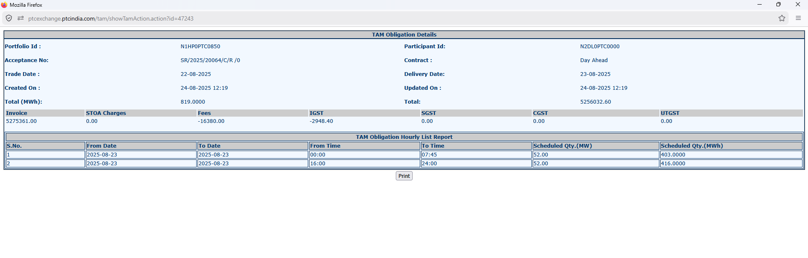

It shows the granular detail view of a Term-Ahead Market (TAM) obligation statement (TAM Obligation Details & TAM Obligation Hourly List Report).
While earlier screenshots showed empty lists or 96-block daily DAM sheets, this view reveals how TAM bilateral contracts are structured, priced, and scheduled differently from standard DAM trades.
Here is the granular, element-by-element breakdown and functional design for your platform.

1. Page Context & High-Level Purpose
- URL Path: [ptcexchange.ptcindia.com/tam/showTamAction.action?id=47243](https://ptcexchange.ptcindia.com/tam/showTamAction.action?id=47243)
- Module Title: TAM Obligation Details
- Business Purpose: This screen provides a single-contract breakdown for a executed Term-Ahead Market (TAM) deal. It serves as the primary audit proof and billing voucher connecting the commercial trade acceptance to hourly physical schedules.

2. Granular Field & Header Metadata Breakdown (Top Section)
Looking at the upper parameter grid:
Metadata Field | Value on Screen | Business & Domain Logic
Portfolio Id | N1HP0PTC0850 | Mapped to Naitwar Mori HEP (60 MW).
Participant Id | N2DL0PTC0000 | PTC India Ltd. exchange membership ID.
Acceptance No | SR/2025/20064/C/R /0 | Unique Exchange Trade Confirmation / Contract ID.  • SR: Southern Region / Specific Corridor  • 2025: Contract Year  • 20064: Unique deal sequence number.
Contract | Day Ahead | TAM Contract Variant. Even within TAM, contracts can be structured as Day-Ahead Contingency, Daily, Weekly, or Intra-day.
Trade Date | 22-08-2025 | Date the TAM contract was executed.
Delivery Date | 23-08-2025 | Date physical power delivery occurred.
Created On / Updated On | 24-08-2025 12:19 | Timestamp when this obligation statement was compiled and published.
Total (MWh) | 819.0000 MWh | Cumulative Traded Volume for the Contract.
Total | 5256032.60 ($\approx ₹52.56\text{ Lakhs}$) | Gross Contract Value in ₹.

3. Financial & Fee Breakdown Line Items (Middle Table)
This table breaks down the net financial realization formula for the contract:
+-----------------------------------------------------------------------------------------------+
| Invoice (Gross ₹) | STOA Charges | Fees | IGST | SGST | CGST | UTGST | Net Total |
+-------------------+--------------+-------------+------------+------+------+-------+------------+
| 52,75,361.00 | 0.00 | -16,380.00 | -2,948.40 | 0.00 | 0.00 | 0.00 | 5256032.60 |
+-----------------------------------------------------------------------------------------------+

Granular Financial Math Verification:
- Gross Invoice Amount: $₹52,75,361.00$
- Exchange / Trading Fees: $-₹16,380.00$
  - Fee Math: $\frac{₹16,380.00}{819\text{ MWh}} = \mathbf{₹20.00/\text{MWh}}$ ($\approx \text{₹0.02/kWh}$ trading margin/fee).
- Applicable Tax (18% IGST on Fee):
  - $₹16,380.00 \times 18\% = \mathbf{₹2,948.40}$.
- Net Receivable Payout:
$$\text{Net Amount} = ₹52,75,361.00 - ₹16,380.00 - ₹2,948.40 = \mathbf{₹52,56,032.60}$$

4. TAM Schedule Structure vs. DAM (Bottom Table)
The bottom table reveals a fundamental structural difference between TAM and DAM scheduling:
- DAM (Day-Ahead Market): Mandates a rigid 96-block continuous table (showing all 15-minute intervals sequentially from 00:00 to 24:00).
- TAM (Term-Ahead Market): Uses Block-Time Aggregation. Instead of listing 96 separate rows, it groups identical continuous delivery hours into defined time blocks!
TAM Obligation Hourly List Report
+-------+------------+------------+-----------+---------+--------------------+---------------------+
| S.No. | From Date | To Date | From Time | To Time | Scheduled Qty (MW) | Scheduled Qty (MWh) |
+-------+------------+------------+-----------+---------+--------------------+---------------------+
| 1 | 2025-08-23 | 2025-08-23 | 00:00 | 07:45 | 52.00 | 403.0000 |
| 2 | 2025-08-23 | 2025-08-23 | 16:00 | 24:00 | 52.00 | 416.0000 |
+-------+------------+------------+-----------+---------+--------------------+---------------------+

Operational Math & Domain Insights:
- Time Block 1 (00:00 - 07:45):
  - Duration: $7.75\text{ hours}$ (31 fifteen-minute blocks).
  - Scheduled Capacity: 52.00 MW.
  - Volume Math: $52.00\text{ MW} \times 7.75\text{ hours} = \mathbf{403.00\text{ MWh}}$.
- Time Block 2 (16:00 - 24:00):
  - Duration: $8.00\text{ hours}$ (32 fifteen-minute blocks).
  - Scheduled Capacity: 52.00 MW.
  - Volume Math: $52.00\text{ MW} \times 8.00\text{ hours} = \mathbf{416.00\text{ MWh}}$.
- Total Combined Energy: $403.00\text{ MWh} + 416.00\text{ MWh} = \mathbf{819.00\text{ MWh}}$. Matches the Total (MWh) in the top metadata block exactly!

Key Operational Observation (Peaking / Non-Delivery Gap):
Notice that between 07:45 AM and 16:00 PM (7.75 hours), there is no scheduled delivery (0.00 MW).
- This is a classic Non-Peak Offload Pattern. The plant conserved its water/head pond storage during low-tariff daytime hours to supply a flat 52 MW during early morning (00:00-07:45) and evening peak (16:00-24:00) blocks.

5. Architectural & UI/UX Requirements for SJVN Platform
- Flexible Schedule Representation Engine:
  - Your PostgreSQL database schema must support both:
    - Granular 96-Block Array Data (for DAM / RTM).
    - Time-Range Aggregated Blocks (from_time, to_time, mw, mwh) for TAM and Bilateral contracts.
- Automated Trade-to-Obligation Cross-Matching:
  - When a TAM deal clears, the system must cross-check the Acceptance No (SR/2025/20064...) against the original bid sheet to verify that the exchange applied the correct fee slab ($₹20/\text{MWh}$) and tax rate.
- UI Terminal Design Pattern:
  - Provide a clean summary card for TAM deals featuring:
    - Contract Header: Acceptance Number, Contract Type, Trade Date vs Delivery Date.
    - Financial Waterfall: Gross Value $\rightarrow$ Operating Fees $\rightarrow$ Tax $\rightarrow$ Net Payout.
    - Time-Block Schedule Summary Table: Clean grouped time ranges showing MW and calculated MWh.
Whenever you're ready, share the next screenshot and we will keep building! 🚀

Key Highlights & Architectural takeaway:

1. TAM Time-Block Aggregation (vs. DAM 96-Block Grid)
- Rule: Unlike DAM/RTM which requires a strict 96-row table (15-min intervals), TAM uses Time-Range Aggregated Blocks.
- On Screen: Shows 00:00 - 07:45 (52 MW / 403 MWh) and 16:00 - 24:00 (52 MW / 416 MWh).
- System Design Implication: Our PostgreSQL DB schema must support both fixed 96-block array data for DAM and grouped time-span rows (from_time, to_time, mw, mwh) for TAM/Bilateral deals.

2. Contract Metadata Tracking
- Acceptance No (SR/2025/20064/C/R /0): Acts as the primary foreign key linking the commercial deal to exchange clearing statements, STOA charges, and billing vouchers.
- Total Value Math:
$$\text{Invoice Gross } (₹52,75,361.00) - \text{Fees } (₹16,380.00) - \text{IGST } (₹2,948.40) = \mathbf{₹52,56,032.60}$$
  - Trading margin fee rate confirmed: $\frac{₹16,380}{819\text{ MWh}} = \mathbf{₹20/MWh}$ ($\approx ₹0.02/\text{unit}$).
Whenever you are ready, please upload the next new screenshot from the PTC portal (e.g., GDAM bidding screens, RTM management, REC management, or profile config) so we can continue building our master UI/UX map! 🚀
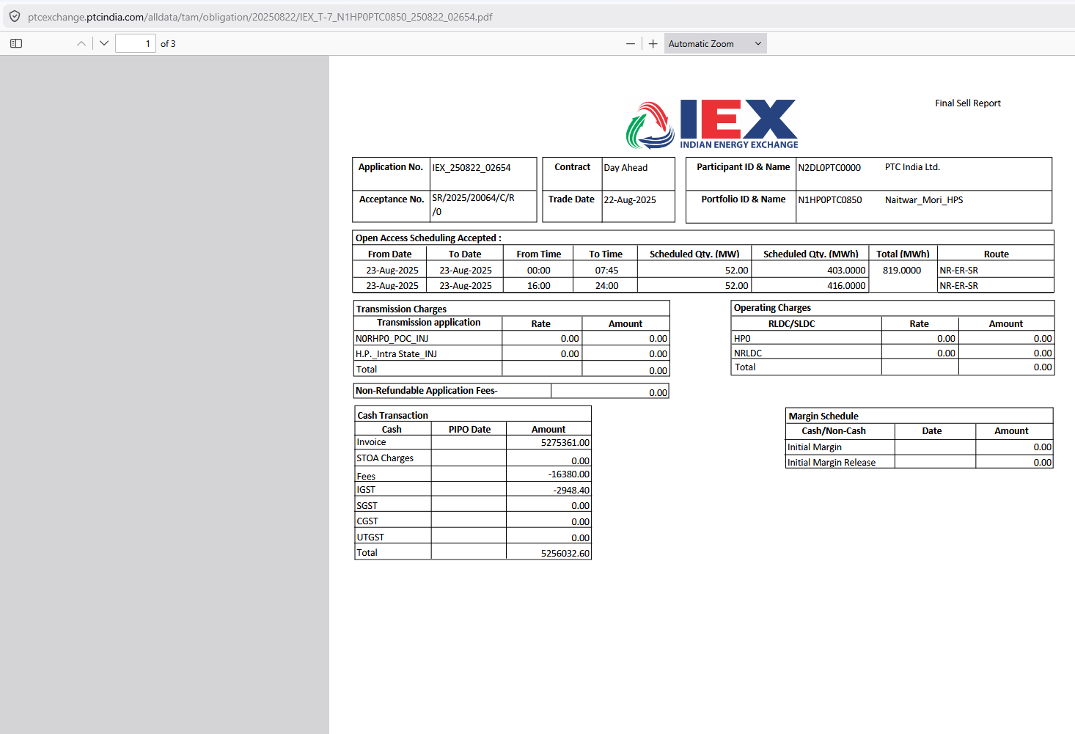

This screenshot is the official IEX-generated PDF document ("Final Sell Report") for the exact same TAM deal (Acceptance No: SR/2025/20064/C/R /0) we just analyzed on the web screen!
Notice the URL path:
[ptcexchange.ptcindia.com/alldata/tam/obligation/20250822/IEX_T-7_N1HP0PTC0850_250822_02654.pdf](https://ptcexchange.ptcindia.com/alldata/tam/obligation/20250822/IEX_T-7_N1HP0PTC0850_250822_02654.pdf)
This PDF provides the legally binding document structure, corridor routing details, transmission charge breakups, and margin schedules for Term-Ahead Market contracts.
Here is the granular, element-by-element breakdown and domain logic for your platform design.

1. Page Context & High-Level Purpose
- Document Title: Final Sell Report (Top Right)
- Document Viewer: Mozilla Firefox PDF Viewer (1 of 3 pages)
- Business Purpose: This PDF is the official IEX Settlement & Open Access Approval Voucher. It serves as proof that the TAM trade was registered, scheduled across regional grid corridors (NR-ER-SR), and cleared financially through IEX's clearinghouse.

2. Granular Field & Table Breakdown

A. Contract Identification Header
Field Name | Value on Screen | Functional & Domain Meaning
Application No. | IEX_250822_02654 | Unique IEX Open Access application tracking number.
Acceptance No. | SR/2025/20064/C/R /0 | Unique exchange trade confirmation / contract identifier.
Contract | Day Ahead | TAM contract segment variant (Day-Ahead Contingency).
Trade Date | 22-Aug-2025 | Execution date.
Participant ID & Name | N2DL0PTC0000 / PTC India Ltd. | Licensee executing trader.
Portfolio ID & Name | N1HP0PTC0850 / Naitwar_Mori_HPS | SJVN hydro asset.

B. Open Access Scheduling Accepted Table
This section reveals the inter-regional corridor routing used to transmit the power:
+---------------------------------------------------------------------------------------------------------+
| From Date | To Date | From Time | To Time | Scheduled Qty (MW) | Scheduled Qty (MWh) | Total (MWh) | Route |
+-------------+-------------+-----------+---------+--------------------+---------------------+-------------+----------+
| 23-Aug-2025 | 23-Aug-2025 | 00:00 | 07:45 | 52.00 | 403.0000 | 819.0000 | NR-ER-SR |
| 23-Aug-2025 | 23-Aug-2025 | 16:00 | 24:00 | 52.00 | 416.0000 | | NR-ER-SR |
+---------------------------------------------------------------------------------------------------------+

New Domain Insight: Route = NR-ER-SR
- Corridor Route: Northern Region (NR) $\rightarrow$ Eastern Region (ER) $\rightarrow$ Southern Region (SR).
- Domain Context: Power generated in Himachal Pradesh (NR) was sold to a buyer in the Southern Region (SR) via the Eastern Region grid corridor.
- Platform Logic: When storing schedule records, our database must track the Grid Transmission Corridor (NR-ER-SR). This is essential because transmission losses and wheeling charges vary depending on the specific transit path used.

C. Transmission Charges & Operating Charges Tables
These tables itemize point-of-connection (PoC) and despatch centre charges:
Charge Category | Line Item | Rate | Amount (₹) | Domain Rule
Transmission Charges | NORHPO_POC_INJ | 0.00 | 0.00 | Northern Region Point-of-Connection Injection charge (Waived/Zero for hydro under GNA).
 | H.P._Intra State_INJ | 0.00 | 0.00 | HP Intra-State Injection charge (Billed separately or zero in this contract).
Operating Charges | RLDC/SLDC (HPO / NRLDC) | 0.00 | 0.00 | Operating fees.
Non-Refundable Application Fees | - | - | 0.00 | Billed at 0.00 for this specific TAM window.

D. Cash Transaction & Margin Schedule Tables
The financial summary matches our previous screen calculations perfectly:
Cash Transaction
+------------------------------------+
| Cash | PIPO Date | Amount (₹) |
+------------------+-----------+--------------+
| Invoice | | 5275361.00 |
| STOA Charges | | 0.00 |
| Fees | | -16380.00 |
| IGST | | -2948.40 |
| Total | | 5256032.60 |
+------------------------------------+

- Margin Schedule Panel: Tracks Initial Margin and Initial Margin Release. (Shows 0.00 here because this is the Final Sell Report after trade settlement, meaning initial exchange cash margins have been fully released).

3. Key Architectural Insights for Our Platform
- PDF Folder Path Convention:
  - URL: /alldata/tam/obligation/20250822/IEX_T-7_...pdf
  - Notice how TAM PDFs are archived under alldata/tam/obligation/YYYYMMDD/. Our document repository service should adopt this exact structured hierarchy.
- 3-Page Document Processing:
  - The viewer shows 1 of 3 pages.
    - Page 1: Executive Obligation & Financial Summary (this view).
    - Page 2 & 3: Regional Open Access Approvals, RLDC Concurrence details, and Format-D schedule mappings.
  - Our automated PDF parsing pipeline should extract financial totals from Page 1 and corridor approval numbers from Pages 2–3.

4. UI Patterns to Replicate in Our React Application
- Corridor Route Visual Badge:
  - In the TAM Contract Details view, render a visual transit pipeline tag:
[ NR (Gen) ⚡ ──> ER ──> SR (Buyer) ]
- One-Click Verified PDF Download:
  - Provide a direct link to view/download this official IEX PDF next to every TAM transaction row.
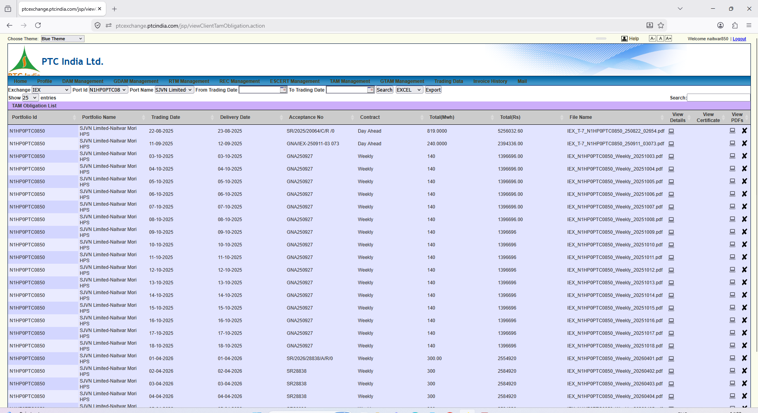

This screenshot is another major piece of the puzzle! It shows the TAM Obligation List main archive screen ([ptcexchange.ptcindia.com/jsp/viewClientTamObligation.action](https://ptcexchange.ptcindia.com/jsp/viewClientTamObligation.action)).
While our previous two screenshots analyzed the individual details and PDF output of a single TAM trade (SR/2025/20064/C/R /0 for 22-08-2025), this screen represents the master dashboard/repository where all historical TAM obligations are listed, filtered, and managed.
Here is the granular, element-by-element breakdown, domain logic, and system requirements for your SJVN platform.

1. Page Context & High-Level Purpose
- URL Path: [ptcexchange.ptcindia.com/jsp/viewClientTamObligation.action](https://ptcexchange.ptcindia.com/jsp/viewClientTamObligation.action)
- Module Title Banner: TAM Obligation List
- Parent Menu Context: Active under TAM Management.
- Business Purpose: Central control desk for tracking all executed Term-Ahead Market (TAM) deals. Commercial traders and accountants use this view to:
  - Monitor active and past term contracts (Day Ahead Contingency, Weekly, Monthly).
  - Access underlying trade detail popups and download official IEX PDF vouchers.
  - Track contract-wise financial yields ($\text{Total Rs}$) and energy volumes ($\text{Total MWh}$).

2. Granular Filter Bar Breakdown (Top Controls)
+-----------------------------------------------------------------------------------------------------------------------------------+
| Exchange: [ IEX v ] Port Id: [ N1HP0PTC08 v ] Port Name: [ SJVN Limited- v ] From Trading Date: [ 📅 ] To Trading Date: [ 📅 ]|
| [ Search ] [ EXCEL v ] [ Export ] |
+-----------------------------------------------------------------------------------------------------------------------------------+

Control Field | Value Sample | Operational Meaning & Domain Context
Exchange | Dropdown (IEX) | Selects the power exchange where the term contracts were executed (IEX, PXIL, HPX).
Port Id / Port Name | N1HP0PTC0850 / SJVN Limited-Naitwar Mori HPS | Asset Account Filter. Context restricted to SJVN's Naitwar Mori HEP (60 MW).
From/To Trading Date | Date Pickers [ 📅 ] | Filters term contracts by execution date range.
Search Button | Action Trigger | Queries the database to populate the TAM list grid.
Export Options | Dropdown (EXCEL) + Export | Bulk exports the contract list into Excel/CSV for management reporting.

3. Data Grid Breakdown & Key Contract Patterns Discovered
Look at the populated rows in this table—they reveal how multi-day Weekly TAM contracts are structured in practice:
+--------------------------------------------------------------------------------------------------------------------------------------------+
| Portfolio Id | Portfolio Name | Trading Date | Delivery Date | Acceptance No | Contract | Total(MWh) | Total(Rs) | File Name... |
+--------------+----------------+--------------+---------------+---------------------+-----------+------------+------------+-----------------+
| N1HP0PTC0850 | SJVN Limited...| 22-08-2025 | 23-08-2025 | SR/2025/20064/C/R/0 | Day Ahead | 819.0000 | 5256032.60 | IEX_T-7_...pdf |
| N1HP0PTC0850 | SJVN Limited...| 03-10-2025 | 03-10-2025 | GNA250927 | Weekly | 140 | 1396696.00 | IEX_N1H...pdf |
| N1HP0PTC0850 | SJVN Limited...| 04-10-2025 | 04-10-2025 | GNA250927 | Weekly | 140 | 1396696.00 | IEX_N1H...pdf |
| ... | ... | ... | ... | ... | ... | ... | ... | ... |
| N1HP0PTC0850 | SJVN Limited...| 18-10-2025 | 18-10-2025 | GNA250927 | Weekly | 140 | 1396696.00 | IEX_N1H...pdf |
+--------------------------------------------------------------------------------------------------------------------------------------------+

Critical Domain Insights & Business Patterns:
- Row 1 Match (Verification):
  - The first row shows 22-08-2025 / Acceptance No: SR/2025/20064/C/R /0 / 819.00 MWh / Rs 5,256,032.60.
  - This confirms 100% data continuity across our screens! Clicking View Details (📄 icon) on this row opens the exact modal popup and PDF we analyzed earlier.
- The "Weekly Contract" Multi-Day Parent/Child Pattern:
  - Look at rows 3 through 18 (Acceptance No: GNA250927, Contract Type: Weekly):
    - Delivery Dates: Runs continuously from 03-10-2025 to 18-10-2025.
    - Daily Quantity: Fixed at 140 MWh per day.
    - Daily Revenue: Fixed at Rs 1,396,696.00 ($\approx \text{Rs } 13.97 \text{ Lakhs/day}$).
  - Domain Rule: A single Weekly TAM Contract (GNA250927) spans multiple consecutive delivery days. The exchange system splits a master weekly agreement into daily schedule entries, each carrying the same parent Acceptance No.
- GNA (General Network Access) Tagging:
  - Notice the prefix GNA in acceptance numbers like GNA250927 and GNA/IEX-250911-03 073.
  - Domain Context: Under CERC's GNA Regulations, power scheduling explicitly tags whether transmission capacity is drawn under GNA allocation or Temporary GNA (T-GNA).

4. Column Action Icons Analysis (Far Right)
Icon Column | Action Icon | Functional Purpose
View Details | 📄 (Sheet Icon) | Opens the in-app modal popup (TAM Obligation Details screen) showing time-block schedules and fee breakdowns.
View Certificate | 📜 (Doc Icon) | Downloads the Standing Clearance / Regional Open Access Concurrence certificate linked to this contract.
View PDFs | 💻 (Screen/PDF Icon) | Direct link to view/download the official signed IEX PDF (IEX_T-7_...pdf) in browser.
Delete / Cancel | ❌ (Red X) | Soft-deletes or archives the obligation record view (permission-restricted).

5. Architectural Requirements for SJVN Platform
- Master-Detail Data Modeling (Parent-Child Contracts):
  - In your PostgreSQL database, a master TAM contract (e.g., Weekly deal GNA250927 for $140\text{ MWh/day} \times 16\text{ days} = 2,240\text{ MWh}$) must be stored in a tam_master_contracts table, with daily scheduled entries auto-populated into a tam_daily_schedules table.
- Unified Search & Pagination:
  - Users need the ability to search by Acceptance No (GNA250927) to bring up all 16 daily schedules associated with a single weekly deal at once.

6. UI Patterns to Replicate in Our React Application
- Grouped Contract Accordion View:
  - Instead of displaying 16 flat, repetitive rows for a single weekly contract (GNA250927), present a expandable Accordion Group:
▼ [ Weekly Contract: GNA250927 ] | 03-Oct to 18-Oct | Total: 2,240 MWh | ₹ 2.23 Cr
├─ 03-10-2025 | 140 MWh | ₹ 13.96 Lakhs | [ View Details ] [ Download PDF ]
├─ 04-10-2025 | 140 MWh | ₹ 13.96 Lakhs | [ View Details ] [ Download PDF ]
└─ ... (14 more days)

- Batch Action Toolbar:
  - Allow checking multiple rows to download all PDFs in a single .zip file or export a consolidated month-end settlement summary for SAP posting

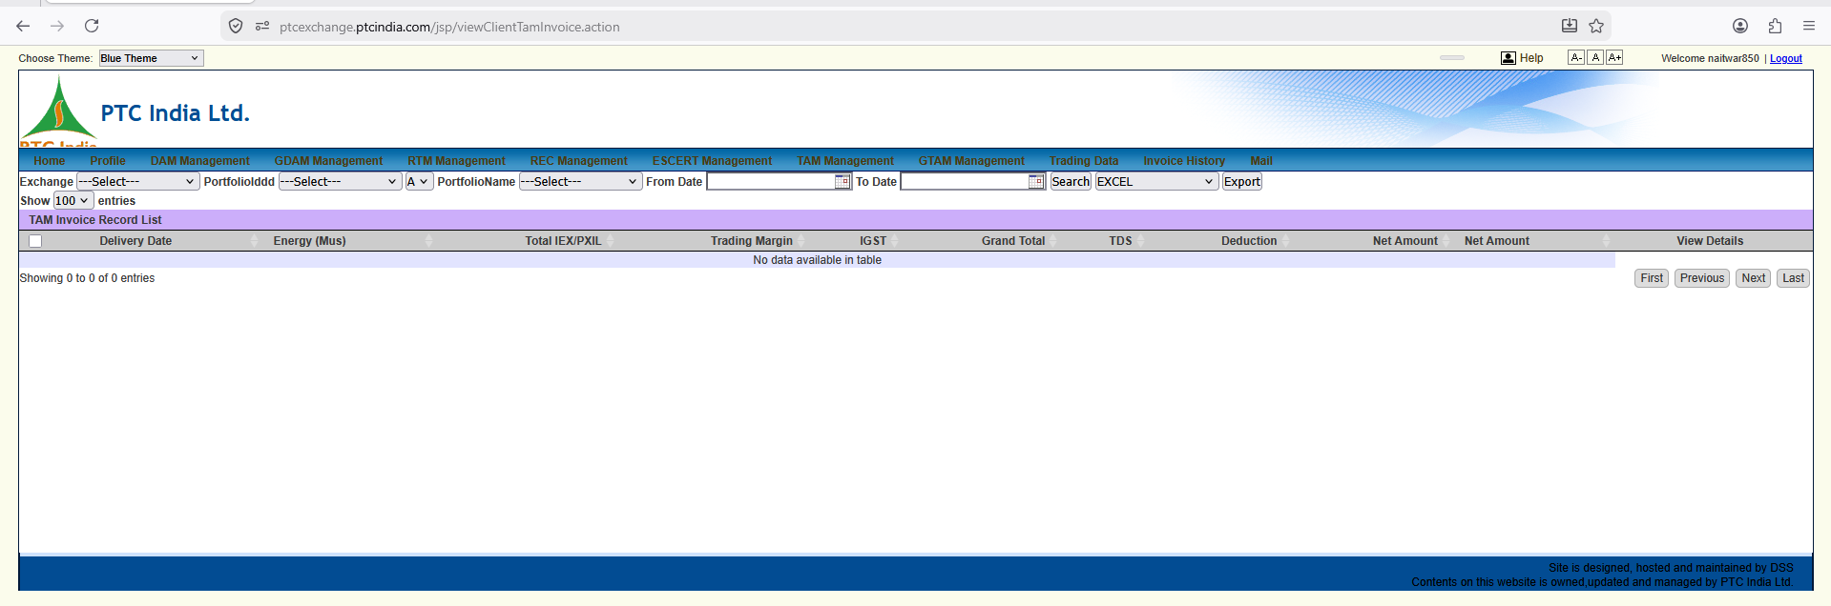

This screen shows the viewClientTamInvoice.action portal view for TAM Invoice Record List.

1. Page Context & How It Differs From Previous Views
- URL Path: [ptcexchange.ptcindia.com/jsp/viewClientTamInvoice.action](https://ptcexchange.ptcindia.com/jsp/viewClientTamInvoice.action)
- Module Title Banner: TAM Invoice Record List
- Active Top Menu Tab: TAM Management
- Key Contextual Observation:
  - In Screenshot #17 (exportTamInvoicerecord.action), we saw the TAM export view which included the persistent top countdown alert banners (19 Days for REC bid, 4 Days for ESCERT bid).
  - In Screenshot #18 (viewClientTamInvoice.action?tr=GTAM), we saw the Green TAM (GTAM) version of this exact view.
  - This screen (image_5b7fb1.png) is the standard Conventional TAM (Term-Ahead Market) Invoice Search & Ledger View without URL flags or top alert banners.

2. Granular UI Element Breakdown
+-----------------------------------------------------------------------------------------------------------------------------------+
| TAM Invoice Record List |
| Exchange: [ ---Select--- v ] PortfolioIddd: [ ---Select--- v ] [ A v ] PortfolioName: [ ---Select--- v ] From Date: [ 📅 ] To Date: [ 📅 ]|
| [ Search ] [ EXCEL v ] [ Export ] |
+-----------------------------------------------------------------------------------------------------------------------------------+
| [ ] | Delivery Date | Energy (Mus) | Total IEX/PXIL | Trading Margin | IGST | Grand Total | TDS | Deduction | Net Amount | View Details |
+-------------------------------------------------------------------------------------------------------------------------------------+
| (No data available in table) |
+-------------------------------------------------------------------------------------------------------------------------------------+

Control Panel & Table Schema Analysis
Control / Column | Options / Input | Business Domain Context & Operational Rule
Exchange Selector | Dropdown (---Select--- / IEX, PXIL, HPX) | Multi-Exchange Selector. Filters bilateral TAM contracts by the executing power exchange.
PortfolioIddd / Name | Dropdowns (N1HP0PTC0850 / SJVN Limited-Naitwar Mori HPS) | Restricts invoice records to a specific power generation asset.
Region / Zone Flag | Dropdown (A) | Filters portfolios by Regional Power Committee or State dispatch zones.
From Date / To Date | Date Pickers (DD-MM-YYYY) | Filters invoices by the multi-day delivery period.
Search Button | Action Trigger | Queries the database to populate the TAM invoice ledger.
Export Options | Dropdown (EXCEL) + Export | Bulk downloads the table summary into Excel/CSV for accounting audits.
Energy (Mus) | Volume in Million Units ($10^6\text{ kWh}$) | Billed Energy Volume. Term contracts operate in MUs rather than daily MWh.
Total IEX/PXIL | Amount in ₹ | Gross power sale value calculated at exchange clearing rates.
Trading Margin | Amount in ₹ | PTC / Brokerage trading commission fee.
IGST (18%) | Amount in ₹ | Tax applied strictly to service charges (Trading Margin + Exchange Fees).
Grand Total | Amount in ₹ | $\text{Gross Value} + \text{Trading Margin} + \text{Taxes}$.
TDS | Amount in ₹ | Statutory Tax Deducted at Source (Section 194Q / 194-O) withheld on bulk power sales.
Deduction | Amount in ₹ | Adjustments for STU/ISTS transmission losses, SLDC fees, or curtailments.
Net Amount | Amount in ₹ | Final net receivable payout transferred to the seller.
View Details | Link / Button | Opens the underlying contract schedule breakdown or original signed tax invoice PDF.

3. Domain Logic & System Design Insights for SJVN Platform
- Unified Endpoint Routing for TAM & GTAM:
  - Notice that PTC uses viewClientTamInvoice.action for conventional TAM and viewClientTamInvoice.action?tr=GTAM for Green TAM.
  - Platform Architecture Rule: We should follow this exact clean design—building one single Term Billing API Endpoint / Component that accepts a parameter (contract_category: "CONVENTIONAL" | "GREEN") to toggle between standard TAM and GTAM invoice views seamlessly.
- Statutory TDS Integration for SAP ERP:
  - Unlike daily DAM market obligations where payouts are net of exchange charges, TAM invoices track explicit TDS (Tax Deducted at Source) withholding amounts.
  - This TDS line item must be extracted directly to populate SJVN’s SAP FI Form 26AS tax credit ledger.

4. UI Patterns for Our React Terminal
- Invoice Type Segmented Control:
  - Use a modern tab switcher at the top of the screen:
[ ⚡ Conventional TAM Invoices ] | [ 🌿 Green TAM (GTAM) Invoices ]
- Direct Voucher Preview:
  - Add a PDF preview icon directly in the View Details column so accountants can view the signed invoice voucher inline without leaving the table.

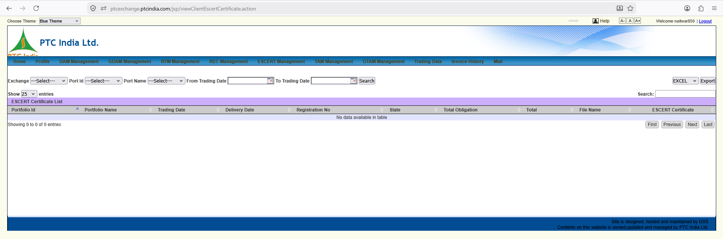

Here is the detailed, granular breakdown of this new screenshot (image_5ab579.png).
This screen transitions us into a completely new market segment on the PTC portal: ESCERT (Energy Saving Certificates) Management.

1. Page Context & Domain Purpose
- URL Path: [ptcexchange.ptcindia.com/jsp/viewClientEscertCertificate.action](https://ptcexchange.ptcindia.com/jsp/viewClientEscertCertificate.action)
- Module Title Banner: ESCERT Certificate List
- Active Top Menu Tab: ESCERT Management
- Business Purpose: This screen functions as the Energy Saving Certificates (EScerts) Registry & Settlement Ledger.

What are ESCerts (PAT Scheme Context)?
Unlike physical electricity trading (DAM/RTM/TAM) or environmental attribute trading (REC):
- ESCerts are issued under India’s PAT (Perform, Achieve and Trade) scheme by the BEE (Bureau of Energy Efficiency) under the Ministry of Power.
- 1 ESCert = 1 metric tonne of oil equivalent (mtoe) of energy savings achieved beyond a designated consumer's (DC) target.
- Energy-intensive industrial entities or power generation units that overachieve their specific energy consumption (SEC) targets earn ESCerts, which they can sell on power exchanges (IEX/PXIL) to entities that failed to meet their reduction targets.

2. Granular UI Element Breakdown
+-----------------------------------------------------------------------------------------------------------------------------------+
| ESCERT Certificate List |
| Exchange: [ ---Select--- v ] Port Id: [ ---Select--- v ] Port Name: [ ---Select--- v ] From Trading Date: [ 📅 ] To Trading Date: [ 📅 ] |
| [ Search ] [ EXCEL v ] [ Export ] |
+-----------------------------------------------------------------------------------------------------------------------------------+
| Portfolio Id | Portfolio Name | Trading Date | Delivery Date | Registration No | State | Total Obligation | Total | File Name | ESCERT Certificate |
+-------------------------------------------------------------------------------------------------------------------------------------+
| No data available in table |
+-------------------------------------------------------------------------------------------------------------------------------------+

Control Panel & Data Table Schema Analysis
Control / Column | Input / Options | Domain Context & Business Logic
Exchange Selector | Dropdown (---Select--- / IEX, PXIL) | Selects the power exchange where the ESCerts auction took place.
Port Id / Port Name | Dropdowns (---Select---) | Filters certificates by specific plant unit/portfolio registered under the PAT scheme.
From / To Trading Date | Date Pickers (DD-MM-YYYY) | Filters transactions by the specific exchange trading session date.
Search Button | Action Trigger | Queries the database to populate the ESCert transaction ledger.
Export Options | Dropdown (EXCEL) + Export | Bulk exports certificate trading logs into Excel format.
Registration No | Text String | BEE / POSOCO Registration Code. The official registration number assigned to the Designated Consumer (DC) on the Registry portal.
State | Text String | The state where the industrial/generation facility is physically located.
Total Obligation | Numeric Quantity (Units) | Number of ESCerts Traded. Quantity in terms of metric tonnes of oil equivalent (mtoe).
Total | Amount in ₹ | Gross Financial Realization. $\text{Traded ESCerts} \times \text{Exchange Market Clearing Price (MCP)}$.
File Name | PDF Link / String | Link to download the raw trade obligation statement exported by IEX/PXIL.
ESCERT Certificate | Action Link / Button | Direct link to view or download the official BEE Issued Electronic ESCert Certificate or transfer approval slip.

3. Structural Differences: ESCerts vs Physical Power Trading
Understanding these differences is vital for designing the certificate module in your platform:
- No Time Blocks or Peripheries:
  - Physical power trading relies on 15-minute time blocks (96 blocks/day) and transmission losses.
  - ESCerts are purely paper/electronic financial certificates. There are no 15-minute schedules, megawatt profiles, or grid losses.
- Auction Session Cycles:
  - Unlike daily DAM or continuous RTM trading, ESCerts are traded during periodic auction windows announced by CERC/BEE (typically held once or twice a week during active compliance cycles).
- Statutory Registry Integration:
  - Certificate ownership transfers must reconcile against the central National Load Despatch Centre (NLDC) / POSOCO ESCert Registry before trade proceeds are settled.

4. Key Platform Requirements for SJVN
- Certificate Asset Management Module:
  - Your system must include a dedicated Certificate Inventory Ledger (handling both RECs and ESCerts) separate from physical power scheduling.
  - It must track:
    - Certificates Issued by BEE
    - Certificates Held in Registry
    - Certificates Sold on Exchange
    - Certificates Retained for Self-Compliance
- Automated Trading Fee & GST Calculation:
  - Exchange trading fees and trading margin (e.g., ₹0.02/kWh equivalent or fixed per-certificate fees) plus 18% GST apply to ESCert transactions.

5. UI Patterns for Our React Terminal
- Certificate Summary Inventory Card:
  - Render a visual top summary widget above the table:
    - 📜 Available ESCerts in Registry: X Units
    - 💰 Last Traded MCP (IEX): ₹ Y / ESCert
    - ⏳ Next Auction Gate Closure: [ Countdown Timer ] (linking back to the countdown widget seen in earlier screenshots)
- Direct BEE Transfer Slip Preview:
  - Include a dedicated PDF icon button in the ESCERT Certificate column to view the official BEE transfer slip inline without leaving the table.

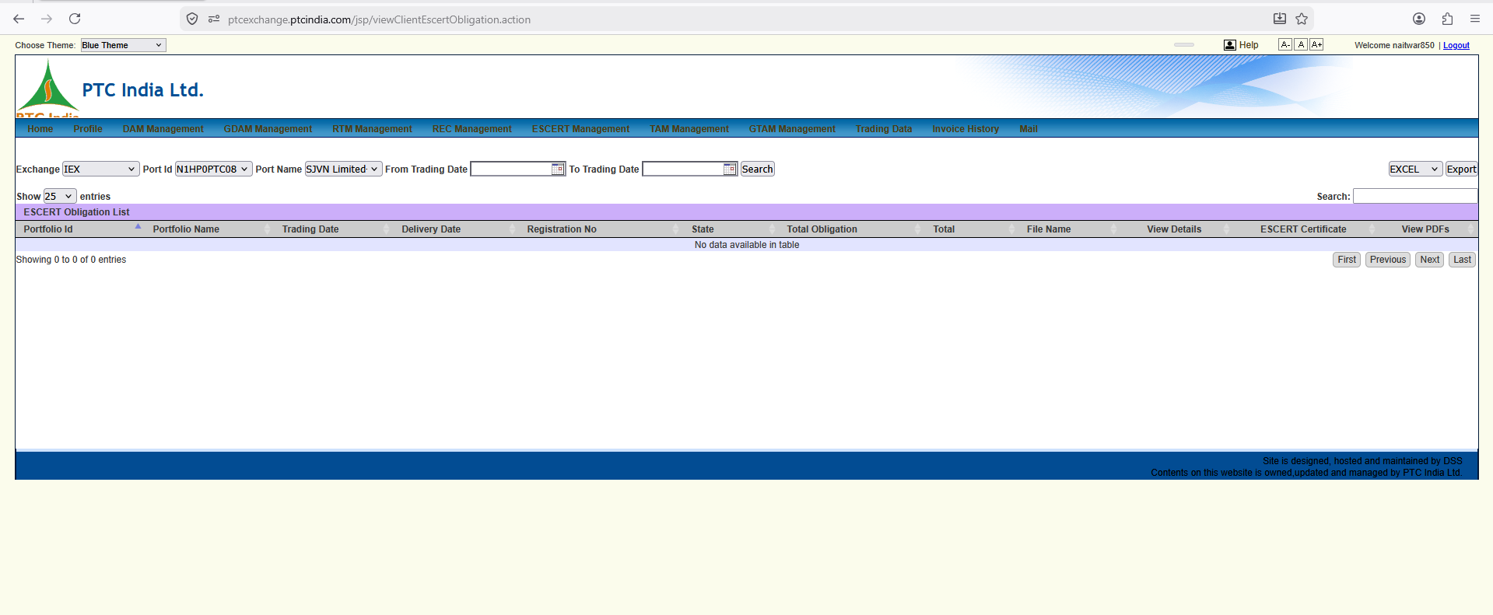

This view represents the viewClientEscertObligation.action portal page, which serves as the ESCERT Obligation List / Financial Clearing Archive.

1. Page Context & How It Differs From the Previous Screen
- URL Path: [ptcexchange.ptcindia.com/jsp/viewClientEscertObligation.action](https://ptcexchange.ptcindia.com/jsp/viewClientEscertObligation.action)
- Module Title Banner: ESCERT Obligation List
- Active Top Menu Tab: ESCERT Management
- Key Structural Difference:
  - In the previous screenshot (viewClientEscertCertificate.action), we analyzed the Certificate Holding/Transfer List.
  - This screen (viewClientEscertObligation.action) represents the Financial Clearing & Obligation Archive for ESCerts. It tracks the exchange daily settlement statements, fees, and PDF vouchers for traded ESCerts.

2. Granular UI Element Breakdown
+-----------------------------------------------------------------------------------------------------------------------------------+
| ESCERT Obligation List |
| Exchange: [ IEX v ] Port Id: [ N1HP0PTC08 v ] Port Name: [ SJVN Limited- v ] From Trading Date: [ 📅 ] To Trading Date: [ 📅 ] |
| [ Search ] [ EXCEL v ] [ Export ] |
+-----------------------------------------------------------------------------------------------------------------------------------+
| Portfolio Id | Portfolio Name | Trading Date | Delivery Date | Registration No | State | Total Obligation | Total | File Name | View Details | ESCERT Certificate | View PDFs |
+-------------------------------------------------------------------------------------------------------------------------------------+
| No data available in table |
+-------------------------------------------------------------------------------------------------------------------------------------+

Control Panel & Data Table Schema Analysis
Control / Column | Options / Input | Business Domain Context & Operational Rule
Exchange Selector | Dropdown (IEX selected) | Selects the power exchange where the ESCert clearing took place (IEX / PXIL).
Port Id / Port Name | Dropdowns (N1HP0PTC0850 / SJVN Limited-Naitwar Mori HPS) | Restricts obligation search context to a specific registered asset/plant.
From / To Trading Date | Date Pickers (DD-MM-YYYY) | Filters clearing records by the specific exchange auction date.
Search Button | Action Trigger | Queries the database to populate the ESCert obligation ledger.
Export Options | Dropdown (EXCEL) + Export | Bulk exports the obligation list into Excel for financial reporting.
Registration No | Text String | Official BEE / POSOCO Registration Number assigned to the facility.
Total Obligation | Numeric Quantity | Number of ESCerts Traded (in mtoe units) during the auction session.
Total | Amount in ₹ | Gross Financial Clearing Value ($\text{ESCert Volume} \times \text{Auction MCP}$).
File Name | File String | Name of the raw exchange obligation report file (.xls/.csv).
View Details | Action Icon (📄) | Opens an in-app modal showing fee breakdowns (BEE registry fee, trading margin, GST).
ESCERT Certificate | Action Link / Icon | Link to download the official transfer approval slip issued by BEE/POSOCO.
View PDFs | Action Icon (💻/📄) | Direct link to open/download the official signed exchange obligation PDF.

3. Core Architectural Insight: Pattern Consistency Across Products
Notice how PTC India’s platform maintains a strict, standardized 3-tier view pattern across all its market products:
- Daily / Intraday Physical Trading (DAM / RTM):
  - Schedule List (ViewClientEnergySchedule.action)
  - Obligation List (ViewClientObligation.action)
- Term-Ahead Bilateral Trading (TAM / GTAM):
  - Contract Schedule List (viewClientTamObligation.action)
  - Invoice / Ledger List (viewClientTamInvoice.action)
- Certificate Trading (REC / ESCERT):
  - Certificate Registry List (viewClientEscertCertificate.action)
  - Financial Obligation List (viewClientEscertObligation.action)

4. How to Replicate This Cleanly in Our Platform
In our React + FastAPI architecture, we don't need to create dozens of separate legacy JSP pages.
Instead, we can build a Single Master Certificate Operations Hub (/trading/certificates):
- Top Module Tabs: [ 📜 Renewable Energy Certificates (RECs) ] | [ ⚡ Energy Saving Certificates (ESCerts) ]
- Sub-View Toggle:
  - [ 📂 Registry Holdings & Inventory ] (Maps to viewClientEscertCertificate.action)
  - [ 💰 Clearing & Financial Obligations ] (Maps to viewClientEscertObligation.action)
- Unified Action Toolbar:
  - One-click download of both the Exchange Settlement PDF and the BEE Ownership Transfer Certificate from a single row.
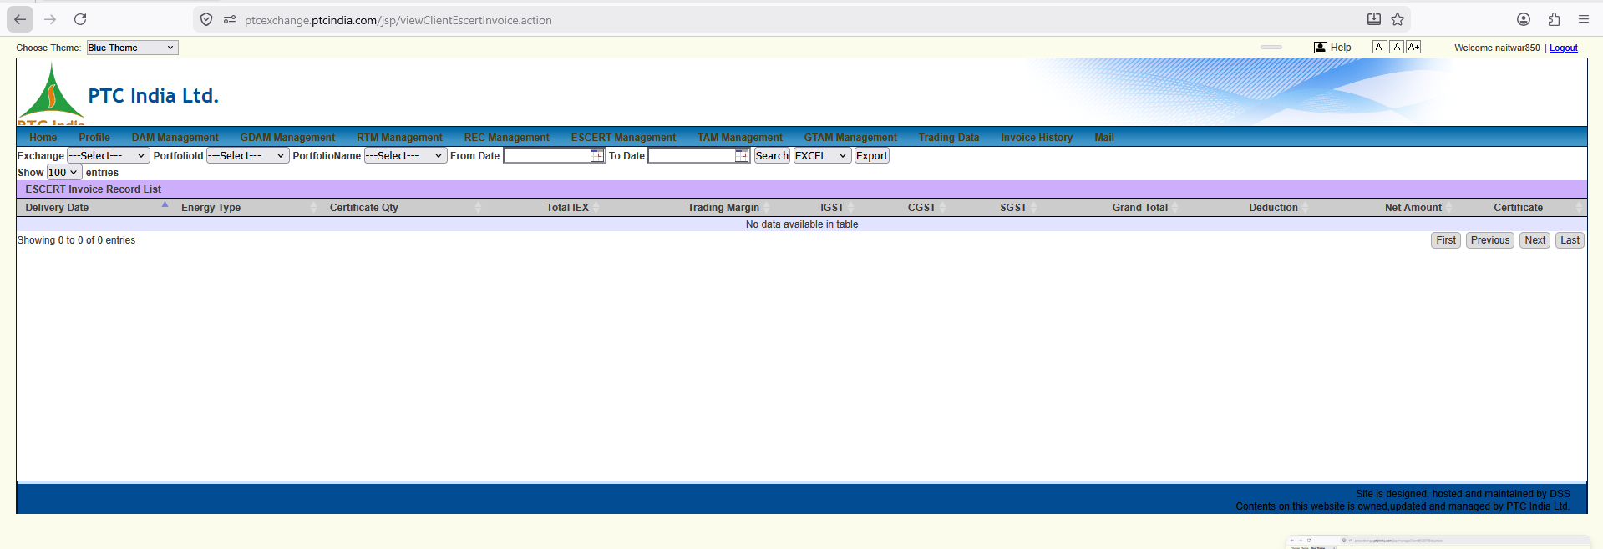

Here is the granular, element-by-element breakdown of this new screenshot (viewClientEscertInvoice.action).
This view completes the ESCERT suite on the portal, representing the ESCERT Invoice Record List / Commercial Tax Ledger.

1. Page Context & How It Fits Into the ESCERT Suite
- URL Path: [ptcexchange.ptcindia.com/jsp/viewClientEscertInvoice.action](https://ptcexchange.ptcindia.com/jsp/viewClientEscertInvoice.action)
- Module Title Banner: ESCERT Invoice Record List
- Active Top Menu Tab: ESCERT Management
- Role in the 3-Tier ESCERT Pattern:
  - viewClientEscertCertificate.action: Inventory & Holding Registry (Tracking issued certificates).
  - viewClientEscertObligation.action: Exchange Settlement Statement (Gross exchange clearing values & PDFs).
  - This Screen (viewClientEscertInvoice.action): Tax & Invoice Ledger (Handling tax deductions, trading margin, GST splits, and net billing values for accounting entries).

2. Granular UI Element Breakdown
+------------------------------------------------------------------------------------------------------------------------------------+
| ESCERT Invoice Record List |
| Exchange: [ ---Select--- v ] PortfolioId: [ ---Select--- v ] PortfolioName: [ ---Select--- v ] From Date: [ 📅 ] To Date: [ 📅 ] |
| [ Search ] [ EXCEL v ] [ Export ] |
+------------------------------------------------------------------------------------------------------------------------------------+
| Delivery Date | Energy Type | Certificate Qty | Total IEX | Trading Margin | IGST | CGST | SGST | Grand Total | Deduction | Net Amount | Certificate |
+------------------------------------------------------------------------------------------------------------------------------------+
| No data available in table |
+------------------------------------------------------------------------------------------------------------------------------------+

Control Panel & Data Table Schema Analysis
Control / Column | Options / Input | Business Domain Context & Operational Rule
Exchange Selector | Dropdown (---Select--- / IEX, PXIL) | Filters tax invoices by the power exchange executing the auction.
PortfolioId / Name | Dropdowns (N1HP0PTC0850 / SJVN Limited...) | Mapped to the specific PAT-designated facility/plant ID.
From Date / To Date | Date Pickers (DD-MM-YYYY) | Filters invoices by billing / auction settlement period.
Delivery Date | Date String | The official settlement/transfer date of the traded ESCerts.
Energy Type | Text Label (e.g., PAT Cycle / Thermal / Hydro) | Categorizes the specific designated consumer sector or PAT cycle under BEE.
Certificate Qty | Numeric Quantity | Total number of ESCerts billed (1 ESCert = 1 mtoe).
Total IEX | Amount in ₹ | Gross market clearing value ($\text{Certificate Qty} \times \text{MCP}$).
Trading Margin | Amount in ₹ | Brokerage fee charged by PTC India Ltd. for executing the auction.
IGST / CGST / SGST | Amounts in ₹ | Tax Split Breakdown: 18% GST applied strictly to service fees (Trading Margin & Exchange Fees), split into IGST (inter-state) or CGST+SGST (intra-state).
Grand Total | Amount in ₹ | $\text{Gross Market Value} + \text{Trading Margin} + \text{Total GST}$.
Deductions | Amount in ₹ | Adjustments for BEE registry transfer fees or exchange transaction charges.
Net Amount | Amount in ₹ | Final Net Receivable/Payable: Payout transferred to the account after fee and tax adjustments.
Certificate | Action Link / Icon | Direct link to view or download the linked tax invoice PDF / BEE transfer slip.

3. Key Financial & System Architectural Takeaways
- Tax Breakdown Support (IGST vs CGST/SGST):
  - Unlike basic schedule views, this table explicitly separates IGST, CGST, and SGST.
  - System Rule: Your FastAPI backend accounting engine must compute tax state mapping automatically based on the location of the seller's entity vs. PTC's billing state.
- Unified Billing Schema Across Modules:
  - Notice how the column structure here (Total IEX, Trading Margin, IGST, Grand Total, Deductions, Net Amount) mirrors the TAM Invoice and GTAM Invoice screens we analyzed earlier.
  - Platform Architecture Advantage: We can design a single reusable Financial Ledger Data Table Component in React that renders conventional TAM, Green TAM, and ESCERT tax invoices simply by passing different dataset props!

4. UI Patterns for Our React Terminal
- Accounting Reconciliation Badge:
  - Render an status tag next to invoice rows:
    - 🟢 Posted to SAP FI: Journal Voucher created.
    - 🟡 Pending GST Matching: Awaiting GSTR-2B reconciliation.
- Inline Tax Breakdown Tooltip:
  - Hovering over Grand Total shows a quick popover:
Gross Value: ₹ X
Trading Margin: ₹ Y
GST (18%): ₹ Z
-------------------
  - Total Invoice: ₹ Grand Total

Here is the granular, element-by-element breakdown of this new screenshot (image_5aad9a.png).
This view covers two important operational aspects simultaneously:
- The manageClientESCERTBid.action page (ESCERT Bid Management) in the background.
- The expanded GDAM Management Sub-Menu Options in the foreground dropdown.

1. Background Page Context: ESCERT Bid Management
- URL Path: [ptcexchange.ptcindia.com/jsp/manageClientESCERTBid.action](https://ptcexchange.ptcindia.com/jsp/manageClientESCERTBid.action)
- Module Title Banner: ESCERT BID LIST
- Active Top Context: Bidding management desk for Energy Saving Certificates (ESCerts).
- Business Purpose: This is where traders place, manage, modify, and track bids submitted for ESCert auction sessions on power exchanges (IEX/PXIL).

Granular Control Bar & Table Schema Analysis
+-----------------------------------------------------------------------------------------------------------------------------------------+
| ESCERT BID LIST |
| Exchange: [ ---Select--- v ] PortfolioId: [ ---Select--- v ] From Date: [ 📅 ] To Date: [ 📅 ] Certificate Type: [ ---Select--- v ] |
| [ EXCEL v ] [ Export ] Status: [ New v ] [ Search ] |
+-----------------------------------------------------------------------------------------------------------------------------------------+
| Portfolio Id | Trading Date | Type | Certificate Type | Certificate Quantity | Per Certificate Price(Rs.) | Status | Creation Date | Updation Date | Modify |
+-----------------------------------------------------------------------------------------------------------------------------------------+
| No data available in table |
+-----------------------------------------------------------------------------------------------------------------------------------------+

Field / Control | Input Options | Operational & Business Logic
Exchange | Dropdown (IEX / PXIL) | Power exchange where the ESCert auction bid is submitted.
PortfolioId | Dropdown (N1HP0PTC0850 / etc.) | The PAT-designated facility submitting the buy/sell bid.
Certificate Type | Dropdown | Identifies specific ESCert vintage, PAT cycle, or sector classification.
Status Filter | Dropdown (New, Approved, Rejected, Executed) | Filters bids by submission/processing stage.
Type Column | Buy / Sell | Indicates whether the entity is selling overachieved energy savings or buying to fulfill compliance targets.
Certificate Quantity | Numeric Integer | Number of ESCerts offered/demanded (in mtoe equivalent).
Per Certificate Price (Rs.) | Currency Value (₹) | Limit price per ESCert entered in the bid.
Creation / Updation Date | Timestamps | Audit trail tracking when the bid was drafted and modified.
Modify Column | Edit/Delete Controls (✏️ / 🗑️) | Allows altering or canceling bids before gate closure.

2. Foreground Sub-Menu: GDAM Management (Green Day-Ahead Market)
The user has hovered over/clicked the GDAM Management tab in the main navigation bar, revealing its complete sub-menu structure:
+---------------------------+
| GDAM Management |
+---------------------------+
| Create Bid |
| Manage GDAM Bid |
| GDAM Bid History |
| View GDAM Obligation |
| View GDAM Energy Schedule |
| View GDAM Invoice Record |
| View GDAM MCP & MCV |
+---------------------------+

Complete Breakdown of GDAM Menu Options & Platform Mapping
This dropdown reveals the entire workflow lifecycle for Green Day-Ahead Market (GDAM) trading:
Menu Item | Business Purpose | Platform Sub-Module Mapping
Create Bid | Entry form to submit 15-minute time block (96-block) price-quantity bids for green power sales. | Bidding Terminal (/gdam/bidding/create)
Manage GDAM Bid | Active workspace to view, edit, or cancel un-cleared GDAM bids before exchange gate closure. | Bid Management Console (/gdam/bidding/manage)
GDAM Bid History | Historical repository of all past submitted bids across trading dates. | Audit & Analytics Log (/gdam/bidding/history)
View GDAM Obligation | Displays cleared trade volumes, gross financial realizations, and exchange fees for GDAM. | Financial Clearing (/gdam/settlement/obligation)
View GDAM Energy Schedule | Displays the 96-block physical delivery schedule (Plant Busbar vs Regional Periphery) for green power. | Schedule Operations (/gdam/scheduling/schedule)
View GDAM Invoice Record | Tax ledger displaying trading margin, IGST/CGST, statutory TDS, and net payouts for GDAM sales. | Commercial Tax Ledger (/gdam/billing/invoices)
View GDAM MCP & MCV | Market Clearing Price (MCP) & Market Clearing Volume (MCV) analytics portal specifically for the GDAM segment. | Market Intelligence (/analytics/gdam-mcp-mcv)

3. Structural Insight: Module Parity Across Markets
Notice how the GDAM sub-menu menu mirrors the exact same structure as the standard DAM (Day-Ahead Market) module:
$$\text{Create Bid} \longrightarrow \text{Manage Bid} \longrightarrow \text{Bid History} \longrightarrow \text{Obligation} \longrightarrow \text{Energy Schedule} \longrightarrow \text{Invoice} \longrightarrow \text{MCP \& MCV}$$
- Core Platform Advantage: In our React + FastAPI system, we don't need distinct code bases for DAM and GDAM. We can create a Single Day-Ahead Market Engine (DAM Core) that takes a market type flag (market_type: "CONVENTIONAL_DAM" | "GREEN_DAM") to render the appropriate color themes, RPO badges, and regulatory tags seamlessly!

4. UI Patterns for Our React Terminal
- Unified Navigation Structure:
  - Replicate the 7-stage workflow under a clean tabbed layout in React:
[ 📝 Create ] | [ ⚙️ Manage ] | [ 📜 History ] | [ 📊 Schedule ] | [ 💰 Obligation ] | [ 📄 Invoice ] | [ 📈 Market MCP ]
- Pre-Gate Closure Countdown Bar:
  - For the Create / Manage Bid screens, display a prominent countdown widget showing time remaining until the GDAM gate closure window (typically 12:00 PM for Day-Ahead auctions).

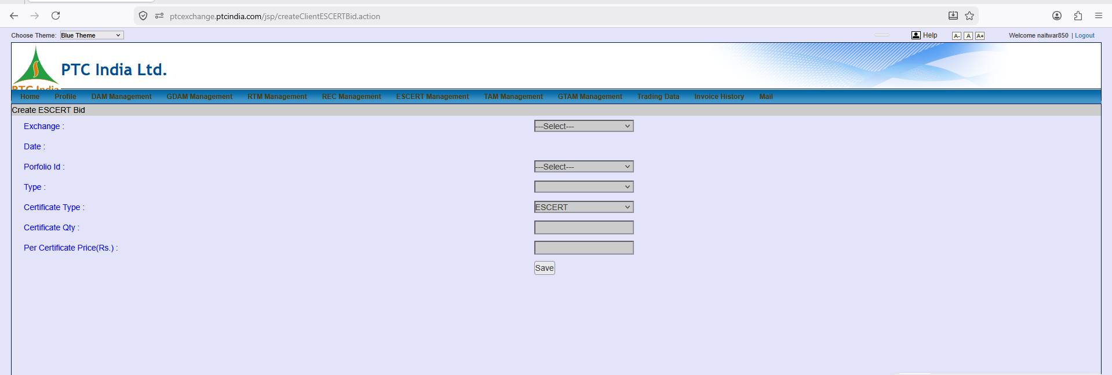

This view shows the createClientESCERTBid.action portal page, which is the Create ESCERT Bid Form.
In the previous turn (manageClientESCERTBid.action), we saw the bid listing grid. This screen represents the actual form where traders submit new Energy Saving Certificate (ESCert) bids to the exchange.

1. Page Context & Operational Purpose
- URL Path: [ptcexchange.ptcindia.com/jsp/createClientESCERTBid.action](https://ptcexchange.ptcindia.com/jsp/createClientESCERTBid.action)
- Module Title Banner: Create ESCERT Bid
- Active Top Menu Tab: ESCERT Management
- Business Purpose: Central input form for entering ESCert buy/sell orders. Plant operators and trading desks use this form to enter limit orders for auction sessions conducted under the Bureau of Energy Efficiency (BEE) PAT scheme.

2. Granular Form Field Breakdown
+------------------------------------------------------------------------------------+
| Create ESCERT Bid |
| |
| Exchange : [ ---Select--- v ] |
| Date : |
| Porfolio Id : [ ---Select--- v ] |
| Type : [ v ] |
| Certificate Type : [ ESCERT v ] |
| Certificate Qty : [ ] |
| Per Certificate Price(Rs.) : [ ] |
| [ Save ] |
+------------------------------------------------------------------------------------+

Form Input Fields Analysis:
Form Field | Field Type | Business Logic & System Constraints
Exchange | Dropdown | Selects target exchange (IEX / PXIL).
Date | Date Field | Trading session auction date.
Portfolio Id | Dropdown | Facility ID registered under the PAT scheme (e.g., N1HP0PTC0850).
Type | Dropdown | Order Direction: Specifies whether this is a Buy order (for entities under-complying) or Sell order (for overachievers).
Certificate Type | Dropdown (Default: ESCERT) | Classifies certificate category or PAT cycle vintage.
Certificate Qty | Text Input (Integer) | Quantity in Units: Number of ESCerts to trade (1 ESCert = 1 mtoe).
Per Certificate Price(Rs.) | Text Input (Decimal) | Limit Price: Maximum price willing to pay (Buy) or minimum price willing to accept (Sell) in ₹.
Save Button | Action Button | Validates inputs and stores the draft bid into PTC's database for exchange submission.

3. Key Differences: ESCert Bid Form vs. DAM/RTM Bidding Form
Understanding these structural differences is essential for designing our unified bidding terminal:
- No 15-Minute / 96-Block Matrix:
  - DAM / RTM Bids: Require entering 96 distinct time-block rows with individual MW quantities and step-wise price tiers.
  - ESCert Bids: Single aggregate quantity (Certificate Qty) and single limit price (Per Certificate Price).
- Single Clearing Session:
  - ESCert auctions do not have continuous intraday market clearing. The exchange matches all buy/sell bids at a single Market Clearing Price (MCP) at the end of the auction session window.

4. UI Patterns for Our React Terminal
- Order Value Estimator:
  - Add an auto-calculating preview widget below the inputs:
$$\text{Estimated Trade Value} = \text{Certificate Qty} \times \text{Price per Certificate}$$
- Registry Balance Validation:
  - Before allowing a Sell bid to be saved, query the central POSOCO/BEE registry balance and flag an error if $\text{Sell Quantity} > \text{Available Holding Balance}$.
- Pre-Submission Modal Summary:
  - Clicking "Submit Bid" triggers a confirmation modal highlighting order type (BUY vs SELL), total quantity, limit price, and total capital obligation.

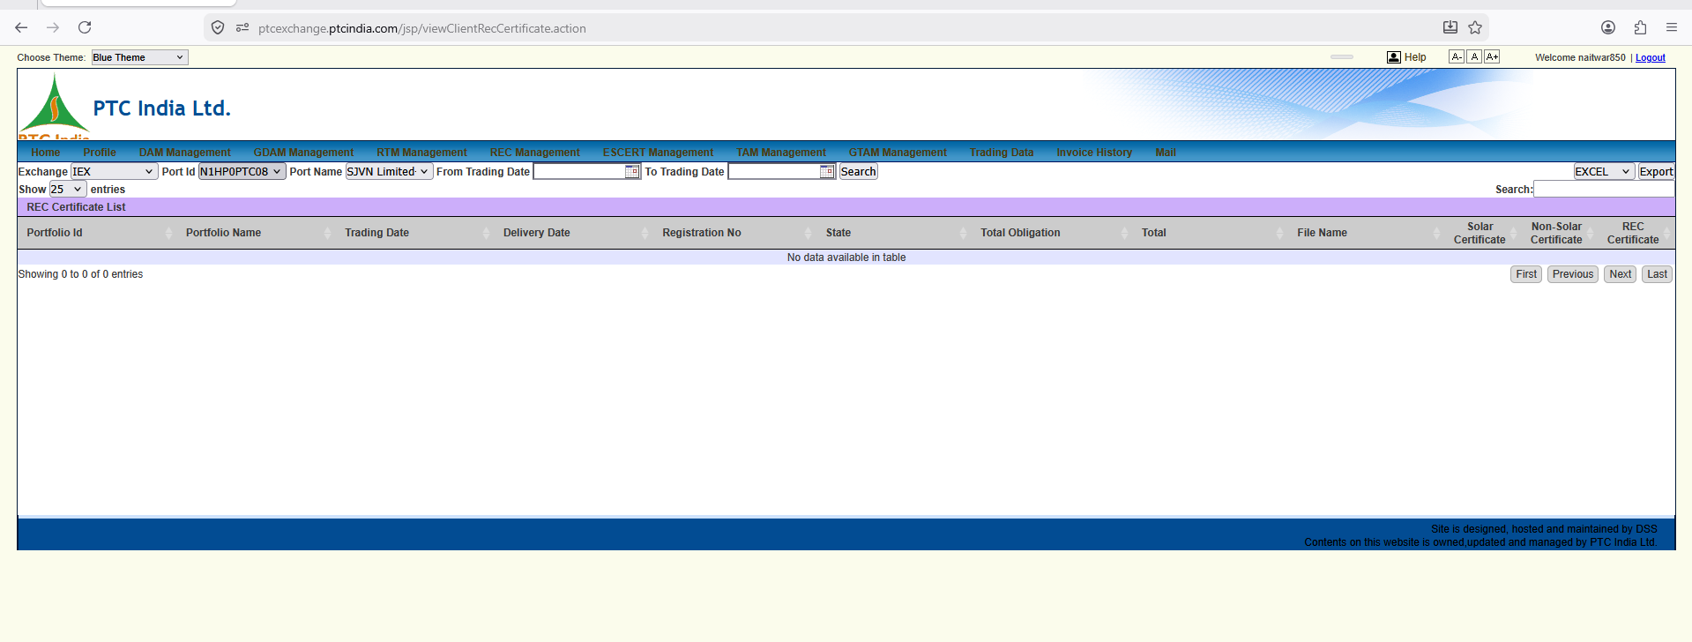

This screen shifts us into the REC (Renewable Energy Certificates) Management module on the PTC portal. Specifically, it displays the viewClientRecCertificate.action page (REC Certificate List / Registry Holdings).

1. Page Context & Domain Purpose
- URL Path: [ptcexchange.ptcindia.com/jsp/viewClientRecCertificate.action](https://ptcexchange.ptcindia.com/jsp/viewClientRecCertificate.action)
- Module Title Banner: REC Certificate List
- Active Top Menu Tab: REC Management
- Business Purpose: Central registry ledger for tracking Renewable Energy Certificates (RECs).

What are RECs (Renewable Purchase Obligation Context)?
- 1 REC = 1 MWh ($1,000\text{ kWh}$) of green power generated from accredited renewable sources (Solar, Wind, Small Hydro, Biomass).
- Obligated Entities (DISCOMs, Open Access consumers, Captive power plants) buy RECs on power exchanges (IEX/PXIL) to fulfill their statutory Renewable Purchase Obligation (RPO) targets set by State Electricity Regulatory Commissions (SERCs).
- Renewable energy generators (like SJVN's solar/wind projects) earn RECs when they sell physical power at conventional tariffs without bundled green attributes.

2. Granular UI Element Breakdown
+-----------------------------------------------------------------------------------------------------------------------------------+
| REC Certificate List |
| Exchange: [ IEX v ] Port Id: [ N1HP0PTC08 v ] Port Name: [ SJVN Limited- v ] From Trading Date: [ 📅 ] To Trading Date: [ 📅 ] |
| [ Search ] [ EXCEL v ] [ Export ] |
+-----------------------------------------------------------------------------------------------------------------------------------+
| Portfolio Id | Portfolio Name | Trading Date | Delivery Date | Registration No | State | Total Obligation | Total | File Name | Solar Certificate | Non-Solar Certificate | REC Certificate |
+-------------------------------------------------------------------------------------------------------------------------------------+
| No data available in table |
+-------------------------------------------------------------------------------------------------------------------------------------+

Control Panel & Table Schema Analysis
Control / Column | Options / Input | Business Domain Context & Operational Rule
Exchange Selector | Dropdown (IEX selected) | Power exchange where the REC auction session was conducted (IEX / PXIL).
Port Id / Port Name | Dropdowns (N1HP0PTC0850 / SJVN Limited...) | Mapped to the specific accredited renewable generation asset.
From / To Trading Date | Date Pickers (DD-MM-YYYY) | Filters certificate trading logs by specific exchange session dates.
Search Button | Action Trigger | Queries the database to populate the REC inventory grid.
Registration No | Text String | NLDC / CERC Registration Code. Official accreditation code assigned on the central REC Registry portal (recindia.in).
State | Text String | Physical state location of the generating station.
Total Obligation | Numeric Quantity (Units) | Total number of RECs traded ($1\text{ REC} = 1\text{ MWh}$).
Total | Amount in ₹ | Gross financial value ($\text{Traded RECs} \times \text{Exchange Market Clearing Price (MCP)}$).
File Name | File Link / String | Name of the raw exchange trading report file (.xls/.csv).
Solar Certificate | Action Link / Document | Legacy Category Filter/Link: Specifically tracks certificates issued to Solar power generators.
Non-Solar Certificate | Action Link / Document | Legacy Category Filter/Link: Tracks certificates issued to Wind, Hydro, or Biomass generators.
REC Certificate | Action Link / Icon | Direct link to view or download the official NLDC / POSOCO Certificate Transfer Slip.

3. Structural Comparison: RECs vs. ESCerts
Understanding these nuances is key for designing our unified certificate management backend:
- Volume Units:
  - RECs: Billed directly in MWh ($1\text{ REC} = 1\text{ MWh}$).
  - ESCerts: Billed in mtoe (metric tonnes of oil equivalent).
- Category Classifications:
  - Notice the explicit distinction between Solar Certificate and Non-Solar Certificate columns. While recent CERC regulations have merged REC categories into a unified fungible certificate framework, historical logs and compliance reporting still require tracking generation tech origin (Solar vs Non-Solar / Hydro).

4. UI Patterns for Our React Terminal
- Combined Certificate Inventory & RPO Compliance Desk (/trading/certificates/rec):
  - Rather than separate sparse tables, present an interactive dashboard card above the grid:
    - ☀️ Solar RECs Held: X Units
    - 💨 Non-Solar / Hydro RECs Held: Y Units
    - 💰 IEX Clearing Price (MCP): ₹ Z / REC
- Automated NLDC Registry Sync:
  - Build a background sync worker that polls the central REC Registry API (recindia.in) to verify holding balances automatically before trading desk users place sell bids on exchange terminals.

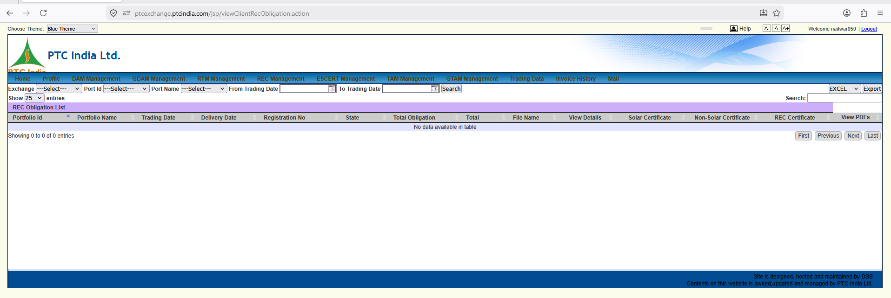

This view represents the viewClientRecObligation.action portal page, which serves as the REC Obligation List / Financial Clearing Archive.

1. Page Context & How It Fits Into the REC Suite
- URL Path: [ptcexchange.ptcindia.com/jsp/viewClientRecObligation.action](https://ptcexchange.ptcindia.com/jsp/viewClientRecObligation.action)
- Module Title Banner: REC Obligation List
- Active Top Menu Tab: REC Management
- Role in the 3-Tier Certificate Pattern:
  - viewClientRecCertificate.action (Previous Turn): Registry Inventory & Holding List (Tracking accredited RECs held/transferred).
  - This Screen (viewClientRecObligation.action): Exchange Financial Clearing & Settlement Archive (Tracking cleared exchange volumes, gross revenues, fees, and PDF obligation reports).
  - viewClientRecInvoice.action (Next logical sub-module): Commercial Tax Ledger (Handling trading margins, GST splits, and net billing vouchers).

2. Granular UI Element Breakdown
+-----------------------------------------------------------------------------------------------------------------------------------+
| REC Obligation List |
| Exchange: [ ---Select--- v ] Port Id: [ ---Select--- v ] Port Name: [ ---Select--- v ] From Trading Date: [ 📅 ] To Trading Date: [ 📅 ] |
| [ Search ] [ EXCEL v ] [ Export ] |
+-----------------------------------------------------------------------------------------------------------------------------------+
| Portfolio Id | Portfolio Name | Trading Date | Delivery Date | Registration No | State | Total Obligation | Total | File Name | View Details | Solar Certificate | Non-Solar Certificate | REC Certificate | View PDFs |
+-------------------------------------------------------------------------------------------------------------------------------------+
| No data available in table |
+-------------------------------------------------------------------------------------------------------------------------------------+

Control Panel & Table Schema Analysis
Control / Column | Options / Input | Business Domain Context & Operational Rule
Exchange Selector | Dropdown (---Select--- / IEX, PXIL) | Selects the power exchange where the REC auction clearing occurred.
Port Id / Port Name | Dropdowns (N1HP0PTC0850 / SJVN Limited...) | Mapped to the specific accredited renewable generation asset/portfolio.
From / To Trading Date | Date Pickers (DD-MM-YYYY) | Filters clearing records by specific exchange auction session dates.
Search Button | Action Trigger | Queries the database to populate the REC obligation ledger.
Export Options | Dropdown (EXCEL) + Export | Bulk exports the obligation ledger into Excel format.
Registration No | Text String | Official NLDC / CERC Accreditation Code assigned on the central REC Registry (recindia.in).
Total Obligation | Numeric Quantity (Units) | Number of RECs Cleared ($1\text{ REC} = 1\text{ MWh}$) during the auction session.
Total | Amount in ₹ | Gross Financial Clearing Realization ($\text{REC Volume} \times \text{Auction Market Clearing Price (MCP)}$).
File Name | File Link / String | Raw exchange settlement statement filename (.xls/.csv).
View Details | Action Icon (📄) | Opens an in-app modal displaying fee breakdowns (Exchange transaction fees, trading margin, GST).
Solar / Non-Solar Certificate | Document Links / Action Icons | Category-specific verification links linking back to tech-origin accreditation records.
REC Certificate | Action Link / Icon | Direct link to download the official NLDC / POSOCO Transfer Approval Slip.
View PDFs | Action Icon (💻/📄) | Direct link to view or download the official signed IEX/PXIL obligation PDF voucher.

3. Structural Comparison: REC vs. ESCERT Obligation Grids
Notice how the table schema for REC Obligations (viewClientRecObligation.action) perfectly mirrors ESCERT Obligations (viewClientEscertObligation.action) with one critical domain exception:
- ESCERT Obligation Grid: Tracks single aggregated ESCERT Certificate transfer slips (measured in mtoe).
- REC Obligation Grid: Explicitly incorporates columns for Solar Certificate and Non-Solar Certificate alongside the unified REC Certificate link.
  - Domain Purpose: While current regulations allow fungible trading across RECs, historical accounting for DISCOM compliance mandates tracking whether the purchased attributes fulfill Solar RPO or Non-Solar / Hydro RPO quotas.

4. Architectural Requirements for SJVN Platform
- Unified Certificate Clearing Engine:
  - In our FastAPI backend, we can use a single certificate_settlements table that handles both RECs and ESCerts with a certificate_type discriminator column (REC_SOLAR, REC_NONSOLAR, REC_HYDRO, ESCERT).
- Double-Voucher Linkage:
  - Each row must maintain dual foreign-key references:
    - exchange_pdf_url: Points to the official IEX/PXIL financial clearing voucher (View PDFs).
    - registry_slip_url: Points to the central NLDC/POSOCO ownership transfer slip (REC Certificate).

5. UI Patterns for Our React Terminal
- Dual Voucher Action Cell:
  - Combine actions into a sleek inline button group:
[ 📄 Exchange PDF ] | [ 📜 NLDC Transfer Slip ] | [ 🔍 Breakup ]
- RPO Allocation Tagging Tooltip:
  - Hovering over the Total Obligation cell shows how the cleared volume maps to SJVN's internal or client RPO fulfillment targets.

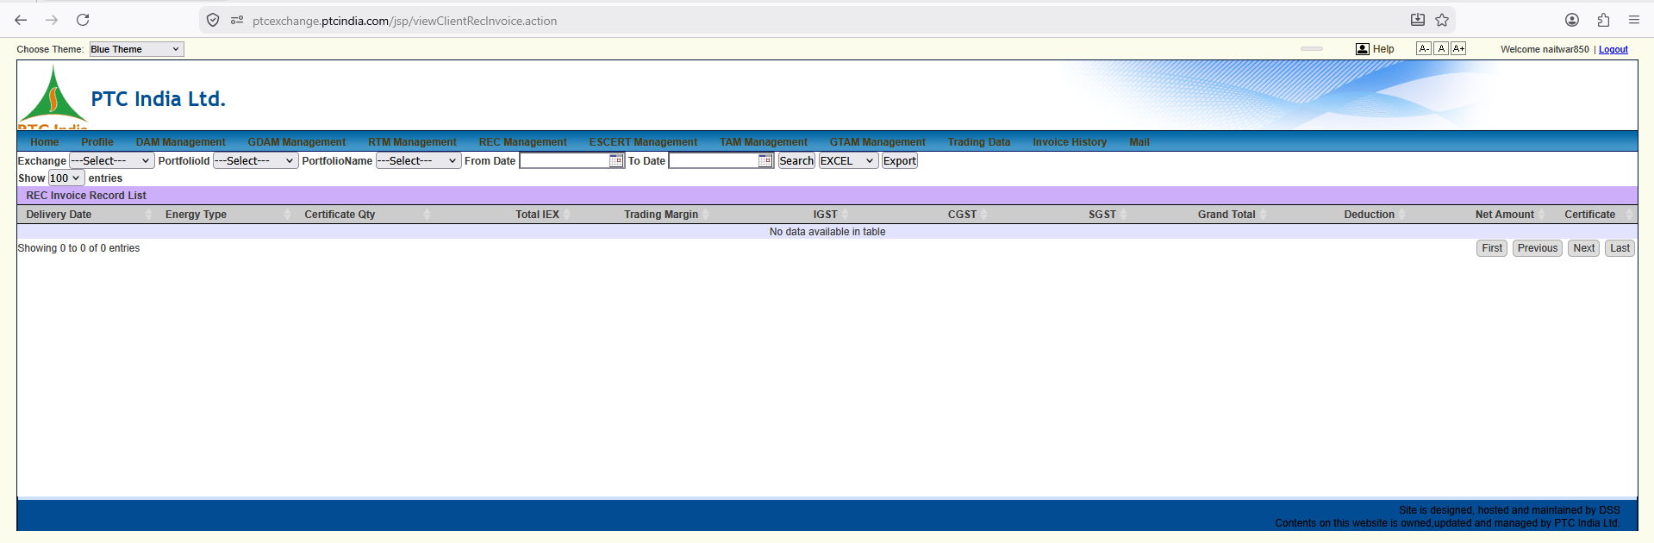

This view completes the REC (Renewable Energy Certificates) suite on the PTC portal, displaying the viewClientRecInvoice.action page (REC Invoice Record List / Commercial Tax Ledger).

1. Page Context & Position in the REC Module Suite
- URL Path: [ptcexchange.ptcindia.com/jsp/viewClientRecInvoice.action](https://ptcexchange.ptcindia.com/jsp/viewClientRecInvoice.action)
- Module Title Banner: REC Invoice Record List
- Active Top Menu Tab: REC Management
- Role in the 3-Tier REC Pattern:
  - viewClientRecCertificate.action: Inventory & Holding Registry (Tracking accredited RECs held/transferred).
  - viewClientRecObligation.action: Exchange Clearing Statement (Gross exchange clearing values & PDFs).
  - This Screen (viewClientRecInvoice.action): Tax & Commercial Billing Ledger (Handling tax deductions, PTC trading margins, GST splits, and net billing vouchers for SAP GL entries).

2. Granular UI Element Breakdown
+------------------------------------------------------------------------------------------------------------------------------------+
| REC Invoice Record List |
| Exchange: [ ---Select--- v ] PortfolioId: [ ---Select--- v ] PortfolioName: [ ---Select--- v ] From Date: [ 📅 ] To Date: [ 📅 ] |
| [ Search ] [ EXCEL v ] [ Export ] |
+------------------------------------------------------------------------------------------------------------------------------------+
| Delivery Date | Energy Type | Certificate Qty | Total IEX | Trading Margin | IGST | CGST | SGST | Grand Total | Deduction | Net Amount | Certificate |
+------------------------------------------------------------------------------------------------------------------------------------+
| No data available in table |
+------------------------------------------------------------------------------------------------------------------------------------+

Control Panel & Table Schema Analysis
Control / Column | Input Options | Business Domain Context & Operational Rule
Exchange Selector | Dropdown (---Select--- / IEX, PXIL) | Filters tax invoices by the power exchange executing the auction.
PortfolioId / Name | Dropdowns (N1HP0PTC0850 / SJVN Limited...) | Mapped to the specific accredited renewable generation asset.
From / To Date | Date Pickers (DD-MM-YYYY) | Filters invoices by billing / auction settlement period.
Delivery Date | Date String | The official settlement/transfer date of the traded RECs.
Energy Type | Text Label (e.g., Solar / Non-Solar / Hydro / Biomass) | Categorizes the specific renewable energy source classification.
Certificate Qty | Numeric Quantity | Total number of RECs billed ($1\text{ REC} = 1\text{ MWh}$).
Total IEX | Amount in ₹ | Gross market clearing value ($\text{Certificate Qty} \times \text{MCP}$).
Trading Margin | Amount in ₹ | Brokerage fee charged by PTC India Ltd. for executing the auction on behalf of SJVN.
IGST / CGST / SGST | Amounts in ₹ | Tax Split Breakdown: 18% GST applied strictly to service fees (Trading Margin & Exchange Fees), split into IGST (inter-state) or CGST+SGST (intra-state).
Grand Total | Amount in ₹ | $\text{Gross Market Value} + \text{Trading Margin} + \text{Total GST}$.
Deductions | Amount in ₹ | Adjustments for NLDC/POSOCO registry transfer fees or exchange transaction charges.
Net Amount | Amount in ₹ | Final Net Receivable/Payable: Payout transferred to SJVN's bank account after fee and tax adjustments.
Certificate | Action Link / Icon | Direct link to view or download the linked commercial tax invoice PDF / NLDC transfer slip.

3. Structural Synergy: Complete Parity Across Certificate & Bilateral Modules
Notice how PTC India uses the exact same underlying HTML grid table structure across all four commercial tax invoice modules on the platform:
- TAM Invoices (viewClientTamInvoice.action)
- GTAM Invoices (viewClientTamInvoice.action?tr=GTAM)
- ESCERT Invoices (viewClientEscertInvoice.action)
- REC Invoices (viewClientRecInvoice.action)

Common Financial Formula Shared Across All Four:
$$\text{Net Amount} = (\text{Total IEX} + \text{Trading Margin} + \text{GST}) - \text{Deductions} - \text{TDS}$$

4. Architectural Implementation for Our SJVN Platform
In our React + FastAPI architecture, we can leverage this consistency:
- Unified Invoice REST API (/api/v1/billing/invoices):
  - A single endpoint that takes a market_segment query parameter:
    - TAM
    - GTAM
    - ESCERT
    - REC
- Single Reusable React Data Table Component (<TaxInvoiceLedgerTable/>):
  - Renders the standard columns (Delivery Date, Quantity, Gross Revenue, Trading Margin, Tax Breakdown, Net Payout) dynamically based on the active market tab.
- ERP / SAP FI Posting Button:
  - Provide a [ ⚡ Generate SAP Journal Entry ] button directly above the table to auto-post the month's cleared invoices into SJVN's SAP ERP financial ledger.

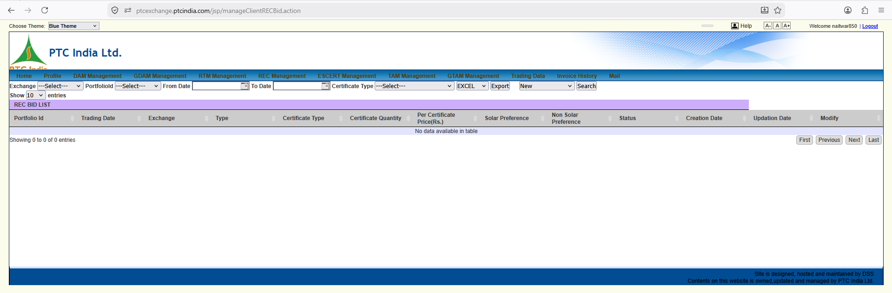

This view completes the REC (Renewable Energy Certificates) suite on the PTC portal, displaying the viewClientRecInvoice.action page (REC Invoice Record List / Commercial Tax Ledger).

1. Page Context & Position in the REC Module Suite
- URL Path: [ptcexchange.ptcindia.com/jsp/viewClientRecInvoice.action](https://ptcexchange.ptcindia.com/jsp/viewClientRecInvoice.action)
- Module Title Banner: REC Invoice Record List
- Active Top Menu Tab: REC Management
- Role in the 3-Tier REC Pattern:
  - viewClientRecCertificate.action: Inventory & Holding Registry (Tracking accredited RECs held/transferred).
  - viewClientRecObligation.action: Exchange Clearing Statement (Gross exchange clearing values & PDFs).
  - This Screen (viewClientRecInvoice.action): Tax & Commercial Billing Ledger (Handling tax deductions, PTC trading margins, GST splits, and net billing vouchers for SAP GL entries).

2. Granular UI Element Breakdown
+------------------------------------------------------------------------------------------------------------------------------------+
| REC Invoice Record List |
| Exchange: [ ---Select--- v ] PortfolioId: [ ---Select--- v ] PortfolioName: [ ---Select--- v ] From Date: [ 📅 ] To Date: [ 📅 ] |
| [ Search ] [ EXCEL v ] [ Export ] |
+------------------------------------------------------------------------------------------------------------------------------------+
| Delivery Date | Energy Type | Certificate Qty | Total IEX | Trading Margin | IGST | CGST | SGST | Grand Total | Deduction | Net Amount | Certificate |
+------------------------------------------------------------------------------------------------------------------------------------+
| No data available in table |
+------------------------------------------------------------------------------------------------------------------------------------+

Control Panel & Table Schema Analysis
Control / Column | Input Options | Business Domain Context & Operational Rule
Exchange Selector | Dropdown (---Select--- / IEX, PXIL) | Filters tax invoices by the power exchange executing the auction.
PortfolioId / Name | Dropdowns (N1HP0PTC0850 / SJVN Limited...) | Mapped to the specific accredited renewable generation asset.
From / To Date | Date Pickers (DD-MM-YYYY) | Filters invoices by billing / auction settlement period.
Delivery Date | Date String | The official settlement/transfer date of the traded RECs.
Energy Type | Text Label (e.g., Solar / Non-Solar / Hydro / Biomass) | Categorizes the specific renewable energy source classification.
Certificate Qty | Numeric Quantity | Total number of RECs billed ($1\text{ REC} = 1\text{ MWh}$).
Total IEX | Amount in ₹ | Gross market clearing value ($\text{Certificate Qty} \times \text{MCP}$).
Trading Margin | Amount in ₹ | Brokerage fee charged by PTC India Ltd. for executing the auction on behalf of SJVN.
IGST / CGST / SGST | Amounts in ₹ | Tax Split Breakdown: 18% GST applied strictly to service fees (Trading Margin & Exchange Fees), split into IGST (inter-state) or CGST+SGST (intra-state).
Grand Total | Amount in ₹ | $\text{Gross Market Value} + \text{Trading Margin} + \text{Total GST}$.
Deductions | Amount in ₹ | Adjustments for NLDC/POSOCO registry transfer fees or exchange transaction charges.
Net Amount | Amount in ₹ | Final Net Receivable/Payable: Payout transferred to SJVN's bank account after fee and tax adjustments.
Certificate | Action Link / Icon | Direct link to view or download the linked commercial tax invoice PDF / NLDC transfer slip.

3. Structural Synergy: Complete Parity Across Certificate & Bilateral Modules
Notice how PTC India uses the exact same underlying HTML grid table structure across all four commercial tax invoice modules on the platform:
- TAM Invoices (viewClientTamInvoice.action)
- GTAM Invoices (viewClientTamInvoice.action?tr=GTAM)
- ESCERT Invoices (viewClientEscertInvoice.action)
- REC Invoices (viewClientRecInvoice.action)

Common Financial Formula Shared Across All Four:
$$\text{Net Amount} = (\text{Total IEX} + \text{Trading Margin} + \text{GST}) - \text{Deductions} - \text{TDS}$$

4. Architectural Implementation for Our SJVN Platform
In our React + FastAPI architecture, we can leverage this consistency:
- Unified Invoice REST API (/api/v1/billing/invoices):
  - A single endpoint that takes a market_segment query parameter:
    - TAM
    - GTAM
    - ESCERT
    - REC
- Single Reusable React Data Table Component (<TaxInvoiceLedgerTable/>):
  - Renders the standard columns (Delivery Date, Quantity, Gross Revenue, Trading Margin, Tax Breakdown, Net Payout) dynamically based on the active market tab.
- ERP / SAP FI Posting Button:
  - Provide a [ ⚡ Generate SAP Journal Entry ] button directly above the table to auto-post the month's cleared invoices into SJVN's SAP ERP financial ledger.

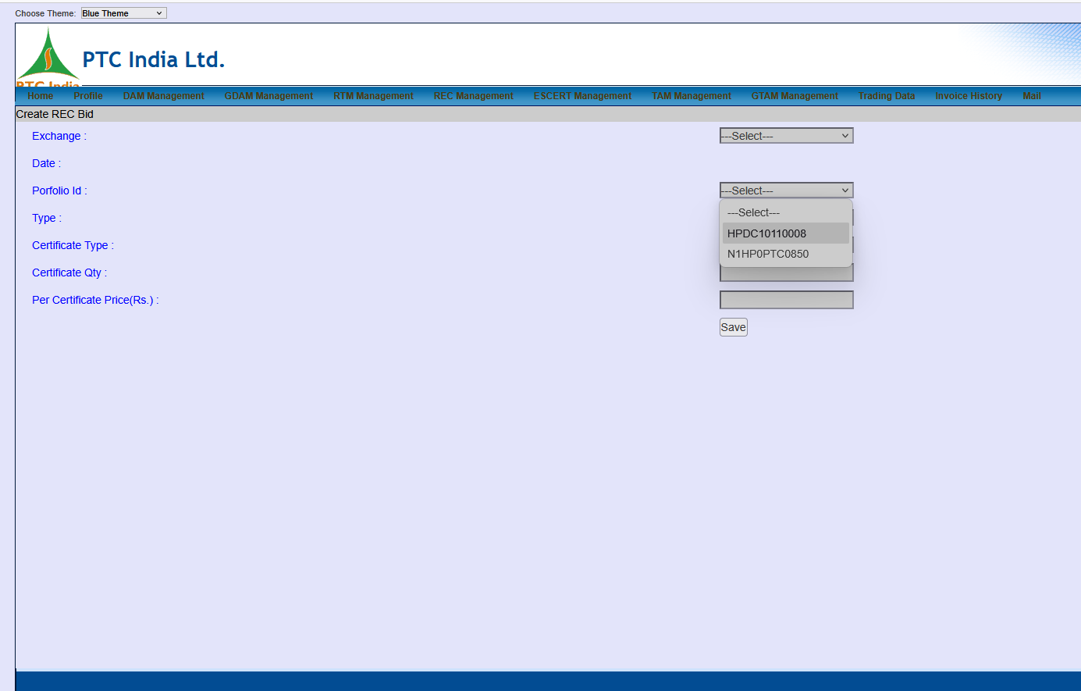
Here is the granular, element-by-element breakdown of this new screenshot (image_5a9713.png).
This view shows the Create REC Bid Form (Create REC Bid), providing a key operational detail—the active Portfolio ID Dropdown Options!

1. Page Context & Functional Purpose
- Module Title Banner: Create REC Bid
- Active Top Menu Tab: REC Management
- Business Purpose: Central order-entry form used by trading desks to submit limit orders (buy or sell) for Renewable Energy Certificate (REC) trading sessions on power exchanges (IEX/PXIL).

2. Granular Form Breakdown & Portfolio Options Discovered
+------------------------------------------------------------------------------------+
| Create REC Bid |
| |
| Exchange : [ ---Select--- v ] |
| Date : |
| Porfolio Id : [ ---Select--- v ] |
| | HPDC10110008 | |
| | N1HP0PTC0850 | |
| +------------------------------------+ |
| Type : [ v ] |
| Certificate Type : [ v ] |
| Certificate Qty : [ ] |
| Per Certificate Price(Rs.) : [ ] |
| [ Save ] |
+------------------------------------------------------------------------------------+

Portfolio ID Options Analysis:
The expanded dropdown reveals two specific asset portfolio identifiers mapped to this account:
- N1HP0PTC0850:
  - Asset Mapped: SJVN's Naitwar Mori Hydroelectric Project (60 MW) located in Himachal Pradesh/Uttarakhand border area.
  - Domain Context: Accredited hydro asset eligible for Hydro REC / Non-Solar REC trading.
- HPDC10110008:
  - Asset Mapped: Designated Entity / Regional Asset Code (likely mapped to Himachal Pradesh State Load Despatch Centre / DISCOM client context or another specific SJVN renewable plant).

Form Field Schema & Constraints:
Field Label | Field Type | Business & Validation Logic
Exchange | Dropdown | Target exchange (IEX / PXIL).
Date | Date Picker | Specific monthly/periodic REC trading session date.
Portfolio Id | Dropdown | Selects the specific accredited renewable generation portfolio (N1HP0PTC0850 / HPDC10110008).
Type | Dropdown | Order Direction (BUY vs SELL).
Certificate Type | Dropdown | Classification category (Solar REC, Non-Solar REC, Hydro REC).
Certificate Qty | Text Input (Integer) | Volume of certificates to trade ($1\text{ REC} = 1\text{ MWh}$).
Per Certificate Price(Rs.) | Text Input (Decimal) | Limit price entered in ₹ per REC (subject to CERC floor/forbearance price bands).
Save Button | Action Button | Stores the draft bid into PTC's staging database prior to exchange submission.

3. UI/UX Refinement Patterns for Our React Terminal
- Auto-Populating Asset Context:
  - When selecting N1HP0PTC0850, auto-fill and display the plant details alongside the form:
  - [ Asset: Naitwar Mori HEP | Tech: Hydro (60 MW) | Accredited RECs Available: 1,250 ]
- Real-time Price Band Guardrails:
  - Embed dynamic price validation logic based on CERC regulations: flag an instant warning if the entered Per Certificate Price(Rs.) falls outside official CERC floor/cap limits.
- Order Value Calculation Card:
  - Display a live summary before saving:
  - $$\text{Total Capital Commitment} = \text{Certificate Qty} \times \text{Price per REC} + \text{Estimated Fees \& 18\% GST}

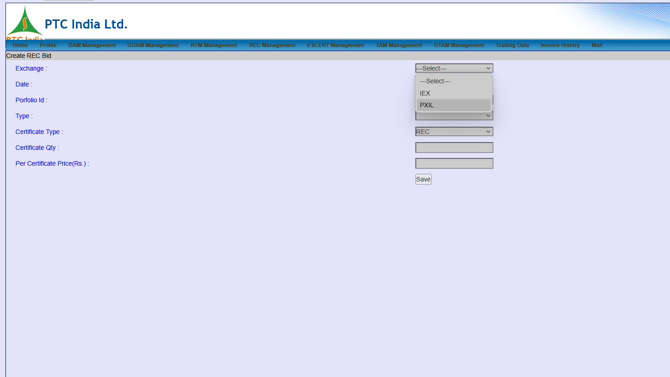

This new screenshot builds directly upon the previous Create REC Bid form by expanding the Exchange Dropdown Options!

1. Page Context & Functional Detail Discovered
- Module Title Banner: Create REC Bid
- Active Top Menu Context: REC Management
- Key Interaction Highlight: The user has clicked open the Exchange dropdown list on the order-entry form.

2. Granular Form Breakdown & Dropdown Options
+------------------------------------------------------------------------------------+
| Create REC Bid |
| |
| Exchange : [ ---Select--- v ] |
| | ---Select--- | |
| | IEX | |
| | PXIL | |
| +------------------------------------+ |
| Date : |
| Porfolio Id : [ ---Select--- v ] |
| Type : [ v ] |
| Certificate Type : [ REC v ] |
| Certificate Qty : [ ] |
| Per Certificate Price(Rs.) : [ ] |
| [ Save ] |
+------------------------------------------------------------------------------------+

Options & Exchange Market Analysis:
Exchange Option | Full Name | Market Role & Trading Context
IEX | Indian Energy Exchange | Primary Liquidity Market. Dominates the lion's share of monthly REC auction volumes in India.
PXIL | Power Exchange India Limited | Alternative Trading Venue. Secondary exchange offering competitive clearing for bilateral/certificate auctions.

3. Structural Observations Across Bid Forms
- Exchange Support Scope:
  - While physical power markets (DAM, GDAM, TAM) are increasingly expanding to HPX (Hindustan Power Exchange), certificate trading in this portal defaults strictly to IEX and PXIL.
- Default Certificate Classification:
  - Notice that the Certificate Type field defaults to REC on this screen, whereas on the ESCert form analyzed earlier (image_5aaa37.png), it defaulted to ESCERT.

4. UI/UX Refinement Patterns for Our React Terminal
- Multi-Exchange Parallel Bidding:
  - Rather than making traders submit separate forms for IEX and PXIL, allow entering a split order:
[ Submit 60% Volume to IEX ] + [ Submit 40% Volume to PXIL ]
- Real-time Exchange Market Depth Indicator:
  - Render an inline widget next to the exchange selection showing historical clearing liquidity (e.g., Last Month's Cleared Volume: IEX = 85,000 RECs vs PXIL = 12,000 RECs).
- Smart Routing Engine:
  - Provide an "Auto-Select Exchange" toggle that routes the REC bid to whichever exchange offers higher execution probabilities based on historical order-book depth.

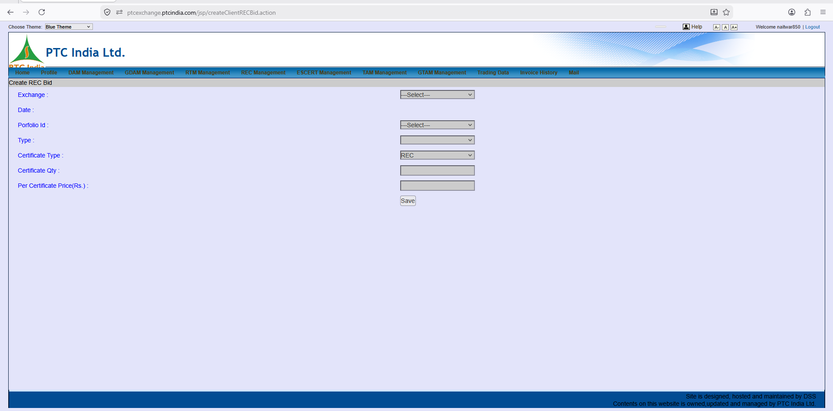

Here is the granular breakdown of this screenshot (image_5a3df4.png).
This view shows the un-collapsed, default state of the createClientRECBid.action page (Create REC Bid Form).

1. Page Context & Operational Purpose
- URL Path: [ptcexchange.ptcindia.com/jsp/createClientRECBid.action](https://ptcexchange.ptcindia.com/jsp/createClientRECBid.action)
- Module Title Banner: Create REC Bid
- Active Top Context: Order-entry form under REC Management
- Business Purpose: This is the default blank state of the bid submission form used by traders to place buy or sell limit orders for Renewable Energy Certificates (RECs) prior to monthly/periodic power exchange gate closure.

2. Granular Form Field Breakdown
+------------------------------------------------------------------------------------+
| Create REC Bid |
| |
| Exchange : [ ---Select--- v ] |
| Date : |
| Porfolio Id : [ ---Select--- v ] |
| Type : [ v ] |
| Certificate Type : [ REC v ] |
| Certificate Qty : [ ] |
| Per Certificate Price(Rs.) : [ ] |
| [ Save ] |
+------------------------------------------------------------------------------------+

Complete Schema & Input Specifications:
Form Field Label | Control Type | Input / Options Range | Domain Rule & System Constraints
Exchange | Dropdown | IEX, PXIL | Specifies target exchange venue for order routing.
Date | Date Field / Picker | DD-MM-YYYY | Auction session date for execution.
Portfolio Id | Dropdown | N1HP0PTC0850, HPDC10110008 | Selects accredited asset/portfolio registered with NLDC.
Type | Dropdown | BUY, SELL | Order direction (Buy for compliance vs Sell for realization).
Certificate Type | Dropdown | REC (Default) | Attribute category (Solar, Non-Solar, Hydro).
Certificate Qty | Text Field (Integer) | Numeric units | Quantity of RECs ($1\text{ REC} = 1\text{ MWh}$).
Per Certificate Price(Rs.) | Text Field (Decimal) | Price in ₹ | Maximum buying price or minimum selling limit price per certificate.
Save Button | Action Button | Form Submission | Validates form data and commits the bid entry to the database.

3. Structural Comparison Across Portal Bidding Forms
Comparing all bidding screens analyzed across the portal (DAM, GDAM, ESCERT, REC):
- Volume Units:
  - DAM / GDAM / RTM: Billed in MW per 15-minute block across a 96-block schedule matrix.
  - ESCERT Bids: Single aggregate volume billed in mtoe units.
  - REC Bids: Single aggregate volume billed in Certificates (MWh).
- Price Structure:
  - Physical Power (DAM): Single or step-wise price-quantity curves.
  - Certificates (REC/ESCERT): Single limit price per certificate ($₹/\text{REC}$ or $₹/\text{ESCert}$), bound by regulatory floor/cap price bands set by CERC/BEE.

4. UI Patterns for Our React Terminal
- Interactive Order Preview Card:
  - Render a dynamic summary card next to the inputs that updates as the trader types:
    - Contract Volume: $X\text{ RECs}$ ($X\text{ MWh}$ equivalent)
    - Capital Outlay / Yield: $₹ (X \times \text{Limit Price})$
    - Estimated Exchange Fees & GST: $₹ \text{Calculated Fee}$
- Form Auto-Validation:
  - Disable the Save button until all required fields (Exchange, Portfolio Id, Type, Qty, Price) pass client-side regex and numeric range validations.
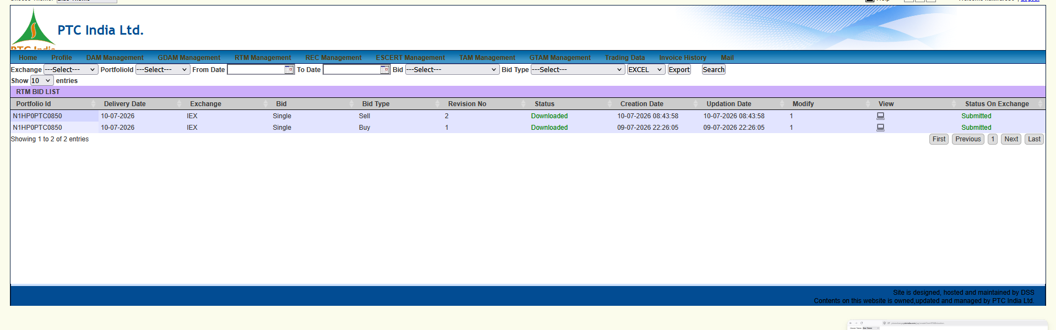

Here is the granular, element-by-element breakdown of this new screenshot (image_5a3d59.png).
This view shifts us into another critical continuous trading segment on the PTC portal: RTM (Real-Time Market) Bid Management (RTM BID LIST).

1. Page Context & Operational Purpose
- URL Path / Action: manageClientRTMBid.action (inferred from RTM BID LIST title)
- Module Title Banner: RTM BID LIST
- Active Top Menu Tab: RTM Management
- Business Purpose: Central active workspace for tracking real-time market bids submitted to power exchanges.

What is RTM (Real-Time Market)?
- Execution Dynamics: RTM operates in half-hourly bidding sessions conducted 48 times a day (every 30 minutes).
- Delivery Window: Power delivery happens 1 hour after gate closure (e.g., gate closes at 12:00 PM for delivery during 01:00 PM – 01:30 PM).
- Grid Balancing Context: SJVN hydro assets (like Naitwar Mori) use RTM to dynamically re-balance schedule deviations, sell un-cleared surplus generation, or cover unexpected generation drops in near real-time.

2. Granular UI Element Breakdown
+-------------------------------------------------------------------------------------------------------------------------------------+
| RTM BID LIST |
| Exchange: [---Select--- v] PortfolioId: [---Select--- v] From Date: [ 📅 ] To Date: [ 📅 ] Bid: [---Select--- v] Bid Type: [---Select--- v] |
| [ EXCEL v ] [ Export ] [ Search ] |
+-------------------------------------------------------------------------------------------------------------------------------------+
| Portfolio Id | Delivery Date | Exchange | Bid | Bid Type | Revision No | Status | Creation Date | Updation Date | Modify | View | Status On Exchange |
+--------------+---------------+----------+--------+----------+-------------+------------+---------------------+---------------------+--------+------+--------------------+
| N1HP0PTC0850 | 10-07-2026 | IEX | Single | Sell | 2 | Downloaded | 10-07-2026 08:43:58 | 10-07-2026 08:43:58 | 1 | 💻 | Submitted |
| N1HP0PTC0850 | 10-07-2026 | IEX | Single | Buy | 1 | Downloaded | 09-07-2026 22:26:05 | 09-07-2026 22:26:05 | 1 | 💻 | Submitted |
+-------------------------------------------------------------------------------------------------------------------------------------+

Data Grid Breakdown & Active Record Analysis
Column | Value Row 1 | Value Row 2 | Operational Domain Meaning
Portfolio Id | N1HP0PTC0850 | N1HP0PTC0850 | SJVN's Naitwar Mori HEP (60 MW) asset.
Delivery Date | 10-07-2026 | 10-07-2026 | Physical power delivery date.
Exchange | IEX | IEX | Indian Energy Exchange RTM market segment.
Bid | Single | Single | Bid Structure Category: Single-block order (as opposed to Block / Combination Bids).
Bid Type | Sell | Buy | Direction: Row 1 is a Generation Offload (Sell) order; Row 2 is a Deficit Coverage (Buy) order.
Revision No | 2 | 1 | Revision Iteration Tracker. Indicates how many times the bid profile was edited prior to gate closure.
Status | Downloaded | Downloaded | PTC internal processing status (Bid file generated/fetched by automated trader gateway).
Creation Date | 10-07-2026 08:43:58 | 09-07-2026 22:26:05 | Timestamp when the bid was drafted/submitted.
Updation Date | 10-07-2026 08:43:58 | 09-07-2026 22:26:05 | Timestamp of the last revision update.
Modify | 1 | 1 | Action trigger / edit count remaining for the session.
View | 💻 (Screen Icon) | 💻 (Screen Icon) | Modal popup to inspect the 15-minute / 30-minute block MW & price curve.
Status On Exchange | Submitted | Submitted | Exchange Gateway Confirmation: Final confirmation that the bid was successfully injected into IEX's clearing system.

3. Crucial Domain Discoveries in RTM Bidding
- Intraday Dual-Direction Trading (Buy & Sell):
  - Notice that the same asset (N1HP0PTC0850) submitted both a Buy bid on 09-07-2026 22:26 and a Sell bid on 10-07-2026 08:43.
  - Domain Context: RTM allows dynamic flexibility. If river inflows drop unexpectedly at night, SJVN buys RTM power to avoid under-injection penalties under DSM (Deviation Settlement Mechanism). Conversely, when daytime inflows surge, SJVN sells extra hydro power in RTM!
- Revision Number Control (Revision No: 2):
  - Real-time trading requires continuous adjustments as weather/water forecasts change right up until gate closure. Tracking explicit Revision Numbers ensures strict audit compliance.

4. UI Patterns for Our React Terminal
- Real-time 30-Min Session Countdown Badge:
  - Render an active pulse indicator showing the open RTM session window:
[ 🟢 Session RTM-18 Open | Gate Closes In: 08m 42s ]
- Live Exchange Order Sync Indicator:
  - Highlight the status badge dynamically:
    - 🟢 Submitted to Exchange (Acknowledged by IEX API)
    - 🟡 Pending Gateway (Queued in FastAPI worker)
    - 🔴 Rejected by Exchange (Price/Quantity boundary error)

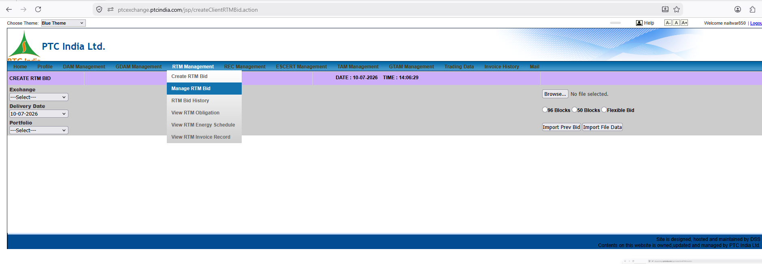

This view captures two core operational elements simultaneously:
- The createClientRTMBid.action workspace in the background (Create RTM Bid Form).
- The expanded RTM Management Sub-Menu Options in the foreground dropdown.

1. Background Workspace: Create RTM Bid Controls
- URL Path: [ptcexchange.ptcindia.com/jsp/createClientRTMBid.action](https://ptcexchange.ptcindia.com/jsp/createClientRTMBid.action)
- Module Title Banner: CREATE RTM BID
- Live Session Clock: DATE : 10-07-2026 | TIME : 14:06:29
- Business Purpose: This is the entry form used by traders to build and upload 15-minute time-block price/quantity bids specifically for Real-Time Market (RTM) sessions.

Granular Form Field & File Upload Controls
+------------------------------------------------------------------------------------------------------------------------------------+
| CREATE RTM BID DATE : 10-07-2026 TIME : 14:06:29 |
| Exchange: [ ---Select--- v ] |
| Delivery Date: [ 10-07-2026 v ] [ Browse... ] No file selected. |
| Portfolio: [ ---Select--- v ] (o) 96 Blocks ( ) 50 Blocks ( ) Flexible Bid|
| [ Import Prev Bid ] [ Import File Data ] |
+------------------------------------------------------------------------------------------------------------------------------------+

Field / Control | Input Options / Type | Operational Domain Meaning
Exchange | Dropdown (IEX / PXIL / HPX) | Power exchange where the real-time bid is targeted.
Delivery Date | Dropdown (10-07-2026 selected) | Targeted physical delivery date.
Portfolio | Dropdown (N1HP0PTC0850 / etc.) | The generation asset submitting the bid profile.
Browse... File Upload | File Selector | Allows uploading pre-formatted CSV/Excel bid matrices.
Block Format Options | Radio Buttons:  • 96 Blocks (Default)  • 50 Blocks  • Flexible Bid | RTM Format Selector:  • 96 Blocks: Full 24-hour daily schedule broken into 15-minute intervals.  • 50 Blocks / Flexible: Specific intraday session windows for half-hourly RTM clearing.
Import Prev Bid | Action Button | Copies the previous day's or previous session's bid matrix to save time during fast-paced intraday trading.
Import File Data | Action Button | Parses the uploaded CSV file and populates the bid table below.

2. Foreground Sub-Menu: RTM Management Suite
The user has hovered over/clicked the RTM Management tab, revealing its complete sub-menu options:
+---------------------------+
| RTM Management |
+---------------------------+
| Create RTM Bid |
| Manage RTM Bid |
| RTM Bid History |
| View RTM Obligation |
| View RTM Energy Schedule |
| View RTM Invoice Record |
+---------------------------+

Complete Breakdown of RTM Menu Options & Platform Mapping
This sub-menu reveals the entire lifecycle for Real-Time Market (RTM) trading:
Menu Item | Business Purpose | Platform Module Mapping
Create RTM Bid | Order-entry workspace for submitting intraday 15-minute time-block bids. | RTM Bidding Terminal (/rtm/bidding/create)
Manage RTM Bid | Active workspace to inspect, edit, or cancel un-cleared RTM bids before session gate closure. | RTM Active Console (/rtm/bidding/manage)
RTM Bid History | Historical log of all past submitted RTM bids, revisions, and exchange statuses. | RTM Audit Log (/rtm/bidding/history)
View RTM Obligation | Displays cleared trade volumes, gross realizations, and exchange fees for RTM sessions. | Financial Clearing (/rtm/settlement/obligation)
View RTM Energy Schedule | Displays 15-minute physical delivery schedules resulting from cleared RTM trades. | Physical Scheduling (/rtm/scheduling/schedule)
View RTM Invoice Record | Commercial tax ledger tracking trading margins, GST splits, and net payouts for RTM. | RTM Tax Ledger (/rtm/billing/invoices)

3. Critical Domain Insights & System Architecture Rules
- Intraday Session Clock (14:06:29):
  - RTM sessions clear every 30 minutes. Having a live, synchronized server clock on the screen is vital so traders know exactly how many minutes remain before the gate closes for the upcoming half-hour delivery window.
- Block Format Flexibility (96 Blocks vs Flexible Bid):
  - Unlike DAM, where the entire 96-block day is submitted at once prior to 12:00 PM, RTM bids often focus on specific dynamic blocks (Flexible Bid) during the remainder of the operating day.

4. UI Patterns for Our React Terminal
- Live Dynamic Session Clock & Gate Closure Bar:
  - Embed a high-visibility header bar in React:
[ 🕒 Current Time: 14:06:29 IST ] | [ ⏳ Active Window: RTM Session #29 | Gate Closes In: 08m 31s ]
- One-Click "Import Prev Session Bid" Button:
  - For fast intraday execution, provide a single keybinding or quick-action button to load the last executed RTM profile and auto-adjust quantities based on real-time SCADA generation telemetry.

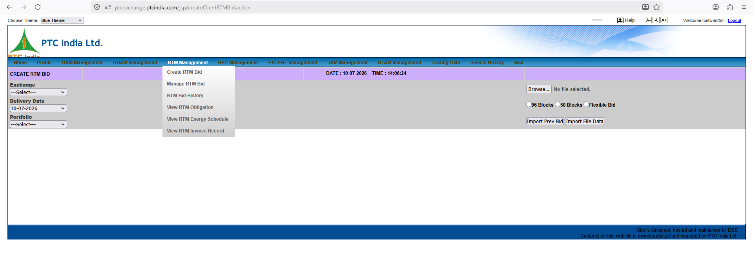

This image is a near-duplicate frame of the createClientRTMBid.action screen analyzed in the previous turn, capturing a tiny 5-second difference in the live server clock!

1. Key Context & Differences From Previous Frame
- URL Path: [ptcexchange.ptcindia.com/jsp/createClientRTMBid.action](https://ptcexchange.ptcindia.com/jsp/createClientRTMBid.action)
- Module Title Banner: CREATE RTM BID
- Live Server Clock: DATE : 10-07-2026 | TIME : 14:06:24
- Comparison with Previous Image (image_5a3a34.png):
  - Previous timestamp: 14:06:29
  - Current timestamp: 14:06:24
  - Insight: This screenshot represents the page view captured 5 seconds prior to the previous frame while the user was interacting with the RTM Management sub-menu dropdown!

2. Granular UI & Control Element Breakdown
+------------------------------------------------------------------------------------------------------------------------------------+
| CREATE RTM BID DATE : 10-07-2026 TIME : 14:06:24 |
| Exchange: [ ---Select--- v ] |
| Delivery Date: [ 10-07-2026 v ] [ Browse... ] No file selected. |
| Portfolio: [ ---Select--- v ] (o) 96 Blocks ( ) 50 Blocks ( ) Flexible Bid|
| [ Import Prev Bid ] [ Import File Data ] |
+------------------------------------------------------------------------------------------------------------------------------------+

Form Control Functions & Domain Rules
Control Field | Input Specification | Domain Rule & Operational Function
Exchange Selector | Dropdown (---Select--- / IEX, PXIL, HPX) | Selects the power exchange venue for real-time clearing.
Delivery Date | Dropdown (10-07-2026 selected) | Specifies the physical delivery date for the intraday energy trade.
Portfolio Selector | Dropdown (---Select---) | Mapped to SJVN's generation assets (e.g., N1HP0PTC0850 / Naitwar Mori HEP).
File Upload (Browse...) | File Chooser | Imports bulk CSV/Excel bid spreadsheets directly into the matrix.
Block Type Selection | Radio Options:  • 96 Blocks (Selected)  • 50 Blocks  • Flexible Bid | Defines the time granularity:  • 96 Blocks: Full day 15-minute intervals.  • 50 Blocks / Flexible: Targeted intraday clearing sessions.
Import Prev Bid | Action Button | Auto-populates the current form with bid vectors submitted in the preceding trading session.
Import File Data | Action Button | Parses the selected file and renders the time-block price/quantity table below.

3. Foreground Menu Overlay: RTM Management Suite
The RTM Management sub-menu remains active in the foreground, outlining the complete operational workflow:
- Create RTM Bid (Active Screen)
- Manage RTM Bid (Active Order Workspace)
- RTM Bid History (Audit Trail)
- View RTM Obligation (Financial Clearing)
- View RTM Energy Schedule (Physical Delivery Schedule)
- View RTM Invoice Record (Commercial Tax Ledger)

4. Architectural & UI Takeaway for SJVN Platform
- Sub-Second Clock Synchronization:
  - Because Real-Time Market (RTM) bidding windows close every 30 minutes, real-time client-side synchronization (via WebSockets or NTP time sync) is critical so traders do not miss gate closures due to local PC clock drift.
- State Retention Across Views:
  - When navigating between sub-menus (like opening the dropdown while drafting a bid), our React application state management (e.g., Redux / Zustand) must preserve form drafts automatically so unsaved inputs are never lost.
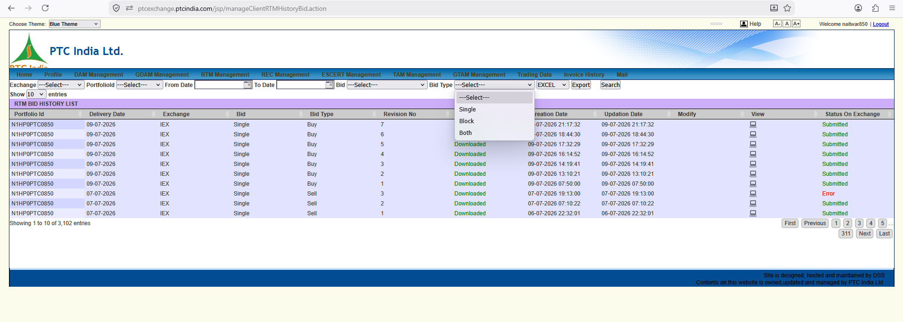

LIST) with the Bid Type filter dropdown open.

1. Page Context & Operational Purpose
- URL Path: [ptcexchange.ptcindia.com/jsp/manageClientRTMHistoryBid.action](https://ptcexchange.ptcindia.com/jsp/manageClientRTMHistoryBid.action)
- Module Title Banner: RTM BID HISTORY LIST
- Active Top Menu Context: RTM Management
- Business Purpose: This is the complete audit trail and historical repository of all Real-Time Market (RTM) bids submitted across all sessions. Notice the scale at the bottom left: Showing 1 to 10 of 3,102 entries across 311 pages!

2. Granular UI Element Breakdown
+--------------------------------------------------------------------------------------------------------------------------------------------------+
| RTM BID HISTORY LIST |
| Exchange: [---Select--- v] PortfolioId: [---Select--- v] From Date: [ 📅 ] To Date: [ 📅 ] Bid: [---Select--- v] Bid Type: [ ---Select--- v ] |
| | Single | |
| | Block | |
| | Both | |
| +------------------+ |
| [ EXCEL v ] [ Export ] [ Search ] |
+--------------------------------------------------------------------------------------------------------------------------------------------------+
| Portfolio Id | Delivery Date | Exchange | Bid | Bid Type | Revision No | Status | Creation Date | Updation Date | Modify | View | Status On Exchange |
+--------------+---------------+----------+--------+----------+-------------+------------+---------------------+---------------------+--------+------+--------------------+
| N1HP0PTC0850 | 09-07-2026 | IEX | Single | Buy | 7 | | 09-07-2026 21:17:32 | 09-07-2026 21:17:32 | | 💻 | Submitted |
| N1HP0PTC0850 | 09-07-2026 | IEX | Single | Buy | 6 | | 09-07-2026 18:44:30 | 09-07-2026 18:44:30 | | 💻 | Submitted |
| N1HP0PTC0850 | 09-07-2026 | IEX | Single | Buy | 5 | Downloaded | 09-07-2026 17:32:29 | 09-07-2026 17:32:29 | | 💻 | Submitted |
| N1HP0PTC0850 | 09-07-2026 | IEX | Single | Buy | 4 | Downloaded | 09-07-2026 16:14:52 | 09-07-2026 16:14:52 | | 💻 | Submitted |
| N1HP0PTC0850 | 09-07-2026 | IEX | Single | Buy | 3 | Downloaded | 09-07-2026 14:19:41 | 09-07-2026 14:19:41 | | 💻 | Submitted |
| N1HP0PTC0850 | 09-07-2026 | IEX | Single | Buy | 2 | Downloaded | 09-07-2026 13:10:21 | 09-07-2026 13:10:21 | | 💻 | Submitted |
| N1HP0PTC0850 | 09-07-2026 | IEX | Single | Buy | 1 | Downloaded | 09-07-2026 07:50:00 | 09-07-2026 07:50:00 | | 💻 | Submitted |
| N1HP0PTC0850 | 07-07-2026 | IEX | Single | Sell | 3 | Downloaded | 07-07-2026 19:13:00 | 07-07-2026 19:13:00 | | 💻 | Error |
| N1HP0PTC0850 | 07-07-2026 | IEX | Single | Sell | 2 | Downloaded | 07-07-2026 07:10:22 | 07-07-2026 07:10:22 | | 💻 | Submitted |
| N1HP0PTC0850 | 07-07-2026 | IEX | Single | Sell | 1 | Downloaded | 06-07-2026 22:32:01 | 06-07-2026 22:32:01 | | 💻 | Submitted |
+--------------------------------------------------------------------------------------------------------------------------------------------------+

3. Critical Domain Insights & Workflow Discoveries

A. High-Frequency Revision Increments (Revision No 1 through 7)
Look at the top 7 rows for delivery date 09-07-2026:
- The asset (N1HP0PTC0850) submitted 7 separate revisions (Revision No: 1 through 7) for a single trading date throughout the day!
- Timestamps:
  - Rev 1: 07:50:00
  - Rev 2: 13:10:21
  - Rev 3: 14:19:41
  - Rev 4: 16:14:52
  - Rev 5: 17:32:29
  - Rev 6: 18:44:30
  - Rev 7: 21:17:32
- Domain Context: RTM clears half-hourly (48 sessions/day). Traders continuously revise their 15-minute MW bid vectors prior to each half-hour gate closure as plant generation updates or State Load Despatch Centre (SLDC) instructions arrive.

B. Bid Type Filter Dropdown
The expanded dropdown exposes the bid structure classifications supported by IEX/PXIL RTM:
- Single: Standard 15-minute block price-quantity order (independent across blocks).
- Block: Combination order executed on an "All-or-None" basis across multiple consecutive hours.
- Both: Returns both Single and Block orders.

C. Exchange Exception Handling (Status On Exchange: Error)
Look at row 8 (07-07-2026 / Revision No: 3):
- Status On Exchange displays Error.
- Domain Context: This indicates that Revision 3 was rejected by IEX's trading engine (e.g., due to price cap violation, transmission constraint, or gate closure timeout).
- System Design Rule: Our platform must flag exchange rejection errors with high-priority visual badges and alert notification toasts so traders can immediately fallback to the previous valid revision.

4. UI Patterns for Our React Terminal
- Version Comparison Diff Tool:
  - Allow selecting two revisions (e.g., Rev 6 vs Rev 7) to highlight the exact MW profile changes across the 96 time blocks in a visual side-by-side comparison modal.
- Error Reason Tooltip:
  - Hovering over Error should display the exact IEX error message (e.g., "Error Code 402: Bid quantity exceeds standing clearance limit").
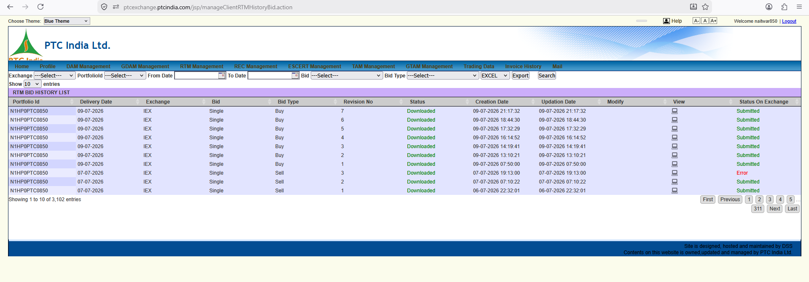

This image is a follow-up view of the same page (manageClientRTMHistoryBid.action), captured right after the user closed the Bid Type dropdown filter.

1. Key Context & Operational Continuity
- URL Path: [ptcexchange.ptcindia.com/jsp/manageClientRTMHistoryBid.action](https://ptcexchange.ptcindia.com/jsp/manageClientRTMHistoryBid.action)
- Module Title Banner: RTM BID HISTORY LIST
- Active Top Menu Context: RTM Management
- Comparison with Previous Screenshot (image_5a357d.png):
  - In the previous frame, the Bid Type dropdown was open, overlaying rows 1–3.
  - In this frame (image_5a3274.png), the dropdown is closed, giving us an unobscured view of all 10 table rows.
  - Notice the Status column update for the top two rows!

2. Granular Data Grid Breakdown
+--------------------------------------------------------------------------------------------------------------------------------------------------+
| RTM BID HISTORY LIST |
| Exchange: [---Select--- v] PortfolioId: [---Select--- v] From Date: [ 📅 ] To Date: [ 📅 ] Bid: [---Select--- v] Bid Type: [---Select--- v] |
| [ EXCEL v ] [ Export ] [ Search ] |
+--------------------------------------------------------------------------------------------------------------------------------------------------+
| Portfolio Id | Delivery Date | Exchange | Bid | Bid Type | Revision No | Status | Creation Date | Updation Date | Modify | View | Status On Exchange |
+--------------+---------------+----------+--------+----------+-------------+------------+---------------------+---------------------+--------+------+--------------------+
| N1HP0PTC0850 | 09-07-2026 | IEX | Single | Buy | 7 | Downloaded | 09-07-2026 21:17:32 | 09-07-2026 21:17:32 | | 💻 | Submitted |
| N1HP0PTC0850 | 09-07-2026 | IEX | Single | Buy | 6 | Downloaded | 09-07-2026 18:44:30 | 09-07-2026 18:44:30 | | 💻 | Submitted |
| N1HP0PTC0850 | 09-07-2026 | IEX | Single | Buy | 5 | Downloaded | 09-07-2026 17:32:29 | 09-07-2026 17:32:29 | | 💻 | Submitted |
| N1HP0PTC0850 | 09-07-2026 | IEX | Single | Buy | 4 | Downloaded | 09-07-2026 16:14:52 | 09-07-2026 16:14:52 | | 💻 | Submitted |
| N1HP0PTC0850 | 09-07-2026 | IEX | Single | Buy | 3 | Downloaded | 09-07-2026 14:19:41 | 09-07-2026 14:19:41 | | 💻 | Submitted |
| N1HP0PTC0850 | 09-07-2026 | IEX | Single | Buy | 2 | Downloaded | 09-07-2026 13:10:21 | 09-07-2026 13:10:21 | | 💻 | Submitted |
| N1HP0PTC0850 | 09-07-2026 | IEX | Single | Buy | 1 | Downloaded | 09-07-2026 07:50:00 | 09-07-2026 07:50:00 | | 💻 | Submitted |
| N1HP0PTC0850 | 07-07-2026 | IEX | Single | Sell | 3 | Downloaded | 07-07-2026 19:13:00 | 07-07-2026 19:13:00 | | 💻 | Error |
| N1HP0PTC0850 | 07-07-2026 | IEX | Single | Sell | 2 | Downloaded | 07-07-2026 07:10:22 | 07-07-2026 07:10:22 | | 💻 | Submitted |
| N1HP0PTC0850 | 07-07-2026 | IEX | Single | Sell | 1 | Downloaded | 06-07-2026 22:32:01 | 06-07-2026 22:32:01 | | 💻 | Submitted |
+--------------------------------------------------------------------------------------------------------------------------------------------------+

3. Important Technical & Domain Discoveries
- Status Progression Revealed (Status: Downloaded):
  - Now that the dropdown overlay is cleared, we can confirm that all 10 rows show the green Downloaded internal status.
  - Workflow Meaning: This confirms that PTC's automated backend background process successfully generated and fetched the bid XML/CSV files for all 7 intraday revisions on 09-07-2026.
- RTM Intraday Revision Sequence Analysis (09-07-2026):
  - Rev 1 (07:50): Initial morning baseline bid prior to early RTM sessions.
  - Rev 2–4 (13:10 to 16:14): Midday schedule adjustments reacting to afternoon river inflows at Naitwar Mori HEP.
  - Rev 5–7 (17:32 to 21:17): Evening peak demand/inflow re-balancing bids submitted late into the night.
- Status Discrepancy Note (Status vs Status On Exchange):
  - Notice Row 8 (07-07-2026 / Rev 3):
    - Status = Downloaded (PTC system processed the file locally).
    - Status On Exchange = Error (IEX rejected the bid).
  - System Architecture Rule: When building SJVN's platform, our API must distinguish between Internal Processing Status (FILE_GENERATED) and Exchange Acknowledgement Status (GATEWAY_REJECTED) so traders don't assume a downloaded bid was successfully cleared at the exchange.

4. UI Patterns for Our React Terminal
- Clean Flat Grid with Status Badges:
  - Render explicit dual-status badges in the audit table:
    - Internal: 🟢 File Prepared
    - Exchange: 🔴 Rejected (Error Code 402)
- Expandable Row Timeline:
  - Clicking any delivery date (e.g., 09-07-2026) expands a nested timeline showing how the 15-minute MW profile evolved from Revision 1 to Revision 7 across the 24-hour delivery day.

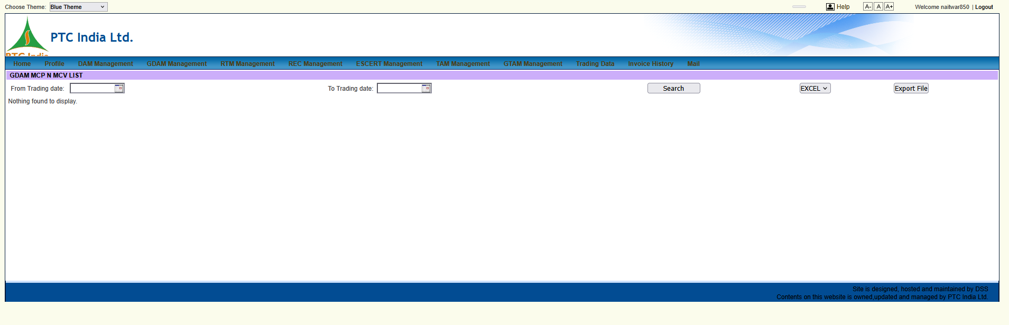

Here is the granular, element-by-element breakdown of this new screenshot (image_5a31d7.png).
This view takes us to the market analytics sub-module within Green Day-Ahead Trading: GDAM MCP N MCV LIST (Market Clearing Price & Market Clearing Volume Analytics).

1. Page Context & Functional Purpose
- Module Title Banner: GDAM MCP N MCV LIST
- Active Context: GDAM Management (navigated from the View GDAM MCP & MCV option seen in earlier menu dropdowns).
- Business Purpose: Central analytics portal for tracking exchange-wide Market Clearing Price (MCP) and Market Clearing Volume (MCV) trends for the Green Day-Ahead Market.

Domain Context (MCP & MCV)
- MCP (Market Clearing Price): The uniform 15-minute price (in ₹/MWh or ₹/kWh) at which green supply bids intersect with green demand bids on power exchanges (IEX/PXIL).
- MCV (Market Clearing Volume): The total volume of green electricity (in MWh) cleared across the grid for each 15-minute time block.

2. Granular UI Element Breakdown
+------------------------------------------------------------------------------------------------------------------------------------+
| GDAM MCP N MCV LIST |
| From Trading date: [ 📅 ] To Trading date: [ 📅 ] [ Search ] [ EXCEL v ] [ Export File ] |
+------------------------------------------------------------------------------------------------------------------------------------+
| Nothing found to display. |
+------------------------------------------------------------------------------------------------------------------------------------+

Control Bar Schema Analysis
Control Field | Input Specification | Operational Domain Meaning
From Trading date | Date Field / Calendar Picker | Sets the start range for historical MCP/MCV analytics queries.
To Trading date | Date Field / Calendar Picker | Sets the end range for historical MCP/MCV analytics queries.
Search Button | Action Trigger | Executes the query to fetch the 96 time-block price & volume curves.
Export Options | Dropdown (EXCEL) | Formats report download outputs (EXCEL / PDF / CSV).
Export File Button | Action Trigger | Downloads the 96-block price/volume data table for financial modeling.

3. Structural Comparison: GDAM Analytics vs. Conventional DAM Analytics
Notice how PTC structures its market intelligence tools:
- Lightweight Data Grid: The portal defaults to a minimal query form (From Trading date to To Trading date).
- Missing Visualization: The legacy portal only exports raw text/table entries ("Nothing found to display" when unpopulated) rather than rendering interactive charts.

4. UI/UX Refinement Patterns for Our React Terminal
In our React + FastAPI platform (/analytics/gdam-mcp-mcv), we can turn this plain data table into a powerful market intelligence dashboard:
- Interactive Heatmaps & Line Charts:
  - Render dynamic 96-Block MCP Charts showing price spikes across peak vs. off-peak hours.
  - Overlay Green Premium Analytics: Compare GDAM MCP directly against Conventional DAM MCP in real time to show the exact monetary premium green power generation yields.
- Green Premium Formula Indicator:
Green Premium (₹/kWh)=MCPGDAM​−MCPDAM​
- One-Click Automated Dispatch Suggestions:
  - If MCPGDAM​>MCPDAM​, automatically alert SJVN trading desks to route available hydro/solar generation capacity to the GDAM segment for maximum revenue optimization.

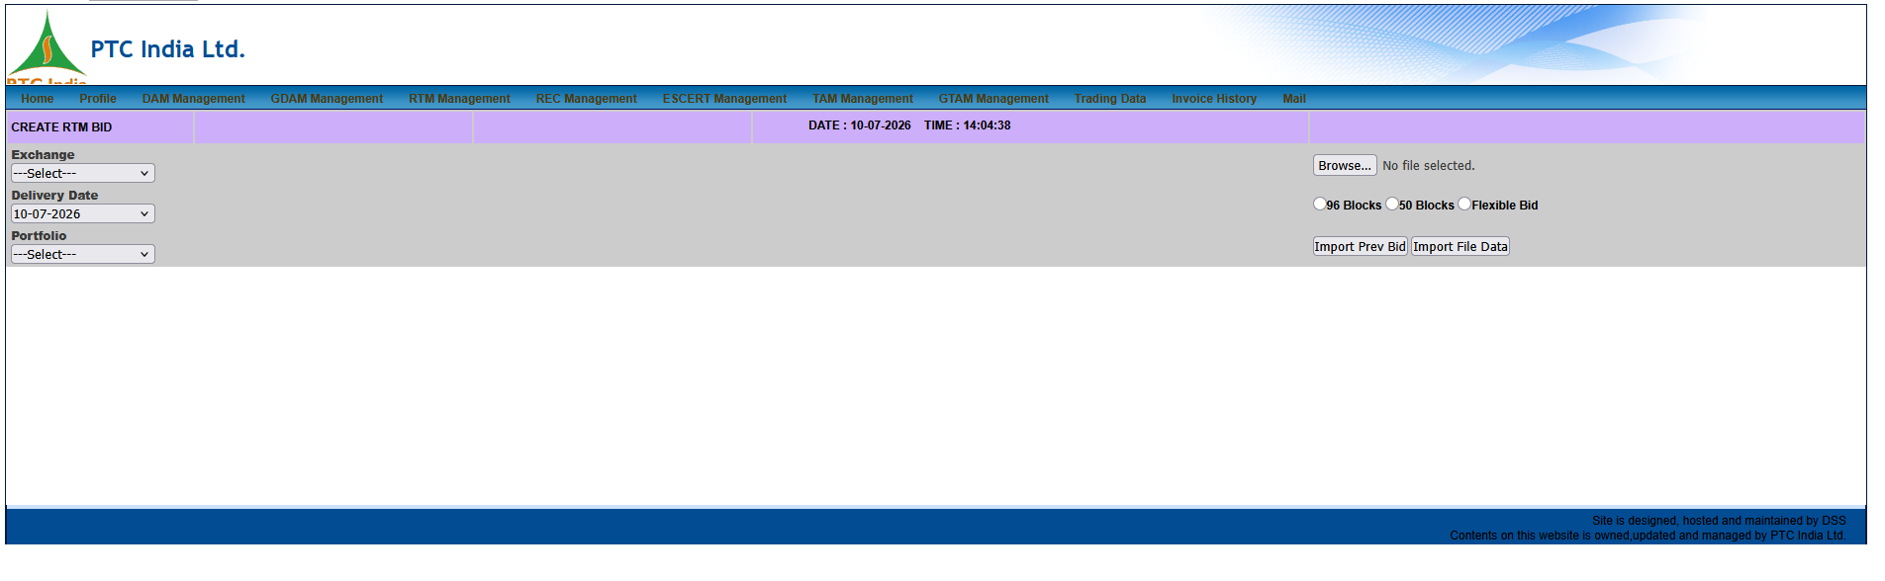

This view represents the clean, unobscured default state of the Create RTM Bid form on the portal.

1. Page Context & Timeline Progression
- Module Title Banner: CREATE RTM BID
- Active Top Menu Tab: RTM Management (Background view, no dropdowns active).
- Live Server Clock: DATE : 10-07-2026 | TIME : 14:04:38

Chronological Context
We are seeing the trader's screen sequence in reverse chronological order based on the server timestamps across your recent uploads:
- This Image (image_5a2ecf.png): Captured at 14:04:38 (Clean default view of the form).
- image_5a3635.png: Captured at 14:06:24 (User opened the RTM Management dropdown).
- image_5a3a34.png: Captured at 14:06:29 (User hovered over dropdown options).

2. Granular Form Element Breakdown
Because there are no foreground menus obstructing the view, here is the complete visual schema of the top control bar for Real-Time Market bid entry.
+------------------------------------------------------------------------------------------------------------------------------------+
| CREATE RTM BID DATE : 10-07-2026 TIME : 14:04:38 |
| Exchange: [ ---Select--- v ] |
| Delivery Date: [ 10-07-2026 v ] [ Browse... ] No file selected. |
| Portfolio: [ ---Select--- v ] (o) 96 Blocks ( ) 50 Blocks ( ) Flexible Bid|
| [ Import Prev Bid ] [ Import File Data ] |
+------------------------------------------------------------------------------------------------------------------------------------+

Form Input Functions & Real-Time Logic
Form Field | Control Type | Business Domain Function
Exchange | Dropdown | Selects the target power exchange (IEX, PXIL) for the intraday session.
Delivery Date | Dropdown (10-07-2026) | Locks in the physical power delivery date (always the current or next day for RTM).
Portfolio | Dropdown | Selects the specific generating asset (like SJVN's Naitwar Mori) submitting the bid.
File Upload | [ Browse... ] Button | Opens local system explorer to upload bulk CSV/Excel bid matrices for rapid entry.
Time Block Matrix | Radio Buttons | Toggles the grid size: 96 Blocks (Full Day) vs 50 Blocks vs Flexible Bid (Targeted Intraday Windows).
Import Prev Bid | Action Button | Instantly loads the bid curve submitted in the immediately preceding 30-minute RTM session.
Import File Data | Action Button | Processes the uploaded file and populates the lower half of the screen (not pictured) with the MW/Price curve.

3. UI/UX Refinement Patterns for Our React Terminal
Looking at this clean state, we can identify a few UX friction points in the legacy design that we should improve in the new platform:
- Consolidated Upload/Import Zone:
  - Instead of scattered buttons on the right side, build a modern Drag-and-Drop Zone component.
  - Example UI: A dashed box stating Drag & Drop Bid CSV Here or [ Browse Files ].
- Visual Session Indicator:
  - While the time 14:04:38 is visible, a trader has to mentally calculate how much time is left until the next gate closure.
  - We should add a dynamic progress bar directly under the clock: [ Next RTM Session Closes in: 10m 22s ].
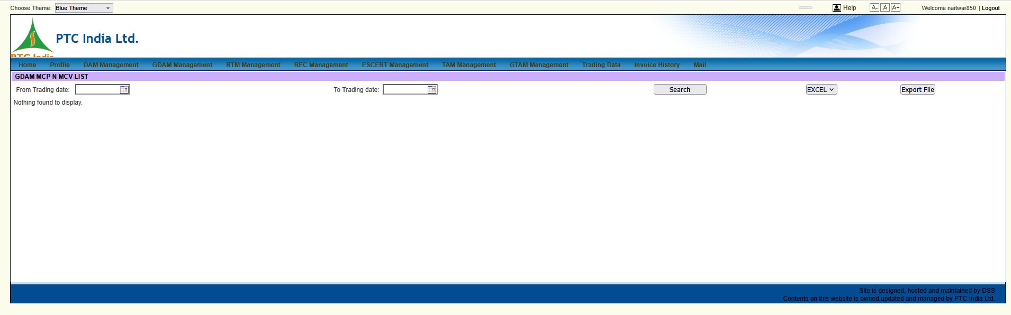

This image represents an unobscured, direct frame of the GDAM MCP N MCV LIST sub-module within Green Day-Ahead Market analytics.

1. Page Context & Operational Purpose
- Module Title Banner: GDAM MCP N MCV LIST
- Active Top Context: Navigated under GDAM Management
- Business Purpose: This page provides market intelligence for the Green Day-Ahead Market (GDAM) by tracking historical Market Clearing Price (MCP) and Market Clearing Volume (MCV) metrics.

Functional Definitions
- MCP (Market Clearing Price): The single, uniform 15-minute price (in ₹/kWh or ₹/MWh) determined at the exchange where green energy supply meets demand.
- MCV (Market Clearing Volume): The aggregate volume of green power (in MWh) cleared across the regional peripheries for each 15-minute time block.

2. Granular UI Element Breakdown
+------------------------------------------------------------------------------------------------------------------------------------+
| GDAM MCP N MCV LIST |
| From Trading date: [ 📅 ] To Trading date: [ 📅 ] [ Search ] [ EXCEL v ] [ Export File ] |
+------------------------------------------------------------------------------------------------------------------------------------+
| Nothing found to display. |
+------------------------------------------------------------------------------------------------------------------------------------+

Control Bar Schema Analysis
Field / Control | Input Type | Domain Meaning & Operational Logic
From Trading date | Date Field (DD-MM-YYYY) | Sets the start boundary for historical price/volume queries.
To Trading date | Date Field (DD-MM-YYYY) | Sets the end boundary for historical price/volume queries.
Search Button | Action Trigger | Queries the backend database to fetch the 96 time-block clearing results.
Export Format Selector | Dropdown (EXCEL) | Selects output file format (EXCEL, CSV, PDF).
Export File Button | Action Trigger | Downloads the 96-block price/volume dataset for offline financial analysis.

3. Structural Synergy Across Analytics Pages
Notice how PTC's portal handles market clearing analytics across different segments:
- DAM MCP N MCV (Conventional Day-Ahead Market) and GDAM MCP N MCV (Green Day-Ahead Market) use identical filter controls and layout grids.
- Current Limitation: The legacy portal only renders a flat table (or "Nothing found to display" when unpopulated), forcing traders to manually export data to Excel to plot trends.

4. UI/UX Refinement Patterns for Our React Terminal
In the new terminal (/analytics/gdam-mcp-mcv), we can upgrade this raw data query page into a real-time market intelligence dashboard:
- Dual-Axis Line & Bar Chart:
  - Render an interactive 96-block chart displaying MCP (₹/kWh) on the primary Y-axis and MCV (MW) on the secondary Y-axis.
- Green Premium Heatmap:
  - Show a live delta comparison between GDAM and conventional DAM:
$$\text{Green Premium} = \text{MCP}_{\text{GDAM}} - \text{MCP}_{\text{DAM}}$$
  - Highlight peak blocks where green power yields the highest premium to help SJVN traders optimize sell order pricing.
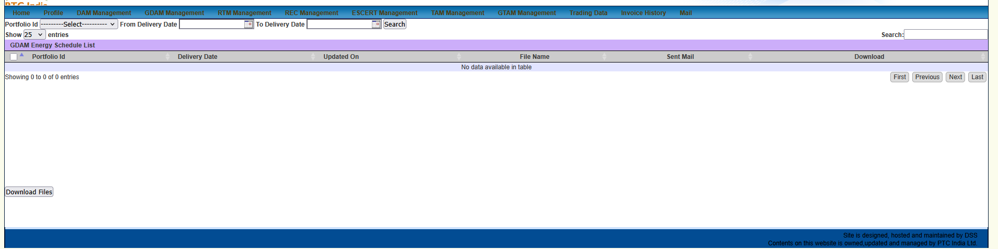

Here is the detailed, granular breakdown of this new screenshot (image_5a2a39.png).
This view brings us to the physical scheduling workspace of Green Day-Ahead Market operations: GDAM Energy Schedule List.

1. Page Context & Operational Purpose
- Module Title Banner: GDAM Energy Schedule List
- Active Top Context: GDAM Management (navigated via View GDAM Energy Schedule)
- Business Purpose: Central repository for fetching physical power scheduling logs resulting from cleared Green Day-Ahead Market (GDAM) trades.

Physical Delivery & Scheduling Context
Unlike certificate trading (RECs/ESCerts) which only transfers ownership attributes, GDAM trades result in actual physical dispatch schedules:
- 15-Minute Block Level Resolution: Specifies power injected/drawn across the 96 time blocks of the delivery day.
- Periphery Reconciliation: Maps schedule values from the plant busbar (e.g., SJVN's renewable asset) to the Regional / State Peripheries, factoring in regional transmission losses.
- RLDC Coordination: Serves as the primary operational data source for filing final daily schedules with Regional Load Despatch Centres (RLDCs) / State Load Despatch Centres (SLDCs).

2. Granular UI Element Breakdown
+------------------------------------------------------------------------------------------------------------------------------------+
| Portfolio Id: [ ---------Select--------- v ] From Delivery Date: [ 📅 ] To Delivery Date: [ 📅 ] [ Search ] |
+------------------------------------------------------------------------------------------------------------------------------------+
| GDAM Energy Schedule List Search: [ ] |
+------------------------------------------------------------------------------------------------------------------------------------+
| [ ] | Portfolio Id | Delivery Date | Updated On | File Name | Sent Mail | Download |
+-----+--------------+---------------+------------+-----------+-----------+----------------------------------------------------------+
| No data available in table |
+------------------------------------------------------------------------------------------------------------------------------------+
| [ Download Files ] |
+------------------------------------------------------------------------------------------------------------------------------------+

Control Panel & Data Table Schema Analysis
Control / Column | Input Specification | Operational Domain Meaning
Portfolio Id | Dropdown (---------Select---------) | Restricts schedule lookup to a specific registered green generation portfolio.
From / To Delivery Date | Date Pickers (DD-MM-YYYY) | Filters physical schedule records by the actual energy delivery date.
Search Button | Action Trigger | Executes query to populate the schedule list grid.
Checkbox Column ([ ]) | Selection Checkbox | Allows multi-selecting schedule rows for bulk file downloads.
Updated On | Timestamp | Audit timestamp indicating when the schedule file was generated/revised by the exchange.
File Name | File String | Raw schedule spreadsheet filename exported by IEX/PXIL (.xls/.csv).
Sent Mail | Status Indicator / Timestamp | Tracks whether automated notification emails containing the schedule were dispatched to the plant operator.
Download | Action Icon / Link | Single-file download trigger for individual schedule statements.
Download Files Button | Bulk Action Button | Zips and downloads all checked schedule files in a single operation.

3. Structural Comparison: GDAM Schedules vs. Conventional DAM Schedules
Notice the architectural pattern:
- Identical Layout: The schema (Portfolio Id, Delivery Date, Updated On, File Name, Sent Mail, Download Files) is identical to the conventional DAM Energy Schedule List.
- Key Functional Difference: GDAM schedules carry specific green attribute tags and must reconcile against renewable plant generation forecasts to ensure green power origin tracking for RPO compliance.

4. UI Patterns for Our React Terminal
In our React + FastAPI platform (/gdam/scheduling/schedule), we can enhance this raw file repository into a full visual scheduling terminal:
- Interactive 96-Block Visual Schedule Chart:
  - Rather than making operators download Excel files to check MW profiles, render an inline 24-Hour Area Chart showing the 96 time-block schedule curve.
- Automated RLDC Schedule Export:
  - Add a [ ⚡ Sync to RLDC / SLDC Portal ] button that formats and pushes the 96-block cleared GDAM schedule directly into the regional grid operator API without manual file handling.
- Bulk Download & Notification Status:
  - Keep the bulk selection toolbar but add instant status tags:
    - 🟢 RLDC Acknowledged
    - 📧 Email Sent to Operator
    - 📄 CSV Exported

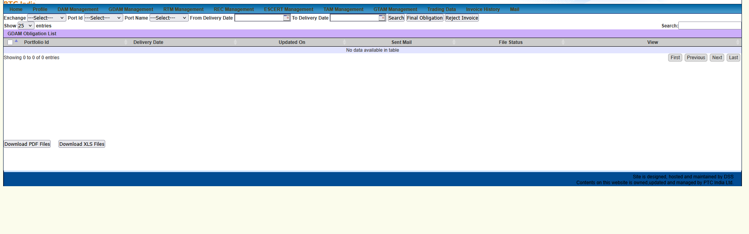

TL;DR Summary: Ye screenshot GDAM Obligation List view hai, jo Green Day-Ahead Market ke exchange financial settlement, invoice verification aur billing clearance ko manage karta hai.

1. Page Context & Operational Purpose
- URL / Title Banner: GDAM Obligation List
- Active Module Tab: GDAM Management
- Business Function: Cleared GDAM trades ki financial obligation files, daily clearing statements, aur commercial invoice approval workflows ko handle karta hai.

2. Granular UI Element Breakdown
+---------------------------------------------------------------------------------------------------------------------------------------+
| Exchange: [---Select--- v] Port Id: [---Select--- v] Port Name: [---Select--- v] From/To Delivery Date: [📅] |
| [ Search ] [ Final Obligation ] [ Reject Invoice ] |
+---------------------------------------------------------------------------------------------------------------------------------------+
| GDAM Obligation List |
| [ ] | Portfolio Id | Delivery Date | Updated On | Sent Mail | File Status | View |
+---------------------------------------------------------------------------------------------------------------------------------------+
| No data available in table |
+---------------------------------------------------------------------------------------------------------------------------------------+
| [ Download PDF Files ] [ Download XLS Files ] |
+---------------------------------------------------------------------------------------------------------------------------------------+

Key Controls & Table Schema Analysis
Control / Column | Input Type | Operational Function & Business Logic
Exchange / Port Filters | Dropdowns | Power exchange (IEX/PXIL) aur plant portfolio filtering ke liye.
Final Obligation | Action Button | Cleared financial trade values ko approve karke commercial invoicing queue me push karta hai.
Reject Invoice | Action Button | Discrepancy milne par exchange statement ya draft invoice ko dispute status me daalta hai.
Updated On / Sent Mail | Timestamps | Statement processing time aur automated client email logs track karta hai.
File Status | Status Label | File generation status show karta hai (e.g., Generated, Approved, Rejected).
Bulk Download Buttons | Action Buttons | Single-click me PDF aur Excel obligation reports export karne ke liye.

3. Core Differences: GDAM Obligation vs. Normal DAM Obligation
- Green Tariff Mapping: GDAM obligations me renewable power attributes aur state-wise green transmission losses mapped hoti hain.
- Dual Export Formats: Yahan explicitly Download PDF Files aur Download XLS Files ke separate buttons diye gaye hain, jabki purane schedule views me sirf Excel list thi.

4. UI/UX Patterns for Our React Terminal
- Approval / Dispute Action Bar:
  - Inline status actions integrate karein: [ 🟢 Approve & Send to Invoicing ] | [ 🔴 Reject & Raise Dispute ]
- Direct Voucher Preview Drawer:
  - Table me View icon par click karte hi side-drawer me PDF clearing statement open ho jaye, bina file download kiye.

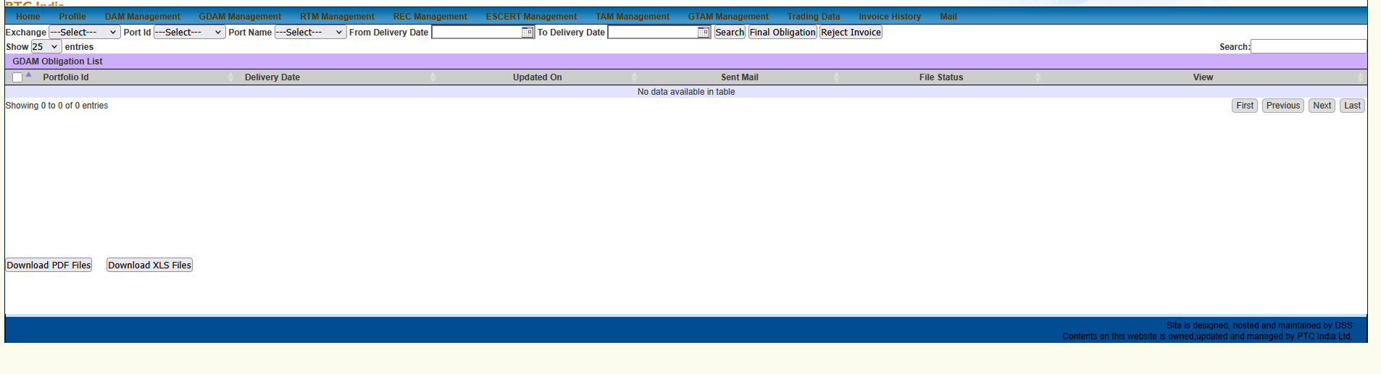

Component Schema: <GDAMObligationConsole/>

1. Filter Control Toolbar
- Filters: Exchange (IEX / PXIL), PortId, PortName, FromDeliveryDate, ToDeliveryDate
- Workflow Action Triggers:
  - [ Final Obligation ]: Batch-approves selected cleared statements $\rightarrow$ updates status to APPROVED_FOR_INVOICING $\rightarrow$ triggers SAP GL queue injection.
  - [ Reject Invoice ]: Opens a dispute modal to flag discrepancies (e.g., rate/MW mismatches) before posting.

2. Table Data Schema & Actions
TypeScript
interface GDAMObligationRecord {
portfolioId: string;
deliveryDate: string; // YYYY-MM-DD
updatedOn: string; // ISO Timestamp
sentMail: boolean | string;
fileStatus: 'GENERATED' | 'APPROVED' | 'DISPUTED' | 'REJECTED';
pdfUrl: string;
xlsUrl: string;
}

Direct Actions & Bulk Exports
- Row Action (View): Triggers an inline PDF preview drawer showing the raw exchange clearing voucher without leaving the workspace.
- Bulk Downloads: Download PDF Files and Download XLS Files buttons pass selected portfolioId array to the export microservice.

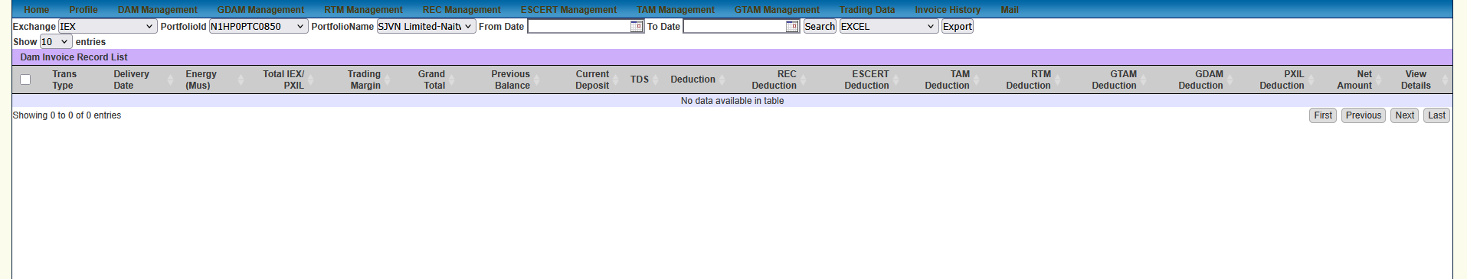

Here is the granular, element-by-element breakdown of this new screenshot.
This view brings us to the Dam Invoice Record List page under the DAM Management tab, revealing a remarkably comprehensive multi-market deduction ledger schema!

1. Page Context & Operational Purpose
- Module Title Banner: Dam Invoice Record List
- Active Navigation Tab: DAM Management
- Active Filter State:
  - Exchange: IEX
  - PortfolioId: N1HP0PTC0850
  - PortfolioName: SJVN Limited-Nait... (Naitwar Mori HEP)
- Business Purpose: Central commercial ledger for Day-Ahead Market (DAM) transactions. Beyond basic power sales, this ledger functions as a cross-market net settlement clearinghouse, deducting balances owed across other trading segments (TAM, RTM, GTAM, GDAM, RECs, ESCerts) directly from DAM receivables.

2. Granular Data Grid Schema Breakdown
+----------------------------------------------------------------------------------------------------------------------------------------------------------------------------------------------------+
| Dam Invoice Record List |
| Exchange: [ IEX v ] PortfolioId: [ N1HP0PTC0850 v ] PortfolioName: [ SJVN Limited-Nait... v ] From Date: [ 📅 ] To Date: [ 📅 ] [ Search ] [ EXCEL v ] [ Export ] |
+----------------------------------------------------------------------------------------------------------------------------------------------------------------------------------------------------+
| [ ] | Trans Type | Delivery Date | Energy (Mus) | Total IEX/PXIL | Trading Margin | Grand Total | Previous Balance | Current Deposit | TDS | Deduction | REC Deduction | ESCERT Deduction | TAM Deduction | RTM Deduction | GTAM Deduction | GDAM Deduction | PXIL Deduction | Net Amount | View Details |
+-----+------------+---------------+--------------+----------------+----------------+-------------+------------------+-----------------+-----+-----------+---------------+------------------+---------------+---------------+----------------+----------------+----------------+------------+--------------+
| No data available in table |
+----------------------------------------------------------------------------------------------------------------------------------------------------------------------------------------------------+

Complete Column Definitions & Domain Mechanics
Column Header | Field Type | Business & Financial Accounting Logic
Trans Type | Label | Transaction direction (Buy vs Sell).
Delivery Date | Date | Physical energy flow date (DD-MM-YYYY).
Energy (Mus) | Decimal | Total power delivered in Million Units (MU) ($1\text{ MU} = 1,000,000\text{ kWh}$).
Total IEX/PXIL | Currency (₹) | Gross energy realization at exchange Market Clearing Price ($\text{Volume} \times \text{MCP}$).
Trading Margin | Currency (₹) | Fee charged by PTC India Ltd. for trading execution.
Grand Total | Currency (₹) | $\text{Total IEX/PXIL} \pm \text{Trading Margin} + \text{Taxes}$.
Previous Balance | Currency (₹) | Carried-over ledger balance from previous billing cycles.
Current Deposit | Currency (₹) | Margin money / collateral deposited by SJVN with the trader.
TDS | Currency (₹) | Tax Deducted at Source (under Sec 194Q / 194O of Income Tax Act).
Deduction | Currency (₹) | General exchange charges, STU/CTU transmission fees, or SLDC operating fees.
REC Deduction | Currency (₹) | Adjustments/dues settled from Renewable Energy Certificate trading.
ESCERT Deduction | Currency (₹) | Adjustments/dues settled from Energy Saving Certificate trading.
TAM Deduction | Currency (₹) | Adjustments/dues settled from Term-Ahead Market physical contracts.
RTM Deduction | Currency (₹) | Net deviation / clearing adjustments from Real-Time Market intraday trading.
GTAM Deduction | Currency (₹) | Adjustments from Green Term-Ahead Market trading.
GDAM Deduction | Currency (₹) | Adjustments from Green Day-Ahead Market trading.
PXIL Deduction | Currency (₹) | Cross-exchange adjustment entries between IEX and PXIL accounts.
Net Amount | Currency (₹) | Final Net Payable/Receivable: The actual bank transfer amount pushed to SJVN's account.
View Details | Action Icon (📄) | Opens a granular modal detailing the tax and fee calculations for each line item.

3. Structural Insight: The Cross-Market Settlement Engine
This table reveals the core financial architecture of power trading in India:
$$\text{Net Amount} = \text{Grand Total} + \text{Deposit} - \left( \text{Prev Bal} + \text{TDS} + \sum \text{Segment Deductions} \right)$$
where:
$$\sum \text{Segment Deductions} = \text{REC} + \text{ESCERT} + \text{TAM} + \text{RTM} + \text{GTAM} + \text{GDAM} + \text{PXIL}$$
Because DAM is the highest-volume liquidity pool, the trading margin account uses DAM payouts as the primary clearing account to offset losses, imbalance charges, or certificate purchases incurred across all other segments!

4. UI Patterns for Our React Terminal (<DAMInvoiceLedger/>)
- Collapsible Cross-Market Deduction Strip:
  - To avoid horizontal scroll bloat in React, group the 7 individual deduction columns (REC, ESCERT, TAM, RTM, GTAM, GDAM, PXIL) into an expandable [ ➖ Total Segment Deductions: ₹ X ] column that expands on click.
- Automated Financial Reconciliation & SAP Export:
  - Include a [ ⚡ Export SAP Journal Entry ] button to auto-map these multi-segment deductions directly into SJVN's SAP GL accounts (e.g., separate cost centers for Hydro generation vs. REC compliance).

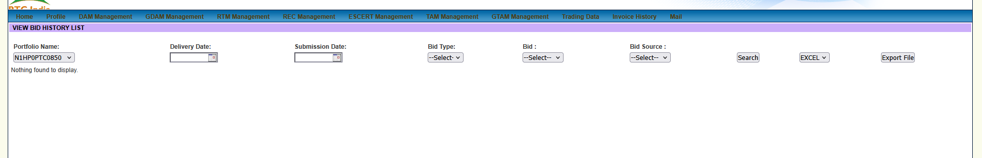

Here is the detailed, granular breakdown of this new screenshot (image_5a21ff.png).
This view takes us to the audit trail interface for conventional Day-Ahead Market bids: VIEW BID HISTORY LIST under DAM Management.

1. Page Context & Operational Purpose
- Module Title Banner: VIEW BID HISTORY LIST
- Active Top Menu Tab: DAM Management
- Active Portfolio Filter: N1HP0PTC0850 (SJVN's Naitwar Mori Hydroelectric Project)
- Business Purpose: Serving as the historical lookup and audit repository for all past Day-Ahead Market (DAM) bid submissions. It allows traders, risk officers, and auditors to review exactly what price-quantity curves were submitted, when they were uploaded, and from which source channel.

2. Granular UI Element Breakdown
+--------------------------------------------------------------------------------------------------------------------------------------------------+
| VIEW BID HISTORY LIST |
| Portfolio Name: [ N1HP0PTC0850 v ] Delivery Date: [ 📅 ] Submission Date: [ 📅 ] Bid Type: [ --Select-- v ] Bid: [ --Select-- v ] |
| Bid Source: [ --Select-- v ] [ Search ] [ EXCEL v ] [ Export File ] |
+--------------------------------------------------------------------------------------------------------------------------------------------------+
| Nothing found to display. |
+--------------------------------------------------------------------------------------------------------------------------------------------------+

Control Bar Schema Analysis
Control Field | Field Type | Operational Domain Meaning
Portfolio Name | Dropdown | Filters bid logs by specific asset code (N1HP0PTC0850 selected).
Delivery Date | Date Picker | Filters by the targeted physical power flow date (DD-MM-YYYY).
Submission Date | Date Picker | Filters by the exact timestamp/date the trader placed the order on the portal.
Bid Type | Dropdown | Filters by transaction direction (Buy vs Sell).
Bid | Dropdown | Filters by bid structure (Single Bid vs Block Bid).
Bid Source | Dropdown | Identifies the submission channel (Web Portal, API Gateway, Excel Upload, FTP Sync).
Search Button | Action Trigger | Executes the query to populate the historical log grid.
Export Options | Dropdown + Action | Export format selection (EXCEL / CSV / PDF) and download trigger (Export File).

3. Structural Synergy: DAM Bid History vs. RTM Bid History
Comparing this screen (VIEW BID HISTORY LIST for DAM) with the RTM History screen analyzed earlier (image_5a3274.png):
- Submission Date vs. Session Revisions:
  - RTM History: Focuses on rapid intraday iteration tracking with explicit Revision No columns (e.g., Rev 1 through Rev 7) due to half-hourly clearing sessions.
  - DAM History: Includes a dedicated Submission Date filter to isolate bids placed before the strict daily 12:00 PM gate closure.
- Channel Provenance (Bid Source):
  - DAM history explicitly tracks Bid Source, allowing risk teams to trace whether an order came from automated scheduling software or manual web portal entry.

4. UI Patterns for Our React Terminal (/dam/bidding/history)
- Multi-Filter Unified Search Header:
  - Build a clean filter toolbar using React Select / Datepickers with instant reactive debouncing.
- Audit Trail Diff Viewer:
  - Clicking any historical DAM record opens a slide-over drawer displaying the full 96-block MW/Price matrix submitted for that delivery day, complete with digital signature details and the exact API/Web origin timestamp.
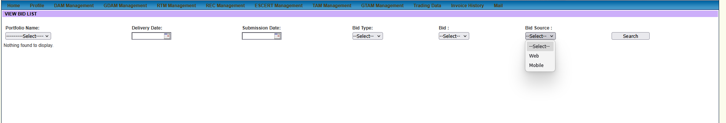

age Context & Key Feature Discovered
- Module Title Banner: VIEW BID LIST (Active DAM Bids Console)
- Active Top Menu Tab: DAM Management
- Key Interaction Focus: The user has clicked open the Bid Source filter dropdown.

2. Granular Form & Dropdown Schema
+--------------------------------------------------------------------------------------------------------------------------------------------------+
| VIEW BID LIST |
| Portfolio Name: [ ---------Select---- v ] Delivery Date: [ 📅 ] Submission Date: [ 📅 ] Bid Type: [ --Select-- v ] Bid: [ --Select-- v ] |
| Bid Source: [ --Select-- v ] [ Search ] |
| | --Select-- | |
| | Web | |
| | Mobile | |
| +------------+ |
+--------------------------------------------------------------------------------------------------------------------------------------------------+
| Nothing found to display. |
+--------------------------------------------------------------------------------------------------------------------------------------------------+

Breakdown of Identified "Bid Source" Options
Bid Source Option | Business Domain Context & System Origin
Web | Bids submitted directly through the PTC India desktop browser portal (ptcexchange.ptcindia.com).
Mobile | Bids placed remotely via PTC’s mobile trading application (used by plant engineers/traders on-the-go).

3. Comparative Insight: Active Console vs. Historical Audit List
Notice the subtle UI shift between this view (VIEW BID LIST) and the previous view (VIEW BID HISTORY LIST in image_59c5d9.png):
- Active/Recent Submissions focus: VIEW BID LIST focuses purely on active orders for upcoming execution sessions. As a result, it omits the bulk Excel export options (EXCEL / Export File) present in the historical audit view, keeping the view clean for rapid operational checking.
- Channel Provenance: Exposing Web vs Mobile as a direct filter helps trading desk managers quickly audit order entry origin (e.g., verifying if an urgent last-minute bid adjustment was made via phone or desk terminal).

4. UI Patterns for Our React Terminal
In our React + FastAPI platform (/dam/bidding/manage):
- Source Channel Badges:
  - In the active order table, render visually distinct channel icons under a Source column:
    - 💻 Web Portal
    - 📱 Mobile App
    - ⚡ Automated API / ERP Pipeline
- Mobile Sync Status:
  - Indicate real-time sync when a trader edits an order on mobile so that desk operators see instant update toasts: "Bid updated via Mobile App by Trader_01 (10s ago)".

This frame is a duplicate capture of the VIEW BID LIST workspace (DAM Management) with the Bid Source filter dropdown expanded.

1. Page Context & Elements Recap
- Module Title Banner: VIEW BID LIST
- Active Navigation Context: DAM Management
- Active Form Control: Bid Source Dropdown (Expanded)

UI Schema Breakdown
+--------------------------------------------------------------------------------------------------------------------------------------------------+
| VIEW BID LIST |
| Portfolio Name: [ ---------Select---- v ] Delivery Date: [ 📅 ] Submission Date: [ 📅 ] Bid Type: [ --Select-- v ] Bid: [ --Select-- v ] |
| Bid Source: [ --Select-- v ] [ Search ] |
| | --Select-- | |
| | Web | |
| | Mobile | |
| +------------+ |
+--------------------------------------------------------------------------------------------------------------------------------------------------+
| Nothing found to display. |
+--------------------------------------------------------------------------------------------------------------------------------------------------+

Control | Values | Operational Domain Meaning
Portfolio Name | Dropdown | Mapped asset portfolio code (e.g., N1HP0PTC0850).
Delivery Date | Date Picker | Targeted physical power flow date (DD-MM-YYYY).
Submission Date | Date Picker | Order placement timestamp filter.
Bid Type | Dropdown (Buy / Sell) | Direction of the trade order.
Bid | Dropdown (Single / Block) | Structure of the price-quantity curve.
Bid Source | Web / Mobile | Order channel origin (Desktop Web Portal vs. Mobile App).

2. Platform Build Specification (<DAMActiveBidsConsole/>)
For our React terminal, we can bundle this active management view with the following specifications:
TypeScript
interface DAMActiveBidQuery {
portfolioId?: string;
deliveryDate?: string;
submissionDate?: string;
bidType?: 'BUY' | 'SELL';
bidStructure?: 'SINGLE' | 'BLOCK';
bidSource?: 'WEB' | 'MOBILE' | 'API';
}

- Channel Tagging Visuals: Render badges directly in the active order grid to distinguish desktop entries (💻 Web) from field/on-call entries (📱 Mobile).
- Real-time Order Status Sync: Connect to WebSockets so any order modified on a mobile device immediately updates on the desk terminal without requiring manual page reloads (Search).

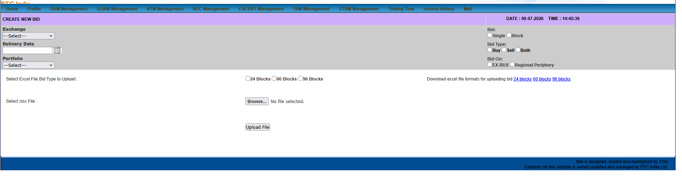

. Page Context & Operational Purpose
- Module Title Banner: CREATE NEW BID
- Active Top Context: DAM Management
- Live Server Timestamp: DATE : 09-07-2026 | TIME : 14:45:36
- Business Purpose: Day-Ahead Market (DAM) ke liye power exchange price-quantity bid vectors draft, upload, aur configure karne ka primary workspace.

2. Granular UI Element Breakdown
+------------------------------------------------------------------------------------------------------------------------------------+
| CREATE NEW BID DATE : 09-07-2026 TIME : 14:45:36 |
| Exchange: [ ---Select--- v ] Bid: ( ) Single ( ) Block |
| Delivery Date: [ 📅 ] Bid Type: ( ) Buy ( ) Sell ( ) Both|
| Portfolio: [ ---Select--- v ] Bid On: ( ) EX-BUS ( ) Regional Periphery |
+------------------------------------------------------------------------------------------------------------------------------------+
| Select Excel File Bid Type to Upload : ( ) 24 Blocks ( ) 60 Blocks ( ) 96 Blocks Download formats: 24 blocks | 60 blocks | 96 blocks |
| Select xlsx File : [ Browse... ] No file selected. |
| [ Upload File ] |
+------------------------------------------------------------------------------------------------------------------------------------+

Complete Control Panel Analysis
Control Group | Options / Input | Operational Domain Meaning
Exchange | Dropdown | Target exchange (IEX, PXIL, HPX).
Delivery Date | Date Picker | Targeted physical flow date.
Portfolio | Dropdown | Registered asset (e.g., SJVN's Naitwar Mori HEP).
Bid Structure | Radio (Single / Block) | Single: Independent price-quantity curve per block.  Block: All-or-Nothing execution across consecutive hours.
Bid Type | Radio (Buy / Sell / Both) | Trade direction (Buy for DISCOMs / Sell for Generators).
Bid On | Radio (EX-BUS / Regional Periphery) | Delivery Point Settlement:  • EX-BUS: Plant busbar (losses borne by buyer).  • Regional Periphery: Grid regional boundary (includes transmission losses).
Block Granularity | Radio (24 Blocks / 60 Blocks / 96 Blocks) | Time Granularity:  • 24 Blocks: Hourly intervals.  • 60 Blocks: Legacy format.  • 96 Blocks: Standard 15-minute intervals.
Template Downloads | Direct Links | Quick download links for blank .xlsx templates (24 blocks, 60 blocks, 96 blocks).
File Upload | [ Browse... ] + [ Upload File ] | Parse and populate the bid matrix from local spreadsheet.

3. Key Domain Takeaway: EX-BUS vs Regional Periphery
Is form me sabse important discovery Bid On options hain:
- EX-BUS: Generating stations like SJVN sell power at their plant boundary ($₹/\text{kWh}$ at plant terminal).
- Regional Periphery: Buying utilities (DISCOMs) prefer pricing at the regional state grid entry point, incorporating CTU/STU transmission loss adjustments directly into the bid pricing equation.

4. Platform Build Specification (<DAMCreateBidForm/>)
React terminal ke liye:
- Delivery Point Auto-Toggle: Asset profile select hote hi automatically default parameters select ho jayein (e.g., Hydro generator selected $\rightarrow$ Auto-select Sell + EX-BUS + 96 Blocks).
- Drag & Drop Upload Zone: Direct spreadsheet parser component integrate karein so users can drop .xlsx files without clicking multiple buttons.

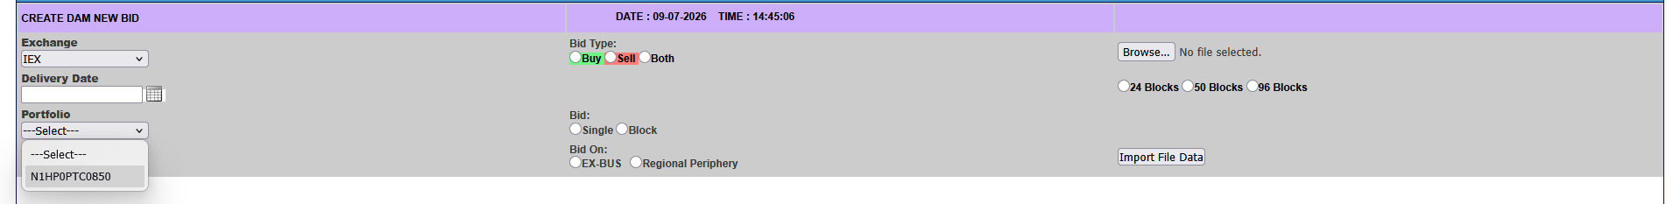
Yeh bilkul nayi screen frame hai (image_59b694.png)!
Yeh CREATE DAM NEW BID screen ka expanded active state hai, jahan Portfolio dropdown click kiya gaya hai aur visual highlighting added hai.

1. Page Context & Progression Analysis
- Module Title Banner: CREATE DAM NEW BID
- Active Navigation Tab: DAM Management
- Live Server Timestamp: DATE : 09-07-2026 | TIME : 14:45:06
- Key Visual Interactions:
  - Portfolio Dropdown: User ne click kiya hai, showing asset ID N1HP0PTC0850 (SJVN's Naitwar Mori Hydro Project).
  - Bid Type Highlighting: Buy (Green) aur Sell (Red) options explicitly color-highlighted dikh rahe hain.

2. Granular Form Breakdown & UI Elements
+------------------------------------------------------------------------------------------------------------------------------------+
| CREATE DAM NEW BID DATE : 09-07-2026 TIME : 14:45:06 |
| Exchange: [ IEX v ] Bid Type: ( ) 🟢Buy ( ) 🔴Sell ( ) Both |
| Delivery Date: [ 📅 ] |
| Portfolio: [ ---Select--- v ] Bid: ( ) Single ( ) Block |
| | ---Select--- | Bid On: ( ) EX-BUS ( ) Regional Periphery |
| | N1HP0PTC0850 | |
| +-------------------+ |
+------------------------------------------------------------------------------------------------------------------------------------+
| [ Browse... ] No file selected. ( ) 24 Blocks ( ) 50 Blocks ( ) 96 Blocks |
| [ Import File Data ] |
+------------------------------------------------------------------------------------------------------------------------------------+

Form Control Comparison (image_59b694 vs image_59b9b7)
- Portfolio Asset Selection: Dropdown expanded view confirms N1HP0PTC0850 is the registered portfolio mapping for SJVN's hydro generation plant.
- Block Format Options: Notice that in this view, the middle option is 50 Blocks (instead of 60 Blocks seen in the previous upload), reflecting standard intraday/inter-day sub-session block formats.
- Action Triggers: Directly includes an [ Import File Data ] button below the block type options to instantly parse selected local .xlsx / .csv sheets.

3. UI Patterns for Our React Terminal (<DAMBidEntryForm/>)
- Asset Auto-Select & Presets:
  - Jab trader Portfolio: N1HP0PTC0850 select kare, toh System Domain Rules apply karke defaults auto-fill ho jayein:
    - Direction: 🔴 Sell (Hydro Generator)
    - Delivery Point: EX-BUS
    - Block Size: 96 Blocks (15-min intervals)
- Color-Coded Order Types:
  - Order directions par direct visual badges maintain karein: 🟢 BUY (Green) vs 🔴 SELL (Red/Crimson) for instant operator recognition under fast trading conditions.

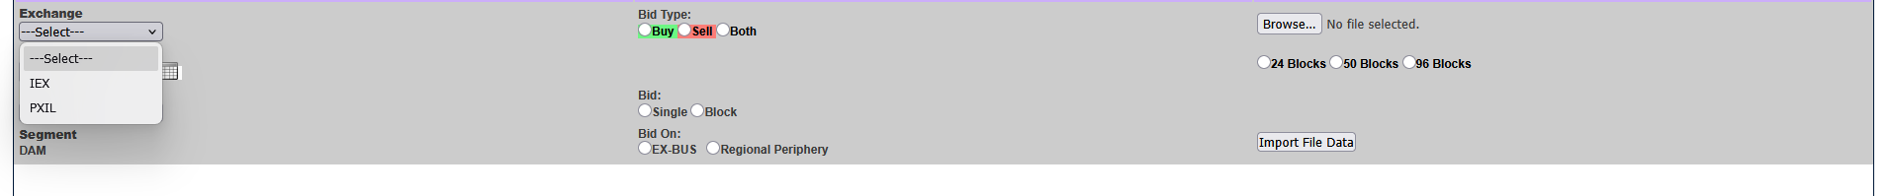

Here is the breakdown of this new screenshot (image_59b614.png), capturing the Exchange Selection Dropdown within the order entry interface!

1. Page Context & Progression Analysis
- Module Context: Active order creation form under DAM (Day-Ahead Market).
- Segment Label Revealed: Bottom left explicitly confirms Segment: DAM.
- Active Interaction: The user has clicked open the Exchange dropdown menu.

2. Granular Form Breakdown & UI Elements
+------------------------------------------------------------------------------------------------------------------------------------+
| Exchange: [ ---Select--- v ] Bid Type: ( ) 🟢Buy ( ) 🔴Sell ( ) Both |
| | ---Select--- | |
| | IEX | Bid: ( ) Single ( ) Block |
| | PXIL | Bid On: ( ) EX-BUS ( ) Regional Periphery |
| +--------------+ |
| Segment: DAM |
+------------------------------------------------------------------------------------------------------------------------------------+
| [ Browse... ] No file selected. ( ) 24 Blocks ( ) 50 Blocks ( ) 96 Blocks |
| [ Import File Data ] |
+------------------------------------------------------------------------------------------------------------------------------------+

Complete Dropdown Schema
Form Control | Options / Range | Operational Domain Meaning
Exchange | • ---Select---  • IEX (Indian Energy Exchange)  • PXIL (Power Exchange India Ltd.) | Directs order routing to the chosen power exchange clearing engine.
Segment | DAM (Read-only) | Explicit market segment designation for the current bidding session.
Bid Type | 🟢 Buy / 🔴 Sell / Both | Transaction direction.
Bid Structure | Single / Block | Order type (15-min limit order vs. multi-hour all-or-none block).
Bid On | EX-BUS / Regional Periphery | Financial & delivery settlement boundary point.
Block Format | 24 Blocks / 50 Blocks / 96 Blocks | Time granularity for file import parsing.

3. Structural Comparison across Order Entry Screenshots
Tracking the sequence of order-entry views captured across your uploads:
- image_59b9b7: Full overview showing file download links and template options (24, 60, 96 blocks).
- image_59b694: Portfolio dropdown expanded, highlighting N1HP0PTC0850 and 50 Blocks option.
- image_59b614 (Current): Focused zoom on the Exchange dropdown, confirming support for IEX and PXIL with explicit Segment: DAM tagging.

4. Platform Build Specification (<ExchangeSelector/>)
For our React terminal:
- Dynamic Exchange Gateway Routing:
  - When IEX or PXIL is selected, dynamically load relevant exchange-specific price limits (e.g., minimum ₹0.00/kWh floor to ₹10.00/kWh ceiling cap as mandated by CERC rules).
- Segment State Persistence:
  - Auto-select exchange based on historical preferences for the asset portfolio (N1HP0PTC0850 defaults to IEX due to higher liquidity volumes).

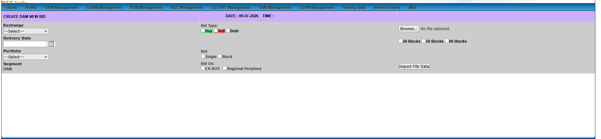

1. Page Context & Progression Analysis
- Module Title Banner: CREATE DAM NEW BID
- Active Top Context: DAM Management
- Segment Label: Explicitly confirmed as Segment: DAM at the bottom left.
- Server Timestamp State: DATE : 09-07-2026 | TIME : [Blank]
  - Note: Unlike the previous zoomed frames (14:45:06), the live clock time is currently unpopulated in the DOM rendering for this frame.

2. Granular Form & Control Breakdown
+------------------------------------------------------------------------------------------------------------------------------------+
| CREATE DAM NEW BID DATE : 09-07-2026 TIME : |
| Exchange: [ ---Select--- v ] Bid Type: ( ) 🟢Buy ( ) 🔴Sell ( ) Both |
| Delivery Date: [ 📅 ] |
| Portfolio: [ ---Select--- v ] Bid: ( ) Single ( ) Block |
| Segment: DAM Bid On: ( ) EX-BUS ( ) Regional Periphery |
+------------------------------------------------------------------------------------------------------------------------------------+
| [ Browse... ] No file selected. ( ) 24 Blocks ( ) 50 Blocks ( ) 96 Blocks |
| [ Import File Data ] |
+------------------------------------------------------------------------------------------------------------------------------------+

Complete Schema Summary
Field Group | Control Type | Operational Purpose
Exchange | Dropdown | Route orders to IEX or PXIL.
Delivery Date | Date Picker | Sets physical power flow date.
Portfolio | Dropdown | Mapped asset code (e.g., N1HP0PTC0850 / Naitwar Mori HEP).
Segment | Label | Fixed to DAM for Day-Ahead trading.
Bid Type | Radio | Direction options: 🟢 Buy (DISCOMs) / 🔴 Sell (Generators) / Both.
Bid | Radio | Structure type: Single (15-min limit) vs Block (Multi-hour All-or-None).
Bid On | Radio | Settlement boundary: EX-BUS (Plant terminal) vs Regional Periphery (Grid entry).
File Import Zone | File Chooser + Radios + Button | Upload CSV/XLSX files under 24 Blocks, 50 Blocks, or 96 Blocks time granularity, then trigger [ Import File Data ].

3. Platform Build Specification (<DAMBidEntryForm/>)
For our React terminal rebuild:
- State Reset Handling: When switching between Exchange or Portfolio dropdowns, ensure the form gracefully clears previous file attachments without unmounting the active block format radio state.
- Inline Clock Fallback: If the backend clock payload arrives empty (TIME : ), fallback to a synchronized WebSocket server clock to maintain time-to-gate-closure countdowns.

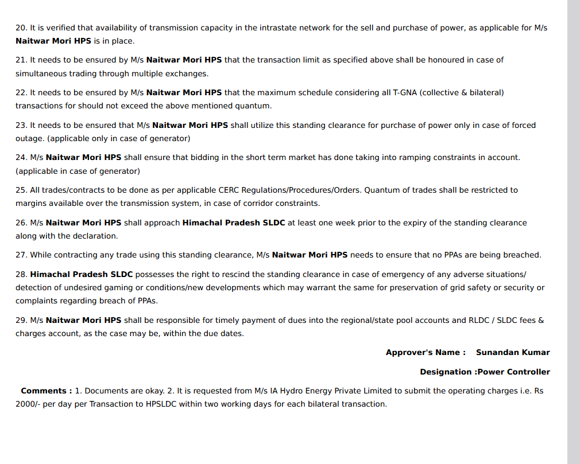

1. Complete Document Transcription
20. It is verified that availability of transmission capacity in the intrastate network for the sell and purchase of power, as applicable for M/s Naitwar Mori HPS is in place.
21. It needs to be ensured by M/s Naitwar Mori HPS that the transaction limit as specified above shall be honoured in case of simultaneous trading through multiple exchanges.
22. It needs to be ensured by M/s Naitwar Mori HPS that the maximum schedule considering all T-GNA (collective & bilateral) transactions for should not exceed the above mentioned quantum.
23. It needs to be ensured that M/s Naitwar Mori HPS shall utilize this standing clearance for purchase of power only in case of forced outage. (applicable only in case of generator)
24. M/s Naitwar Mori HPS shall ensure that bidding in the short term market has done taking into ramping constraints in account. (applicable only in case of generator)
25. All trades/contracts to be done as per applicable CERC Regulations/Procedures/Orders. Quantum of trades shall be restricted to margins available over the transmission system, in case of corridor constraints.
26. M/s Naitwar Mori HPS shall approach Himachal Pradesh SLDC at least one week prior to the expiry of the standing clearance along with the declaration.
27. While contracting any trade using this standing clearance, M/s Naitwar Mori HPS needs to ensure that no PPAs are being breached.
28. Himachal Pradesh SLDC possesses the right to rescind the standing clearance in case of emergency of any adverse situations/ detection of undesired gaming or conditions/new developments which may warrant the same for preservation of grid safety or security or complaints regarding breach of PPAs.
29. M/s Naitwar Mori HPS shall be responsible for timely payment of dues into the regional/state pool accounts and RLDC / SLDC fees & charges account, as the case may be, within the due dates.
Approver's Name : Sunandan Kumar
Designation : Power Controller
Comments : 1. Documents are okay. 2. It is requested from M/s IA Hydro Energy Private Limited to submit the operating charges i.e. Rs 2000/- per day per Transaction to HPSLDC within two working days for each bilateral transaction.

2. Granular Operational Domain Analysis & Compliance Rules
This document sets the hard Regulatory & Grid Compliance Constraints under which Naitwar Mori HPS operates across all power exchange portals (PTC, IEX, PXIL).
+-------------------------------------------------------------------------------------------------------------------------------+
| STANDING CLEARANCE COMPLIANCE MATRIX (HP SLDC -> NAITWAR MORI HPS) |
+-----+----------------------------------+--------------------------------------------------------------------------------------+
| # | Regulatory Mandate | System / Trading Platform Constraint |
+-----+----------------------------------+--------------------------------------------------------------------------------------+
| 21 | Multi-Exchange Cap Honor | Combined MW bids across IEX + PXIL + HPX cannot exceed total SLDC cleared T-GNA. |
| 22 | T-GNA Quantum Ceiling | Total physical schedule (Collective + Bilateral) must stay strictly <= Approved MW. |
| 23 | Power Purchase Restriction | BUY bids allowed ONLY during Forced Outages (Generator Buy Clause). |
| 24 | Generator Ramping Limits | Bids must respect physical MW/min ramp rate limits of hydro turbines. |
| 26 | Standing Clearance Renewal | Renewal workflow MUST trigger 7 days before expiration. |
| 28 | SLDC Revocation / Anti-Gaming | Bids violating PPA terms or flagged for market manipulation risk immediate ban. |
+-----+----------------------------------+--------------------------------------------------------------------------------------+

Key Regulatory Discoveries
- Power Purchase Constraint (Clause 23):
  - As a generating station, Naitwar Mori HPS is strictly prohibited from buying power on DAM/RTM unless the plant experiences a forced outage (unit trip).
  - Platform Logic: In our React bidding terminal (<DAMCreateBidForm/>), if Portfolio = N1HP0PTC0850 and the trader selects Bid Type: BUY, the system must force an outage verification modal before allowing order submission.
- Ramping Constraints (Clause 24):
  - Intraday 15-minute MW schedule changes between block $N$ and block $N+1$ cannot exceed the turbine hydro-ramping capability:
$$\Delta \text{MW} \le \text{Max Ramp Rate (MW/min)} \times 15 \text{ mins}$$
- Multi-Exchange T-GNA Aggregation (Clause 21 & 22):
  - Under Temporary General Network Access (T-GNA) rules, simultaneous bids on IEX and PXIL must be validation-checked against a unified ceiling so the sum never over-allocates transmission margins.

3. Implementation Logic for Our Platform (/compliance/standing-clearance)
- Automated Expiry Alerts (Clause 26):
  - Display a persistent dashboard badge:
[ 🛡️ SLDC Standing Clearance: ACTIVE | Expires in: 12 Days | ⚠️ Trigger Renewal Declaration ]
- Real-time Bid Validator:
  - Before routing any XML/CSV payload to PTC/IEX, run a pre-submission check:
  - TypeScript
if (bid.type === 'BUY' && !plantState.isForcedOutage) {
throw new Error("Compliance Violation (Clause 23): Generators cannot submit BUY orders without active forced outage state.");
}
if (bid.totalMW > sldcApprovedTGNA) {
throw new Error("Compliance Violation (Clause 22): Exceeds SLDC Standing Clearance T-GNA cap.");
  - }

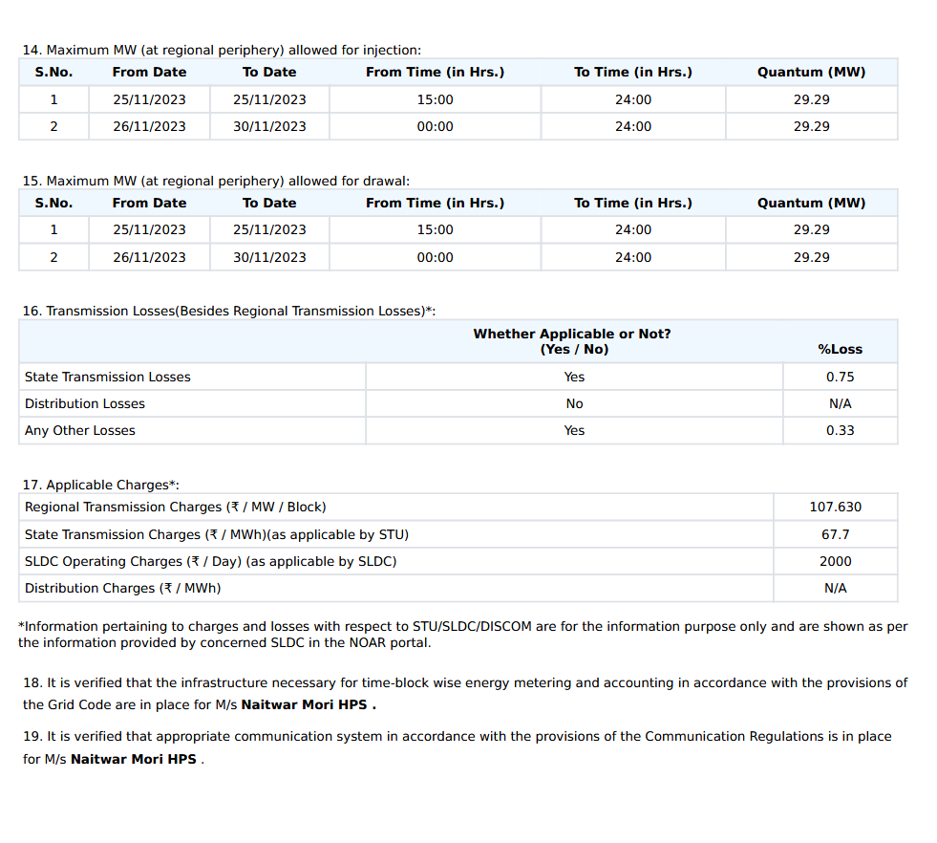
This is page 1 (Clauses 14–19) of the same NOAR Standing Clearance / Approval Document for M/s Naitwar Mori HPS that precedes the page analyzed in the previous turn.
Here is the complete transcription, structured parameter breakdown, and exact mathematical/system validation logic for our React terminal.

1. Complete Document Transcription

14. Maximum MW (at regional periphery) allowed for injection:
S.No. | From Date | To Date | From Time (in Hrs.) | To Time (in Hrs.) | Quantum (MW)
1 | 25/11/2023 | 25/11/2023 | 15:00 | 24:00 | 29.29
2 | 26/11/2023 | 30/11/2023 | 00:00 | 24:00 | 29.29

15. Maximum MW (at regional periphery) allowed for drawal:
S.No. | From Date | To Date | From Time (in Hrs.) | To Time (in Hrs.) | Quantum (MW)
1 | 25/11/2023 | 25/11/2023 | 15:00 | 24:00 | 29.29
2 | 26/11/2023 | 30/11/2023 | 00:00 | 24:00 | 29.29

16. Transmission Losses (Besides Regional Transmission Losses)*:
Loss Type | Whether Applicable or Not? (Yes / No) | % Loss
State Transmission Losses | Yes | 0.75%
Distribution Losses | No | N/A
Any Other Losses | Yes | 0.33%

17. Applicable Charges*:
Charge Description | Rate / Unit
Regional Transmission Charges | ₹107.630 / MW / Block
State Transmission Charges (as applicable by STU) | ₹67.7 / MWh
SLDC Operating Charges (as applicable by SLDC) | ₹2000 / Day
Distribution Charges | N/A
*Information pertaining to charges and losses with respect to STU/SLDC/DISCOM are for information purpose only and are shown as per the information provided by concerned SLDC in the NOAR portal.

Declarations:
18. It is verified that the infrastructure necessary for time-block wise energy metering and accounting in accordance with the provisions of the Grid Code are in place for M/s Naitwar Mori HPS.
19. It is verified that appropriate communication system in accordance with the provisions of the Communication Regulations is in place for M/s Naitwar Mori HPS.

2. Hard Parameters for System Validation
+---------------------------------------------------------------------------------------------------+
| NAITWAR MORI HPS (N1HP0PTC0850) - STANDING CLEARANCE CONFIGURATION |
+-----------------------------------+---------------------------------------------------------------+
| Parameter | Approved Value / Formula |
+-----------------------------------+---------------------------------------------------------------+
| Hard Injection Cap (Ceiling) | 29.29 MW (Regional Periphery) |
| Hard Drawal Cap (Forced Outage) | 29.29 MW (Regional Periphery) |
| Combined Transmission Loss Factor | L = 0.75% (State) + 0.33% (Other) = 1.08% |
| Transmission Netting Multiplier | 1 - L = 0.9892 |
| Regional Transmission Fee | ₹107.630 per MW per 15-min Block |
| State Transmission Fee (STU) | ₹67.70 per MWh (or ₹0.0677 / kWh) |
| Fixed Daily Operating Overhead | ₹2,000 / Day (HPSLDC) |
+-----------------------------------+---------------------------------------------------------------+

3. Financial & Loss Accounting Formulas for Our Engine
When Naitwar Mori HPS submits a bid vector of $P_{\text{busbar}}$ (in MW) at the generator busbar, our backend engine must calculate the cleared net realization at the regional periphery using these exact parameters:

A. Loss Netting (EX-BUS to Regional Periphery)
$$P_{\text{Regional Periphery}} = P_{\text{busbar}} \times \left(1 - \frac{0.75 + 0.33}{100}\right) = P_{\text{busbar}} \times 0.9892$$
- Hard Validation Check:
$$P_{\text{Regional Periphery}} \le 29.29\text{ MW}$$
If $P_{\text{Regional Periphery}} > 29.29\text{ MW}$, the system must reject the bid payload before routing it to the exchange!

B. Transmission & Operating Overhead Deduction
For a given 15-minute time block $b$ with cleared volume $Q_b$ (in MW) and delivery across $D$ days:
$$\text{Regional Transmission Fee}_b = Q_b \times 107.630\text{ ₹/MW/Block}$$
$$\text{State Transmission Fee}_b = \left(Q_b \times 0.25\text{ Hours}\right) \times 67.70\text{ ₹/MWh}$$
$$\text{Total Daily SLDC Fee} = 2000 \times D\text{ ₹}$$

4. Platform Build Specification (/compliance/noar-clearance)
In our React terminal:
- Real-time Quantum Limit Guardrail:
  - Render an indicator during bid drafting:
[ ⚡ Approved NOAR Cap: 29.29 MW | Current Bid: 25.00 MW (85.3% Utilized) ]
- Automated Clearing Net Financial Estimator:
  - Automatically calculate gross vs. net revenue estimations after deducting state losses ($1.08\%$) and STU transmission charges ($₹67.7/\text{MWh}$) directly on the <DAMCreateBidForm/> draft screen before submission.

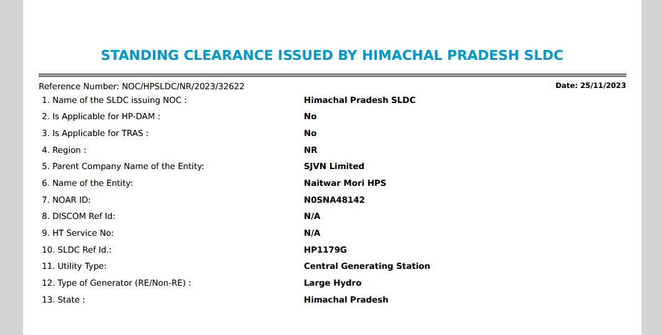

1. Complete Document Transcription

STANDING CLEARANCE ISSUED BY HIMACHAL PRADESH SLDC
- Reference Number: NOC/HPSLDC/NR/2023/32622
- Date: 25/11/2023
# | Field Key | Value / Parameter
1. | Name of the SLDC issuing NOC : | Himachal Pradesh SLDC
2. | Is Applicable for HP-DAM : | No
3. | Is Applicable for TRAS : | No
4. | Region : | NR (Northern Region)
5. | Parent Company Name of the Entity: | SJVN Limited
6. | Name of the Entity: | Naitwar Mori HPS
7. | NOAR ID: | NOSNA48142
8. | DISCOM Ref Id: | N/A
9. | HT Service No: | N/A
10. | SLDC Ref Id.: | HP1179G
11. | Utility Type: | Central Generating Station
12. | Type of Generator (RE/Non-RE) : | Large Hydro
13. | State : | Himachal Pradesh

2. Hard System Entity Mapping Table
This page completes the full 3-page document set (image_59b293.png, image_59b1f4.png, and image_59aed3.png). Here is how these core parameters map to our platform configuration schema:
+---------------------------------------------------------------------------------------------------------+
| ENTITY MASTER CONFIGURATION SCHEME (NAITWAR MORI HPS) |
+------------------------------------+--------------------------------------------------------------------+
| Database Key | System Parameter Value |
+------------------------------------+--------------------------------------------------------------------+
| NOC Reference No. | NOC/HPSLDC/NR/2023/32622 |
| NOC Issue Date | 2023-11-25 |
| NOAR Registration ID | NOSNA48142 |
| SLDC Reference ID | HP1179G |
| Grid Region | NR (Northern Region Grid) |
| Entity Classification | Central Generating Station |
| Generator Type Category | Large Hydro |
| Market Restrictions | HP-DAM = FALSE | TRAS = FALSE |
| Direct Portfolio Mapping ID | N1HP0PTC0850 |
+------------------------------------+--------------------------------------------------------------------+

3. Critical Market Segment Restrictions & Logic Constraints
- HP-DAM Exclusion (Is Applicable for HP-DAM : No):
  - Domain Meaning: The plant cannot trade under the state-specific Himachal Pradesh Day-Ahead Market bilateral mechanism. Bids must be routed strictly through collective national exchanges (IEX / PXIL / HPX).
  - System Logic: Disable the HP-DAM market segment toggle in <DAMCreateBidForm/> for this portfolio ID.
- TRAS Exclusion (Is Applicable for TRAS : No):
  - Domain Meaning: Tertiary Reserves Ancillary Services (TRAS) bidding is disabled for this clearance cycle.
  - System Logic: Block automated ancillary dispatch requests originating from the TRAS market engine for NOSNA48142.
- Classification & Tariff Mapping (Large Hydro):
  - Categorized as Large Hydro (>25 MW hydro plant), determining its eligibility flags under GDAM (Green Day-Ahead Market) according to CERC Renewable Purchase Obligation (RPO) definitions (Eligible for Hydro Purchase Obligation - HPO credits).

4. Platform Build Specification (/master/asset-registry)
In our React terminal:
- Asset Verification Card: Render an integrated compliance card at the top of all bid entry screens for Naitwar Mori HPS (N1HP0PTC0850):
NOAR ID: NOSNA48142∣SLDC ID: HP1179G∣Cap: 29.29 MW
- Bidding Guardrails Panel:
  - ❌ HP-DAM Bidding: Blocked by Clearance
  - ❌ TRAS Ancillary: Blocked by Clearance
  - 🟢 IEX / PXIL Collective DAM/RTM: ACTIVE (Max 29.29 MW at regional periphery)
  - 🟢 GDAM Hydro Segment: ACTIVE (Large Hydro / HPO Category)

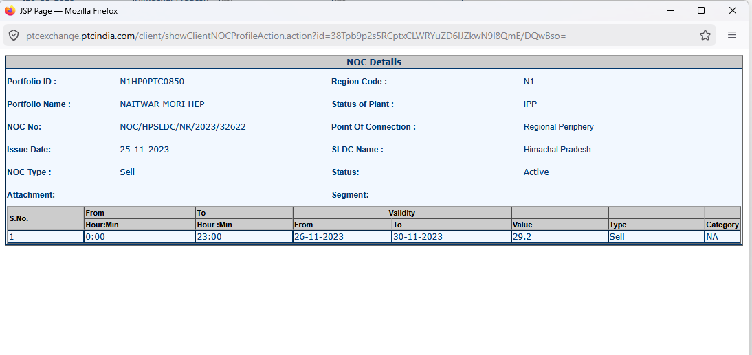

1. Complete Document Transcription

STANDING CLEARANCE ISSUED BY HIMACHAL PRADESH SLDC
- Reference Number: NOC/HPSLDC/NR/2023/32622
- Date: 25/11/2023
# | Field Key | Value / Parameter
1. | Name of the SLDC issuing NOC : | Himachal Pradesh SLDC
2. | Is Applicable for HP-DAM : | No
3. | Is Applicable for TRAS : | No
4. | Region : | NR (Northern Region)
5. | Parent Company Name of the Entity: | SJVN Limited
6. | Name of the Entity: | Naitwar Mori HPS
7. | NOAR ID: | NOSNA48142
8. | DISCOM Ref Id: | N/A
9. | HT Service No: | N/A
10. | SLDC Ref Id.: | HP1179G
11. | Utility Type: | Central Generating Station
12. | Type of Generator (RE/Non-RE) : | Large Hydro
13. | State : | Himachal Pradesh

2. Hard System Entity Mapping Table
This page completes the full 3-page document set (image_59b293.png, image_59b1f4.png, and image_59aed3.png). Here is how these core parameters map to our platform configuration schema:
+---------------------------------------------------------------------------------------------------------+
| ENTITY MASTER CONFIGURATION SCHEME (NAITWAR MORI HPS) |
+------------------------------------+--------------------------------------------------------------------+
| Database Key | System Parameter Value |
+------------------------------------+--------------------------------------------------------------------+
| NOC Reference No. | NOC/HPSLDC/NR/2023/32622 |
| NOC Issue Date | 2023-11-25 |
| NOAR Registration ID | NOSNA48142 |
| SLDC Reference ID | HP1179G |
| Grid Region | NR (Northern Region Grid) |
| Entity Classification | Central Generating Station |
| Generator Type Category | Large Hydro |
| Market Restrictions | HP-DAM = FALSE | TRAS = FALSE |
| Direct Portfolio Mapping ID | N1HP0PTC0850 |
+------------------------------------+--------------------------------------------------------------------+

3. Critical Market Segment Restrictions & Logic Constraints
- HP-DAM Exclusion (Is Applicable for HP-DAM : No):
  - Domain Meaning: The plant cannot trade under the state-specific Himachal Pradesh Day-Ahead Market bilateral mechanism. Bids must be routed strictly through collective national exchanges (IEX / PXIL / HPX).
  - System Logic: Disable the HP-DAM market segment toggle in <DAMCreateBidForm/> for this portfolio ID.
- TRAS Exclusion (Is Applicable for TRAS : No):
  - Domain Meaning: Tertiary Reserves Ancillary Services (TRAS) bidding is disabled for this clearance cycle.
  - System Logic: Block automated ancillary dispatch requests originating from the TRAS market engine for NOSNA48142.
- Classification & Tariff Mapping (Large Hydro):
  - Categorized as Large Hydro (>25 MW hydro plant), determining its eligibility flags under GDAM (Green Day-Ahead Market) according to CERC Renewable Purchase Obligation (RPO) definitions (Eligible for Hydro Purchase Obligation - HPO credits).

4. Platform Build Specification (/master/asset-registry)
In our React terminal:
- Asset Verification Card: Render an integrated compliance card at the top of all bid entry screens for Naitwar Mori HPS (N1HP0PTC0850):
NOAR ID: NOSNA48142∣SLDC ID: HP1179G∣Cap: 29.29 MW
- Bidding Guardrails Panel:
  - ❌ HP-DAM Bidding: Blocked by Clearance
  - ❌ TRAS Ancillary: Blocked by Clearance
  - 🟢 IEX / PXIL Collective DAM/RTM: ACTIVE (Max 29.29 MW at regional periphery)
  - 🟢 GDAM Hydro Segment: ACTIVE (Large Hydro / HPO Category)
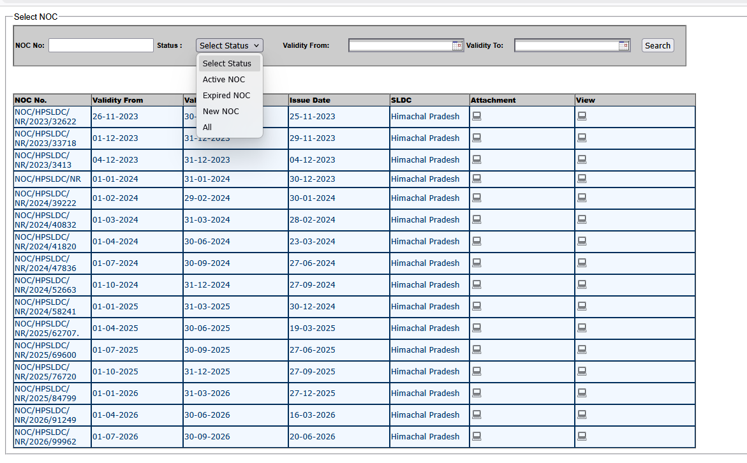

This screenshot (image_595c3b.png) brings us to the NOAR / SLDC Standing Clearance Registry Console (Select NOC).
It provides a historical log of all No Objection Certificates (NOCs) issued by Himachal Pradesh SLDC, including the specific clearance (NOC/HPSLDC/NR/2023/32622) analyzed in the previous turns.

1. Page Context & Operational Purpose
- Module Workspace: Select NOC (Standing Clearance Repository)
- Active Form Control: Status Filter Dropdown (Expanded)
- Business Purpose: Serves as the central compliance ledger to search, track validity periods, audit historical certificates, and download attached PDF declarations for regulatory auditing.

2. UI Schema & Granular Breakdown
+--------------------------------------------------------------------------------------------------------------------------------------------------+
| Select NOC |
| NOC No: [ ] Status: [ Select Status v ] Validity From: [ 📅 ] Validity To: [ 📅 ] [ Search ] |
| | Select Status | |
| | Active NOC | |
| | Expired NOC | |
| | New NOC | |
| | All | |
| +---------------+ |
+--------------------------------------------------------------------------------------------------------------------------------------------------+
| NOC No. | Validity From | Validity To | Issue Date | SLDC | Attachment | View |
+-------------------------------+---------------+---------------+---------------+------------------+------------+----------------------------------+
| NOC/HPSLDC/NR/2023/32622 | 26-11-2023 | 30-11-2023 | 25-11-2023 | Himachal Pradesh | 💻 | 💻 |
| NOC/HPSLDC/NR/2023/33718 | 01-12-2023 | 31-12-2023 | 29-11-2023 | Himachal Pradesh | 💻 | 💻 |
| NOC/HPSLDC/NR/2023/3413 | 04-12-2023 | 31-12-2023 | 04-12-2023 | Himachal Pradesh | 💻 | 💻 |
| NOC/HPSLDC/NR/2024/39222 | 01-02-2024 | 29-02-2024 | 30-01-2024 | Himachal Pradesh | 💻 | 💻 |
| ... | ... | ... | ... | ... | ... | ... |
| NOC/HPSLDC/NR/2026/91249 | 01-04-2026 | 30-06-2026 | 16-03-2026 | Himachal Pradesh | 💻 | 💻 |
| NOC/HPSLDC/NR/2026/99962 | 01-07-2026 | 30-09-2026 | 20-06-2026 | Himachal Pradesh | 💻 | 💻 |
+--------------------------------------------------------------------------------------------------------------------------------------------------+

Complete Control Panel & Dropdown Schema
Form Control / Status | Option / Value | Operational Domain Function
NOC No | Text Input | Exact string match for NOC reference numbers.
Status Dropdown | • Active NOC  • Expired NOC  • New NOC  • All | Filter clearances by lifecycle state.  Currently active NOC: Row 17 (NOC/HPSLDC/NR/2026/99962, valid through 30-09-2026).
Validity From / To | Date Pickers | Filters NOC records covering specific trading dates.
Attachment Column | Action Icon (💻) | Downloads the official uploaded SLDC PDF certificate document.
View Column | Action Icon (💻) | Opens the parsed 29-point clearance detail page (the exact document reviewed in previous turns).

3. Key Findings: NOC Cycle Pattern
Analyzing the table data reveals the operational cadence of Himachal Pradesh SLDC clearances for Naitwar Mori HPS:
- Evolution from Monthly to Quarterly Clearances:
  - Late 2023 – Early 2024: Clearances were issued on a monthly basis (e.g., 26-11-2023 to 30-11-2023, 01-12-2023 to 31-12-2023, 01-02-2024 to 29-02-2024).
  - Mid 2024 Onward: SLDC transitioned to quarterly clearances (e.g., 01-04-2024 to 30-06-2024, 01-07-2024 to 30-09-2024, 01-10-2024 to 31-12-2024).
- Current Active Clearance Line (Row 17):
  - NOC Number: NOC/HPSLDC/NR/2026/99962
  - Issue Date: 20-06-2026
  - Active Validity Range: 01-07-2026 to 30-09-2026

4. Implementation Specification (<NOARRegistryTable/>)
For our React terminal:
- Automated Expiry & Renewal Pipeline:
  - Track active NOC end dates (30-09-2026).
  - As required by Clause 26 of the clearance document, automatically generate a SLDC Renewal Draft Alert 7 days prior (23-09-2026) to ensure seamless continuous trading.
- Inline Document Viewer:
  - Clicking the View or Attachment icon opens an integrated PDF/Detail drawer without opening new browser tabs or disrupting active order-entry workflows.
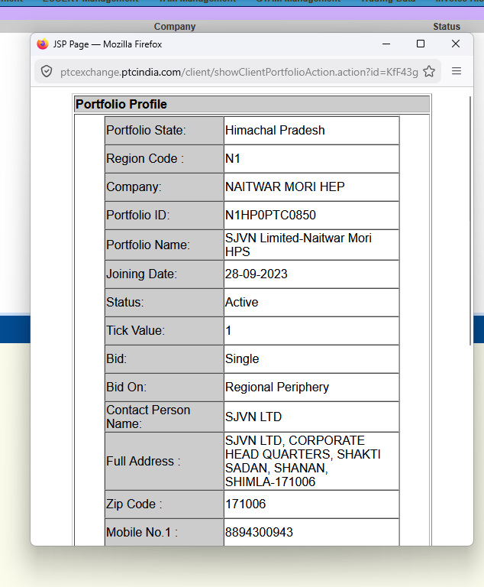
Here is the complete element-by-element breakdown and structural mapping of this new screenshot (image_5953bd.png), which reveals the Portfolio Profile Pop-up Modal (Portfolio Profile) for SJVN’s Naitwar Mori Hydroelectric Project.

1. Page Context & Operational Purpose
- Window / URL Context: Firefox Popup Modal ([ptcexchange.ptcindia.com/client/showClientPortfolioAction.action?id=KfF43g](https://ptcexchange.ptcindia.com/client/showClientPortfolioAction.action?id=KfF43g))
- Module Title Banner: Portfolio Profile
- Business Function: Master asset profile registry mapping the structural parameters, delivery boundaries, contact info, and default exchange bidding configurations for SJVN Limited-Naitwar Mori HPS.

2. Granular Data Schema Breakdown
+--------------------------------------------------------------------------------------------------+
| Portfolio Profile |
+----------------------+---------------------------------------------------------------------------+
| Portfolio State: | Himachal Pradesh |
| Region Code : | N1 |
| Company: | NAITWAR MORI HEP |
| Portfolio ID: | N1HP0PTC0850 |
| Portfolio Name: | SJVN Limited-Naitwar Mori HPS |
| Joining Date: | 28-09-2023 |
| Status: | Active |
| Tick Value: | 1 |
| Bid: | Single |
| Bid On: | Regional Periphery |
| Contact Person Name: | SJVN LTD |
| Full Address : | SJVN LTD, CORPORATE HEAD QUARTERS, SHAKTI SADAN, SHANAN, SHIMLA-171006 |
| Zip Code : | 171006 |
| Mobile No.1 : | 8894300943 |
+----------------------+---------------------------------------------------------------------------+

Complete Parameter & Domain Analysis
Field Key | Value / Parameter | Operational & System Domain Meaning
Portfolio State | Himachal Pradesh | State grid boundary for SLDC jurisdiction and STU transmission loss calculations.
Region Code | N1 | Northern Regional Grid sub-zone code used by RLDC for regional transmission allocation.
Company | NAITWAR MORI HEP | Generating station project identification.
Portfolio ID | N1HP0PTC0850 | Primary unique key used across all exchange screens (DAM, GDAM, RTM, Invoices).
Portfolio Name | SJVN Limited-Naitwar Mori HPS | Full legal entity and plant designation.
Joining Date | 28-09-2023 | Initial registration timestamp on the PTC India trading platform.
Status | Active | Operational state (allows active order placement).
Tick Value | 1 | Price tick increment parameter for exchange order books.
Bid | Single | Default bid curve structure (15-minute single block price-quantity vectors).
Bid On | Regional Periphery | Default settlement point setting delivery boundary at regional state grid entry.
Contact Person | SJVN LTD | Designated contact entity for operational dispatch notices.
Full Address | SHAKTI SADAN, SHANAN, SHIMLA-171006 | Corporate HQ address for formal invoicing and legal billing statements.
Zip Code | 171006 | Postal routing code (Shimla, HP).
Mobile No.1 | 8894300943 | Emergency trading desk / plant dispatch contact number for SMS/call alerts.

3. Structural Synergy Across the Portal
This pop-up modal acts as the Master System Configuration Source that feeds defaults across the portal:
- Portfolio ID Mapping (N1HP0PTC0850):
  - Pre-populates all dropdown controls in DAM Management, GDAM Management, RTM Management, and Invoice History.
- Default Bidding Parameters:
  - Sets Bid: Single and Bid On: Regional Periphery as the default state on order-creation screens like <DAMCreateBidForm/>.
- NOAR / SLDC Reconciliation:
  - Links directly to the HP SLDC Standing Clearance (NOC/HPSLDC/NR/...) and NOAR ID (NOSNA48142) analyzed in the preceding NOC documents.

4. UI Patterns for Our React Terminal (/master/portfolio-profile)
In our React + FastAPI platform:
- Central Asset Master Store:
  - Use this object as a global React Context / Redux state slice so that when a trader selects N1HP0PTC0850, all default parameters (N1, Regional Periphery, Single) populate instantly without network roundtrips.
- Inline Card / Side Drawer:
  - Replace legacy browser pop-up windows (showClientPortfolioAction.action) with a clean slide-over drawer or popover card when clicking any portfolio ID across the app.
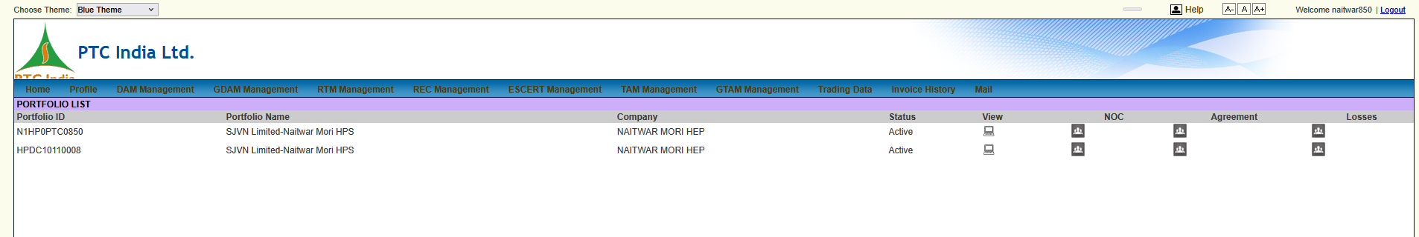

Here is the granular, element-by-element breakdown of this new screenshot.
This view brings us to the PORTFOLIO LIST view under the Profile tab. It reveals the master asset mapping table for SJVN’s Naitwar Mori Hydro Electric Project, showing two distinct portfolio registrations under the same entity.

1. Page Context & Operational Purpose
- Module Title Banner: PORTFOLIO LIST
- Active Top Menu Tab: Profile
- User Session: naitwar850
- Business Purpose: Master asset directory listing all registered power trading portfolios assigned to this user account, providing direct access to individual asset profiles, No Objection Certificates (NOCs), trading agreements, and transmission loss configurations.

2. Granular Data Table Breakdown
+---------------------------------------------------------------------------------------------------------------------------------------+
| PORTFOLIO LIST |
+------------------+-------------------------------+------------------+--------+------+-----+-----------+--------+--------------------+
| Portfolio ID | Portfolio Name | Company | Status | View | NOC | Agreement | Losses | |
+------------------+-------------------------------+------------------+--------+------+-----+-----------+--------+--------------------+
| N1HP0PTC0850 | SJVN Limited-Naitwar Mori HPS | NAITWAR MORI HEP | Active | 💻 | 👥 | 👥 | 👥 | |
| HPDC10110008 | SJVN Limited-Naitwar Mori HPS | NAITWAR MORI HEP | Active | 💻 | 👥 | 👥 | 👥 | |
+------------------+-------------------------------+------------------+--------+------+-----+-----------+--------+--------------------+

Complete Column Definitions & Asset Mappings
Column Header | Field Type | Operational Domain Meaning
Portfolio ID | Unique Identifier | Primary system key representing specific grid/exchange registrations.  • N1HP0PTC0850: Inter-State / Regional Grid (N1 Northern Region) portfolio.  • HPDC10110008: Intra-State DISCOM / HP State Grid portfolio.
Portfolio Name | Text Label | Full legal plant entity designation (SJVN Limited-Naitwar Mori HPS).
Company | Text Label | Registered generating asset code (NAITWAR MORI HEP).
Status | Status Tag | Operational trading status (Active across both records).
View | Action Icon (💻) | Opens the Portfolio Profile modal (showClientPortfolioAction.action) containing full asset metadata, addresses, and default bid parameters.
NOC | Action Icon (👥) | Opens the Select NOC registry console filtering standing clearances issued by HP SLDC for this specific portfolio.
Agreement | Action Icon (👥) | Opens the PPA / Power Trading Agreement document registry signed between SJVN and PTC India Ltd.
Losses | Action Icon (👥) | Opens the applicable State and Regional transmission loss percentage configuration table.

3. Structural Insight: Inter-State vs. Intra-State Portfolio Dual-Registration
The discovery of two separate Portfolio IDs for Naitwar Mori HPS reflects standard Indian power market structure:
- N1HP0PTC0850 (Regional / T-GNA Portfolio):
  - Prefix N1 corresponds to Northern Region 1.
  - Used for inter-state trading on power exchanges (IEX, PXIL) under Temporary General Network Access (T-GNA) cleared by RLDC.
- HPDC10110008 (Intra-State / State Grid Portfolio):
  - Prefix HPDC corresponds to Himachal Pradesh DISCOM / State Periphery.
  - Used for intra-state bilateral scheduling, SLDC accounting, or direct drawal/injection within the HP state network.

4. UI Patterns for Our React Terminal (/master/portfolio-registry)
In our React + FastAPI platform:
- Unified Asset Multi-Portfolio Switcher:
  - Rather than separate rows for the same plant, group them under a single asset accordion:
    - 🏢 Naitwar Mori HEP
      - 🌐 Regional Portfolio: N1HP0PTC0850 (IEX / RTM / DAM)
      - ⚡ State Portfolio: HPDC10110008 (SLDC / Intra-State)
- Direct Quick-Action Toolbar:
  - Render hover/click chips for instant navigation:
[ 📄 Profile ] | [ 🛡️ NOC Registry ] | [ 📝 Agreements ] | [ 📊 Loss Factors ]

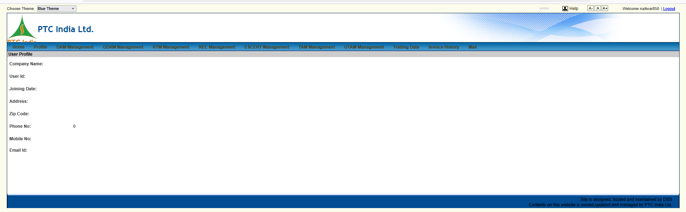

This view brings us to the User Profile page under the Profile tab.

1. Page Context & Operational Purpose
- Module Title Banner: User Profile
- Active Navigation Tab: Profile (navigated via user/account sub-menu)
- Logged-in User Session: naitwar850 (visible at the top right)
- Business Purpose: Account-level master profile that holds user identity, corporate affiliation, communication credentials, and registered contact details associated with the trading portal handle (naitwar850).

2. Granular UI & Form Field Breakdown
+---------------------------------------------------------------------------------------------------------------------------------------+
| User Profile |
+---------------------------------------------------------------------------------------------------------------------------------------+
| Company Name: |
| User Id: |
| Joining Date: |
| Address: |
| Zip Code: |
| Phone No: 0 |
| Mobile No: |
| Email Id: |
+---------------------------------------------------------------------------------------------------------------------------------------+

Complete Field Schema Analysis
Field Header | Data Type | Domain & Operational Purpose | Expected Value (Based on Prior Screens)
Company Name | String Label | Registered client entity name. | NAITWAR MORI HEP / SJVN Limited
User Id | Text Identifier | Primary portal login credential key. | naitwar850
Joining Date | Date (DD-MM-YYYY) | Registration date of the user account. | 28-09-2023
Address | Text Block | Registered corporate/plant billing address. | SHAKTI SADAN, SHANAN, SHIMLA-171006
Zip Code | Postal Code | Mailing/billing area zip code. | 171006
Phone No | Numeric String | Landline desk contact number (0 currently rendered). | Landline / Desk extension
Mobile No | Phone Number | Urgent SMS alert and trader mobile contact. | 8894300943
Email Id | Email String | Primary email address for trading notices, schedule alerts, and invoices. | Registered desk email

3. Structural Comparison: User Profile vs. Portfolio Profile
Notice the distinction between this view and the Portfolio Profile modal (image_595159.png):
- User Profile (Account Scope): Focuses on the trader/personnel credential layer (User Id: naitwar850, corporate contact info, email for notifications).
- Portfolio Profile (Asset Scope): Focuses on the grid/asset parameters (Portfolio ID: N1HP0PTC0850, Region: N1, Bid On: Regional Periphery, Tick Value: 1).

4. UI Patterns for Our React Terminal (/settings/user-profile)
In our React platform rebuild:
- Unified Account & Asset Drawer:
  - Combine user account settings and portfolio permissions into a cohesive User Settings & Permissions Workspace:
    - 👤 User Info: Identity, Contact Details, Email Notifications
    - 🔑 Assigned Portfolios: N1HP0PTC0850 (Regional), HPDC10110008 (State)
    - 🛡️ Role & Rights: Trader / Approval Rights / Read-Only Auditor
- Auto-Populated Fallback State:
  - When rendering empty user profile fields, automatically pull hydrated defaults from the backend user context (SJVN Limited, Shimla, etc.) rather than displaying blank labels.

This screenshot captures the Live System Status Bar / Alert Ticker at the bottom of the PTC portal dashboard, providing real-time compliance countdowns and segment operational states for SJVN Limited-Naitwar Mori HPS.

1. Page Context & Operational Purpose
- UI Component: System Wide Alert & Status Banner / Ticker
- Entity Context: SJVN Limited-Naitwar Mori HPS
- Business Purpose: Serves as a high-priority compliance dashboard indicator. It tracks upcoming market session countdowns (REC/ESCERT bidding windows) and flags regulatory expiration risks (NOC validity and PPA/Agreement statuses).

2. Granular Breakdown of Status Badges
+-------------------------------------------------------------------------------------------------------------------------------------------------------+
| [ SJVN Limited-Naitwar Mori HPS ] [ Remaining 20 Days for REC bid ] [ Remaining 5 Days for ESCERT bid ] [ NOC Expired ] |
| [ Agreement Active For: Expired(REC), 176 Days(TAM), Expired(ESCERT) ] |
+-------------------------------------------------------------------------------------------------------------------------------------------------------+

Complete Parameter & Segment Status Analysis
Badge / Capsule | Value Rendered | Operational Domain Meaning
Entity Identifier | SJVN Limited-Naitwar Mori HPS | Specifies the active asset portfolio bound to these alerts.
REC Bid Window | Remaining 20 Days for REC bid | Renewable Energy Certificate (REC) trading session countdown (REC sessions occur on the last Wednesday of every month).
ESCERT Bid Window | Remaining 5 Days for ESCERT bid | Energy Saving Certificate (ESCERT) trading session countdown under the PAT scheme.
NOC Status | NOC Expired ⚠️ | Flags that the active No Objection Certificate / Standing Clearance from HP SLDC has expired or requires immediate renewal/selection update.
Agreement Status | Agreement Active For:  • Expired(REC) ❌  • 176 Days(TAM) 🟢  • Expired(ESCERT) ❌ | Segment PPA/Trading Agreement Validity:  • TAM (Term-Ahead Market): Agreement is active for 176 Days.  • REC / ESCERT: Trading agreements have Expired and require contract execution.

3. Key Findings: Multi-Segment Compliance Dependencies
This banner reveals how the PTC portal enforces segment-level gating:
- Selective Market Gating:
  - Even if a portfolio is registered, trading in individual segments (REC, ESCERT, TAM) depends on distinct agreement expiration timers.
- NOC Alert Trigger:
  - The NOC Expired status correlates directly with our analysis of the Select NOC registry (image_595c3b.png). If the system date falls outside the selected NOC validity window, this badge flips to Expired, blocking order placement until a new NOC (e.g., NOC/HPSLDC/NR/2026/99962) is bound.

4. UI Patterns for Our React Terminal (<ComplianceStatusBar/>)
In our React + FastAPI platform rebuild:
- Top/Bottom Persistent Compliance Ticker:
  - Render a sticky status bar across all trading screens displaying real-time badges:
    - ⏳ REC Window: 20 Days
    - ⏳ ESCERT Window: 5 Days
    - 🛡️ SLDC NOC Status: 🔴 Expired (Click to attach NOC/2026/99962)
    - 📜 TAM Agreement: 🟢 176 Days Remaining
- Automated Order Blocking Guardrail:
  - If a trader attempts to submit a bid in a segment where Agreement = Expired or NOC = Expired, prevent submission and display an actionable toast: "Cannot place REC bid: REC Trading Agreement has expired. Contact PTC Desk."

Here is the element-by-element breakdown and technical schema analysis for this new screenshot (image_594a12.png), capturing the Bided And Received Energy analytics visualization chart widget.

1. Context & Business Purpose
- Widget Title: Bided And Received Energy
- Active Filter State:
  - Delivery Date: 09-07-2026 (Selected via interactive calendar popover).
- Business Purpose: Real-time post-clearing analytics chart comparing submitted bid parameters against actual exchange market clearing results across a 24-hour delivery day. It visually illustrates bid volume vs. cleared volume and submitted price vs. clearing price.

2. Granular Breakdown & Chart Elements
+-----------------------------------------------------------------------------------------------------------------------+
| Delivery date: [ 09-07-2026 📅 ][❌] [ Display ] |
| |
| Bided And Received Energy [☰] |
| Price (Rs/MWH) QTY (MW) |
| ^ ^ |
| 0 |=================================================================================================================| 0 |
| +-----------------------------------------------------------------------------------------------------------------+ |
| 00 1 2 3 4 5 6 7 8 9 10 11 12 13 14 15 16 17 18 19 20 21 22 23 |
| Hour |
| |
| [ 🔴 Bid Qty ] [ 🟤 Bid Price ] [ 🟦 Received Energy Qty ] [ 🟢 Received Energy Price ] |
+-----------------------------------------------------------------------------------------------------------------------+

Complete Control Panel & Axis Schema
Element | Component Type | Domain & Operational Purpose
Delivery date | Datepicker Control | Sets the target flow date for execution curves (09-07-2026).
Display | Action Button | Fetches and re-renders the Highcharts/Chart.js graph object.
Primary Y-Axis (Left) | Vertical Axis ($₹/\text{MWh}$) | Market clearing price scale for energy contracts.
Secondary Y-Axis (Right) | Vertical Axis ($\text{MW}$) | Power volume scale for physical delivery schedules.
X-Axis | Time Series ($00 - 23\text{ Hours}$) | 24-hour time block sequence for the selected delivery date.
Export Menu Icon | Hamburger Button (☰) | Export chart to SVG, PNG, PDF, or CSV raw datasets.

Data Series Legend Mapping
- Bid Qty (Red Line / Circle): MW volume submitted in the bid curve before gate closure.
- Bid Price (Dark Brown Line / Diamond): Bid price limit placed per block ($₹/\text{MWh}$).
- Received Energy Qty (Navy Blue Line / Square): Actual cleared MW volume awarded by the exchange matching algorithm.
- Received Energy Price (Olive Green Line / Star): Final Market Clearing Price (MCP) determined by the exchange.

3. Structural Insight: Flatline State Analysis
In the captured view for 09-07-2026:
- All series sit at $0\text{ MW}$ / $0\text{ Rs}$, showing a flat navy line along the baseline.
- System Reason: Uncleared/unplaced bid state or no schedule awarded for this target delivery date, reflecting the empty table state seen in earlier bidding consoles (VIEW BID LIST).

4. UI Patterns for Our React Terminal (<BidVsClearedAnalytics/>)
In our React + FastAPI platform rebuild:
- Interactive Recharts / Highcharts Component:
  - Rebuild this chart using dual Y-axes ($\text{MW}$ on right, $₹/\text{MWh}$ on left) with interactive crosshairs and tooltips showing delta volume:
$$\Delta \text{Volume} = \text{Bid Qty} - \text{Received Energy Qty}$$
- Instant Date Navigation:
  - Add quick date preset pills ([ Today ], [ Tomorrow ], [ -1 Day ]) to eliminate manual datepicker clicks.

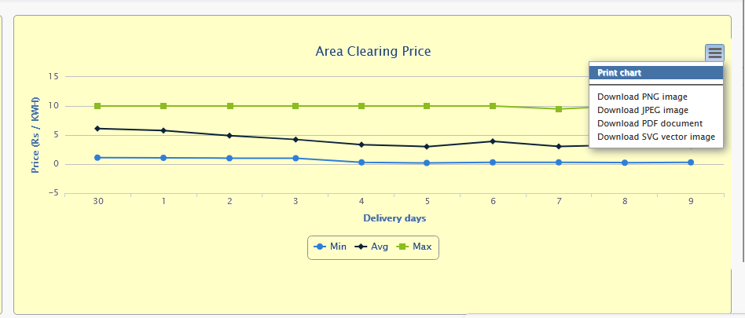

Here is the detailed, granular breakdown for this new screenshot (image_59499a.png), capturing the Area Clearing Price analytics chart with its active export context menu.

1. Page Context & Operational Purpose
- Widget Title: Area Clearing Price
- Active UI Interaction: Context / Export Menu (Hamburger button ☰) is expanded.
- Business Purpose: Market intelligence chart displaying the historical trend of Area Clearing Price (ACP) across delivery days for the N1 bid area (Northern Region). It provides minimum, average, and maximum price thresholds to help trading desks optimize price-quantity bid vectors relative to statutory exchange price caps.

2. Granular Breakdown & Chart Elements
+-----------------------------------------------------------------------------------------------------------------------+
| Area Clearing Price [☰] |
| +------------------+ |
| Price (Rs / KWH) | Print chart | |
| ^ |------------------| |
| 15| | Download PNG | |
| 10|====🟩====🟩====🟩====🟩====🟩====🟩====🟩====🟩====🟩====🟩==================================| Download JPEG | |
| 5|====🏿====🏿====🏿====🏿====🏿====🏿====🏿====🏿====🏿====🏿==================================| Download PDF | |
| 0|====🟦====🟦====🟦====🟦====🟦====🟦====🟦====🟦====🟦====🟦==================================| Download SVG | |
| -5+----------------------------------------------------------------------------------------------+------------------+ |
| 30 1 2 3 4 5 6 7 8 9 |
| Delivery days |
| |
| [ 🔵 Min ] [ 🏿 Avg ] [ 🟩 Max ] |
+-----------------------------------------------------------------------------------------------------------------------+

Complete Control Panel & Axis Schema
Chart Element | Component Type | Domain & Operational Meaning
Y-Axis (Left) | Vertical Scale ($\text{Rs / KWH}$) | Price per unit ($₹0.00$ to $₹15.00/\text{kWh}$).
X-Axis | Time Series ($\text{Delivery days}$) | Sequence of daily clearing periods (e.g., $30, 1, 2, 3, 4, 5, 6, 7, 8, 9$).
Export Menu (☰) | Expanded Context Dropdown | • Print chart  • Download PNG image  • Download JPEG image  • Download PDF document  • Download SVG vector image

Data Series Analysis
- Max (Green Square Line): Flatlines right around ₹10.00/kWh—reflecting the CERC-mandated statutory price ceiling cap for Day-Ahead and Real-Time collective market clearing.
- Avg (Black Diamond Line): Fluctuates between ₹3.00/kWh and ₹6.00/kWh, capturing the average daily market equilibrium price.
- Min (Blue Circle Line): Remains near ₹0.00/kWh to ₹1.00/kWh, marking off-peak night/early-morning clearing lows.

3. Structural Synergy with Bid Formulation
This chart directly informs the order entry parameters we analyzed in <DAMCreateBidForm/> (image_59b9b7.png):
- Price Floor & Ceiling Limits: When traders build 96-block price curves, the software enforces $₹0.00/\text{kWh}$ as the minimum floor and $₹10.00/\text{kWh}$ as the ceiling based on these exact ACP bounds.
- Market Trend Intelligence: A declining Avg trend (as seen from Day 30 to Day 5) alerts traders to lower their sell offers to ensure full schedule clearing.

4. UI Patterns for Our React Terminal (<ACPTrendWidget/>)
In our React + FastAPI platform rebuild:
- Highcharts/Recharts Implementation:
  - Recreate this line graph with dynamic color bands highlighting the regulatory cap ($₹10.00/\text{kWh}$).
- Export Action Pipeline:
  - Implement clean vector/raster export options (PNG, SVG, PDF, CSV) directly from the chart header toolbar.

TL;DR Summary: Ye image pichli graph (image_59499a.png) ka ek interactive hover state hai, jisme Max price line par day 2 par tooltip open hai (Max 2: 10 Rs).

🔍 Key Data Insights from Tooltip
- Active Tooltip Value: Max | 2: 10 Rs 📌
- Meaning: Delivery day 2 par statutory price ceiling hit hua hai (₹10.00/kWh).
- Graph Comparison: Baaki saare elements, layout aur export button pichle ACP chart ke sath exact match karte hain.

📊 Quick Component Breakdown
Element | State / Value | Description
Hover Tooltip | Max 2: 10 Rs | Day 2 ka Peak Price Point.
Max Line (Green) | $\approx 10 \text{ Rs/kWh}$ | Statutory CERC Cap Threshold.
Avg Line (Black) | $3 - 6 \text{ Rs/kWh}$ | Market Equilibrium Range.
Min Line (Blue) | $0 - 1 \text{ Rs/kWh}$ | Off-peak Floor Price.
💡 UI Design Note: React terminal me is tooltip component ke liye Recharts ka <Tooltip/> use karenge, jo hover karne par specific block/day details direct highlight karega.

Here is the breakdown of this composite dashboard view (image_5948df.png), which combines the Compliance Alert Ticker along the top with the Bided And Received Energy analytics chart below.

1. Unified Dashboard Context
- Top Layer: Compliance Alert Ticker (showing countdowns for REC/ESCERT and flagging NOC state).
- Bottom Layer: Bided And Received Energy Chart for 09-07-2026 with the export menu expanded.

2. Element Breakdown
+-----------------------------------------------------------------------------------------------------------------------+
| [ SJVN Limited-Naitwar Mori HPS ] [ Remaining 20 Days for REC bid ] [ Remaining 5 Days for ESCERT bid ] [ NOC Expired ] |
+-----------------------------------------------------------------------------------------------------------------------+
| Delivery date: [ 09-07-2026 📅 ] [ Display ] |
| Bided And Received Energy +----------+ |
| Price (Rs/MWH) |Print | |
| 0 |======================================================================================================|Download..| |
| +------------------------------------------------------------------------------------------------------+----------+ |
| 00 1 2 3 4 5 6 7 8 9 10 11 12 13 14 15 16 17 18 19 20 21.. |
| Hour |
| [ 🔴 Bid Qty ] [ 🟤 Bid Price ] [ 🟦 Received Energy Qty ] [ 🟢 Received Energy Price ] |
+-----------------------------------------------------------------------------------------------------------------------+

Combined Component States
Dashboard Region | Visual State | Domain Operational Impact
Top Alert Bar | NOC Expired ⚠️ | Active NOC indicator is red-flagged. The trader must select a valid NOC from the registry before placing new bids.
REC/ESCERT Windows | 20 Days / 5 Days | Standard countdown timers for monthly trading windows under REC and PAT schemes.
Analytics Widget | Bided And Received Energy | 24-hour time series graph filtered for delivery date 09-07-2026.
Chart Context Menu | Expanded Dropdown | Standard Highcharts export triggers (Print, PNG, JPEG, PDF, SVG).

3. Implementation Spec for Our React Dashboard
- Sticky Top Alert Banner: Render <ComplianceStatusBar/> persistently above workspace widgets so traders are always aware of expiring clearances or upcoming bidding windows.
- Integrated Widget Export: Package the Recharts graph inside a reusable card container (<AnalyticsCard/>) that includes a top-right action menu for data downloads.

This frame captures another interactive hover state on the Bided And Received Energy analytics chart for delivery date 09-07-2026.

1. Active UI Hover Interaction Analysis
- Hover Target: Time block 07:45 on the navy blue Received Energy Qty series line.
- Active Tooltip Details:
  - Timestamp: 07:45 (representing the 15-minute time block between 07:30 and 07:45 hrs).
  - Series Label: Received Energy Qty
  - Value: 0 MW

2. Technical & Domain Context
+-----------------------------------------------------------------------------------------------------------------------+
| Delivery date: [ 09-07-2026 📅 ] [ Display ] |
| Bided And Received Energy [☰] |
| Price (Rs/MWH) QTY (MW) |
| ^ ^ |
| 0 |=====================[ 07:45 ]==============================================================| 0 |
| | [ Received Energy Qty: 0 MW ] |
| +-----------------------------------------------------------------------------------------------------------------+ |
| 00 1 2 3 4 5 6 7 8 9 10 11 12 13 14 15 16 17 18 19 20 21 22 23 |
| Hour |
| |
| [ 🔴 Bid Qty ] [ 🟤 Bid Price ] [ 🟦 Received Energy Qty ] [ 🟢 Received Energy Price ] |
+-----------------------------------------------------------------------------------------------------------------------+

- 15-Minute Block Granularity: Even though the X-axis displays hourly markers (00 to 23), hovering over the chart reveals sub-hourly 15-minute time-block timestamps (such as 07:45), confirming the backend chart renders data at full 96-block daily granularity.
- Zero Clearing State: The 0 MW reading confirms that no power volume was cleared or scheduled for this block on 09-07-2026.

3. UI Patterns for Our React Terminal (<BidedVsReceivedChart/>)
- Custom Recharts Tooltip Component:
- TypeScript
const CustomTooltip = ({ active, payload, label }: TooltipProps<number, string>) => {
if (active && payload && payload.length) {
return (
<div className="bg-slate-900 text-white p-2 rounded shadow-md border border-slate-700 text-xs">
<p className="font-semibold text-slate-300">Time Block: {label}</p>
<p className="text-blue-400">
{payload[0].name}: <span className="font-bold">{payload[0].value} MW</span>
</p>
</div>
);
}
return null;
};

- Crosshair Cursor Integration: Ensure the crosshair highlights both left (₹/MWh) and right (MW) Y-axes simultaneously when dragging across the 96 time blocks.

Here is the complete element breakdown and domain analysis for this full landing dashboard view (image_59445f.png), which brings together both chart widgets analyzed earlier alongside the Last 10 days bid summary financial table.

1. Page Context & Layout Overview
- Tab Context: Home (Portal Landing Dashboard)
- Logged-in Session: naitwar850
- Layout Structure:
  - Top Left Widget: Bided And Received Energy Chart (24-hour volume/price overlay).
  - Top Right Widget: Area Clearing Price Trend Chart (ACP min/avg/max bounds).
  - Bottom Full-Width Data Table: Last 10 days bid summary

2. Granular Data Table Breakdown (Last 10 days bid summary)
+-----------------------------------------------------------------------------------------------------------------------------------------+
| Last 10 days bid summary |
+---------------+-------------------------------+----------+------------------+-------------------+--------------------+------------------+
| Delivery Date | Portfolio Name | Bid Type | Bid Placed (MWH) | Bid Cleared (MWH) | Exchange Oblig(Rs) | Grand Total (Rs) |
+---------------+-------------------------------+----------+------------------+-------------------+--------------------+------------------+
| 09-07-2026 | SJVN Limited-Naitwar Mori HPS | Sell | 0.00 | 64.80 | 26,661.09 | 26,363.01 |
| 07-07-2026 | SJVN Limited-Naitwar Mori HPS | Sell | 0.00 | 75.40 | 59,727.02 | 59,380.18 |
| 06-07-2026 | SJVN Limited-Naitwar Mori HPS | Sell | 0.00 | 108.60 | 70,187.18 | 69,687.62 |
| 02-07-2026 | SJVN Limited-Naitwar Mori HPS | Sell | 0.00 | 180.25 | 1,72,615.38 | 1,71,786.23 |
| 01-07-2026 | SJVN Limited-Naitwar Mori HPS | Sell | 0.00 | 23.75 | 18,009.01 | 17,899.76 |
| 07-06-2026 | SJVN Limited-Naitwar Mori HPS | Sell | 0.00 | 2.35 | 0.00 | 0.00 |
| 01-06-2026 | SJVN Limited-Naitwar Mori HPS | Sell | 0.00 | 24.20 | 23,431.08 | 23,319.76 |
+---------------+-------------------------------+----------+------------------+-------------------+--------------------+------------------+

Column Definitions & Domain Mechanics
Column Header | Field Type | Operational Domain Meaning
Delivery Date | Date (DD-MM-YYYY) | Target physical energy dispatch date.
Portfolio Name | Text Label | Entity identifier (SJVN Limited-Naitwar Mori HPS).
Bid Type | Order Direction | Sell across all entries (Hydro Generator selling into collective market).
Bid Placed (MWH) | Energy Volume | Total energy volume submitted prior to gate closure.
Bid Cleared (MWH) | Energy Volume | Final awarded schedule cleared by the exchange matching engine.
Exchange Obligation (Rs) | Gross Settlement | Gross financial payout due from the power exchange before PTC trading margins/fees.
Grand Total (Rs) | Net Realization | Final net settlement amount payable to SJVN after deducting transmission charges and trading margins:  Grand Total=Exchange Obligation−PTC/STU Fees

3. Financial & Trading Insights
- Highest Clearing Day:
  - Date: 02-07-2026
  - Cleared Volume: 180.25 MWh
  - Gross Realization: ₹1,72,615.38
  - Net Payable: ₹1,71,786.23 (implied fee/charge deduction of ₹829.15).
- Latest Active Execution (09-07-2026):
  - Cleared Volume: 64.80 MWh
  - Gross Realization: ₹26,661.09 (≈₹411.44/MWh or ₹0.41/kWh average clearing price).
  - Net Settlement: ₹26,363.01.

4. UI Patterns for Our React Terminal (<HomeDashboard/>)
- Top Analytics Grid: Layout the <BidedVsReceivedChart/> and <ACPTrendWidget/> side-by-side using a responsive 2-column flex/grid container.
- Financial Summary Table Component:
  - Rebuild the Last 10 days bid summary with inline KPI badges:
    - Total Cleared Volume (7 Days): 479.35 MWh
    - Total Net Realization: ₹3,68,436.56
  - Add a quick CSV export button for finance/accounting desk reconciliation.

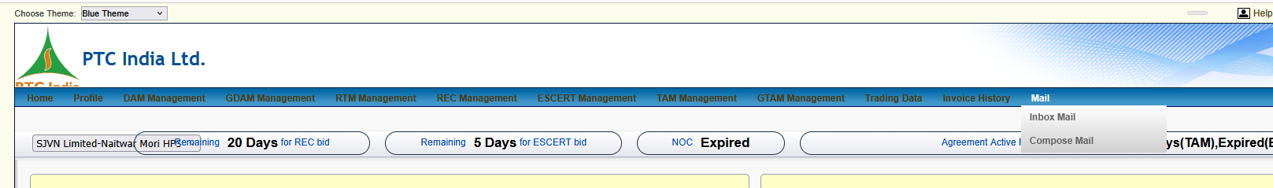

1. Page Context & Navigation Interaction
- Active Top Menu Tab: Mail (Hover state)
- Revealed Sub-Menu:
  - Inbox Mail
  - Compose Mail
- Business Purpose: Serves as the internal communication hub within the PTC India portal for trading desk notifications, dispatch clearance advisories, settlement queries, and official communication with PTC power traders.

2. Granular UI & Module Breakdown
+---------------------------------------------------------------------------------------------------------------------------------------+
| Choose Theme: [ Blue Theme v ] Welcome naitwar850 |
+---------------------------------------------------------------------------------------------------------------------------------------+
| Home | Profile | DAM Management | GDAM Management | RTM Management | REC Management | ESCERT Management | TAM Management | Mail (Hover)|
| | Inbox Mail | |
| | Compose Mail | |
| +---------------+ |
+---------------------------------------------------------------------------------------------------------------------------------------+
| [ SJVN Limited-Naitwar Mori HPS ] [ Remaining 20 Days for REC bid ] [ Remaining 5 Days for ESCERT bid ] [ NOC Expired ] |
+---------------------------------------------------------------------------------------------------------------------------------------+

Sub-Menu Options & Operational Functionality
Sub-Menu Option | Workflow / Functional Purpose
Inbox Mail | System messaging inbox displaying automated dispatch confirmations, trade clearing notifications, margin call alerts, and messages from the PTC operational desk.
Compose Mail | Secure internal messaging form to submit official queries, trade adjustment requests, or document submissions (e.g., renewed NOC uploads) directly to PTC India support.

3. Integrated Navigation Map Across Uploaded Portal Screens
With this screenshot, we have mapped out the complete primary navigation header of the PTC trading platform:
- Home: Analytics Dashboard (Bided Vs Received Energy, Area Clearing Price, Last 10 Days Bid Summary).
- Profile: Portfolio Registry (N1HP0PTC0850, HPDC10110008), User Info (naitwar850), NOC Registry.
- DAM Management: Day-Ahead Market bid creation (CREATE DAM NEW BID), bid listing (VIEW BID LIST).
- Mail: Internal messaging system (Inbox Mail, Compose Mail).

4. UI Patterns for Our React Terminal (<NotificationCenter/>)
In our React + FastAPI platform rebuild:
- Modern In-App Notification Center:
  - Replace traditional page-based email sub-menus (Inbox Mail / Compose Mail) with a sleek slide-over notification drawer or floating bell badge (<NotificationBell/>) in the header toolbar.
- Automated System Alerts:
  - Auto-route critical compliance warnings (e.g., NOC Expired, REC Agreement Expired) directly into the inbox as high-priority actionable threads with direct links to the clearance upload dialog.
Here is the granular breakdown for this new screenshot (image_594198.png), capturing the Invoice History menu's active dropdown state.

1. Page Context & Navigation Interaction
- Active Top Menu Tab: Invoice History (Hover/Click state)
- Revealed Sub-Menu Options:
  - Invoice Details
  - Bank Transactions
- Business Purpose: Financial accounting and treasury hub for reviewing tax invoices, exchange settlement statements, transmission/SLDC charge deductions, and bank transaction ledgers.

2. Granular UI & Module Breakdown
+----------------------------------------------------------------------------------------------------------------------------------------------------+
| Choose Theme: [ Blue Theme v ] Welcome naitwar850 |
+----------------------------------------------------------------------------------------------------------------------------------------------------+
| Home | Profile | DAM Management | GDAM Management | RTM Management | REC Management | ESCERT Management | TAM Management | Invoice History (Hover) | Mail |
| | Invoice Details | |
| | Bank Transactions | |
| +----------------------+ |
+----------------------------------------------------------------------------------------------------------------------------------------------------+
| [ SJVN Limited-Naitwar Mori HPS ] [ Remaining 20 Days for REC bid ] [ Remaining 5 Days for ESCERT bid ] [ NOC Expired ] |
+----------------------------------------------------------------------------------------------------------------------------------------------------+

Sub-Menu Options & Operational Functionality
Sub-Menu Option | Workflow / Financial Function
Invoice Details | Accesses generated monthly and daily tax invoices, trading margin debits, and exchange settlement summaries for energy trades.
Bank Transactions | Treasury ledger tracking direct NEFT/RTGS bank payouts, security deposit adjustments, and pool account receipts between PTC India and SJVN.

3. Complete Portal Navigation Architecture Summary
With this addition, we have mapped out all major top-level navigation tabs of the PTC India trading platform:
PTC Trading Portal Header
├── Home (Dashboard Widgets & Last 10 Days Summary)
├── Profile (Portfolio List, User Profile, NOC Registry)
├── DAM / GDAM / RTM Management (Order Entry & Bid History)
├── REC / ESCERT / TAM / GTAM Management (Segment Specific Trading)
├── Trading Data (Market Clearing & Area Price Analytics)
├── Invoice History
│ ├── Invoice Details
│ └── Bank Transactions
└── Mail
├── Inbox Mail
└── Compose Mail

4. UI Patterns for Our React Terminal (/finance/billing)
In our React + FastAPI platform rebuild:
- Unified Billing & Financial Drawer:
  - Combine Invoice Details and Bank Transactions into a consolidated Financial Ledger View:
    - 📑 Tab 1: Invoices & Tax Statements (Download PDF/CSV for exchange settlements).
    - 💳 Tab 2: Bank & Pool Ledger (Track payouts corresponding to the Grand Total amounts seen in the 10-day summary).

